Spring Framework

Spis treści
Spring Framework 1
1. What is what and why 4
2. Why do we need Spring 4
2.1. now I move the configuration to an XML file 6
2.2. what if I get the same bean's object several times? 19
3. More details on application context configuration 19
3.1. I create basic Java project using Spring 19
3.2. how to set properties of different types 23
3.2.1. informal, inclomplete and simplified but useful grammar of the configuration of an application context 23
3.2.2. examples 24
4. Using a DataSource 34
4.1. I create and use a DataSource 35
4.2. how does <property-placeholder /> work 46
4.3. InitializingBean interface, interface injection 47
4.4. LocalEntityManagerFactoryBean 49
4.5. now I move as much code as possible out of Main 52
4.6. postprocessors 60
4.7. if we didn't use ClassPathXmlApplicationContext we would have to do more to make this example work 63
4.8. autowiring with annotations 67
4.9. some experiments with injecting using annotations 69
4.10. turning on AutowiredAnnotationBeanPostProcessor with context:annotation-config 75
4.11. context:component-scan 76
4.12. @PersistenceUnit and @PersistenceContext 78
5. Spring MVC 80
5.1. I install and configure Tomcat 80
5.2. I create a new project and deploy it in Tomcat 81
5.3. dispatcher servlet 86
5.4. I do the basic configuration of the dispatcher servlet 87
5.5. I configure the dispatcher servlet so that some URLs are handled by some handlers and produce some HTTP response 92
5.5.1. I write a hello world handler mapper 92
5.5.2. I write some real handler and its handler mapping and handler adapter 95
5.5.3. I use handler adapter and handler interface written by authors of Spring MVC 104
5.5.3.1. I use a handler interface called Controller 104
5.5.3.2. I use SimpleUrlHandlerMapping to map some URLs to the CatController 104
5.5.3.3. I use the InternalResourceViewResolver view resolver to display the model using a JSP template 107
5.5.3.4. I use the BeanNameUrlHandlerMapping handler mapping 115
5.5.3.5. I use the DefaultAnnotationHandlerMapping handler mapping and the AnnotationMethodHandlerAdapter handler adapter 117
5.5.3.5.1. I use the DefaultAnnotationHandlerMapping handler mapping 117
5.5.3.5.2. I use the AnnotationMethodHandlerAdapter handler adapter 119
5.5.3.5.3. I use the DefaultAnnotationHandlerMapping handler mapping and the AnnotationMethodHandlerAdapter handler adapter together 122
5.5.3.5.3.1. I write a JSP template 122
5.5.3.5.3.2. I write two annotated handlers with annotated methods 123
5.5.3.5.3.3. I configure the application context and test if everything works 125
5.5.3.5.3.4. Limitations of DefaultAnnotationHandlerMapping and AnnotationMethodHandlerAdapter 126
5.5.3.5.3.4.1. I do two controllers that are mapped to the same pattern, they only differ by the pattern of their methods 126
5.5.3.5.3.4.2. I do two controllers that are mapped to the same pattern, they only differ that their methods are annotated to react to different HTTP methods 127
5.5.3.5.3.4.3. I test DefaultAnnotationHandlerMapping without dispatcher servlet 129
5.5.3.5.3.4.4. I take a look at the mapping that DefaultAnnotationHandlerMapping uses to map requests to handlers 135
5.5.3.6. I use the RequestMappingHandlerMapping handler mapping and the RequestMappingHandlerAdapter handler adapter 140
6. Summary 142
6.1. Core 142
6.2. Web MVC 143
6.2.1. Stuff which you don’t want to write yourself 144

What is what and why
There is a project called Spring framework. This project consists of several parts (for instance, when we add Spring Framework as a dependency to our project, it adds several jars). Some of these parts are:
- spring-core – it is an inversion of control container
- spring-webmvc – it is a framework for web applications
- spring-webflux – it is a new (since Spring Framework 5.0, so since 2017), reactive framework for web applications
Authors of Spring Framework have also created a lot of other projects which names start with Spring: for instance Spring Boot or Spring Security. It causes some ambiguity: when people talk about Spring, sometimes they mean Spring Framework, sometimes they mean all Spring something projects and sometimes they mean I don’t know what.
This document describes two parts of Spring Framework: spring-core and spring-webmvc.

Why do we need Spring
The program I write in this chapter and in following chapters is in the project MySpringHelloWorld.
Let's imagine I have to write a program which will show current date.
I will make it modular. There will be:
- DateProducer – a factory that can produce a date,
- DatePrinter – a class that can print out a date,
- MyProgram – a class that needs to have injected DateProducer and DatePrinter and that uses them to print a date,
- Main – a class that instantiates all three classes, injects the instance of DateProducer and DatePrinter into MyProgram and runs MyProgram.
I create in NetBeans a new project of type maven -> Java application. I call it MySpringHelloWorld. In it, I create the DateProducer class:
package pl.kuku.myspringhelloworld;
import java.util.Date;
public class DateProducer {
private Date date;
public void setDate(Date date) {
this.date = date;
}
public Date giveMeADate() {
return date;
}
}
And the DatePrinter class:
package pl.kuku.myspringhelloworld;
import java.util.Date;
public class DatePrinter {
public void printDate(Date d) {
System.out.println("date: " + d);
}
}
And the MyProgram class:
package pl.kuku.myspringhelloworld;
public class MyProgram {
private DateProducer producer;
private DatePrinter printer;
public void setProducer(DateProducer producer) {
this.producer = producer;
}
public void setPrinter(DatePrinter printer) {
this.printer = printer;
}
public void run() {
printer.printDate(producer.giveMeADate());
}
}
And the Main class:
package pl.kuku.myspringhelloworld;
import java.util.Date;
public class Main {
public static void main(String[] args) {
Date d = new Date();
d.setYear(115);
d.setMonth(2);
d.setDate(23);
DateProducer producer = new DateProducer();
producer.setDate(d);
DatePrinter printer = new DatePrinter();
MyProgram mp = new MyProgram();
mp.setProducer(producer);
mp.setPrinter(printer);
mp.run();
}
}
I run this program. It works.
The advantage of such modular design is that if I want to use another date producer or another date printer – for instance in order to do tests – there is only one source file that contains the configuration – the Main class.
The program will be even more configurable if I move the configuration from the Main class to some XML file which will be read during the runtime.

now I move the configuration to an XML file
Now I add Spring Framework as a dependency of my project. I add following fragment to the pom.xml file of my project:
<?xml version="1.0" encoding="UTF-8"?>
<project xmlns="http://maven.apache.org/POM/4.0.0" xmlns:xsi="http://www.w3.org/2001/XMLSchema-instance" xsi:schemaLocation="http://maven.apache.org/POM/4.0.0 http://maven.apache.org/xsd/maven-4.0.0.xsd">
<modelVersion>4.0.0</modelVersion>
<groupId>com.mycompany</groupId>
<artifactId>MySpringHelloWorld</artifactId>
<version>1.0-SNAPSHOT</version>
<packaging>jar</packaging>
<properties>
<project.build.sourceEncoding>UTF-8</project.build.sourceEncoding>
<maven.compiler.source>1.7</maven.compiler.source>
<maven.compiler.target>1.7</maven.compiler.target>
</properties>
<dependencies>
<dependency>
<groupId>org.springframework</groupId>
<artifactId>spring-context</artifactId>
<version>4.0.3.RELEASE</version>
</dependency>
</dependencies>
</project>
Now in Netbeans I go to files tab and there I create file src/main/resources/myconfig.xml – I create it as a file of type Spring XML config, with p and config namespaces:
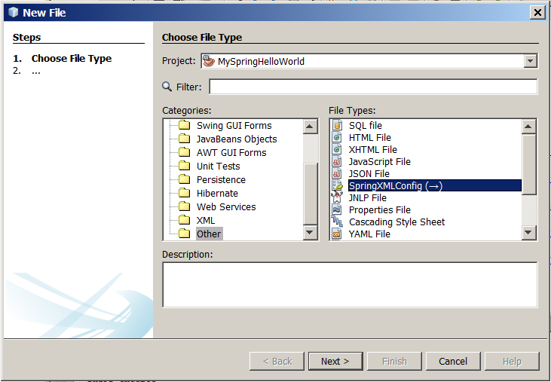
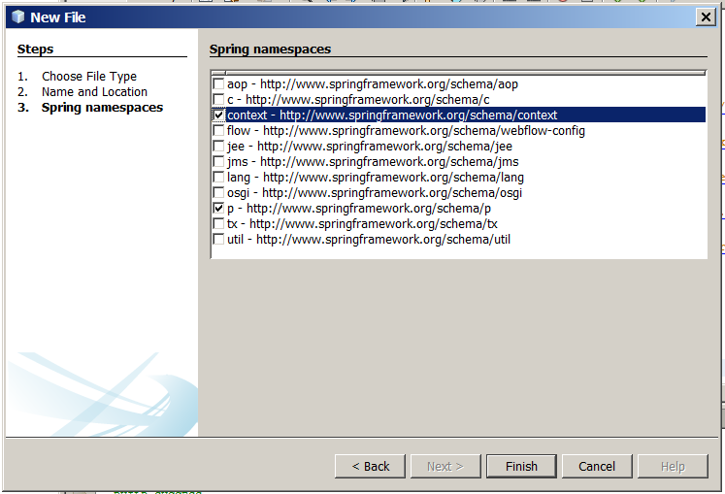
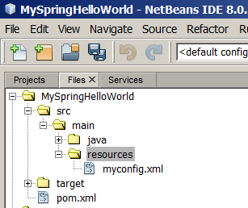
Now I look at this file (before I write anything in it):
<?xml version="1.0" encoding="UTF-8"?>
<beans xmlns="http://www.springframework.org/schema/beans"
xmlns:xsi="http://www.w3.org/2001/XMLSchema-instance"
xmlns:context="http://www.springframework.org/schema/context"
xmlns:p="http://www.springframework.org/schema/p"

xsi:schemaLocation="http://www.springframework.org/schema/beans http://www.springframework.org/schema/beans/spring-beans-4.0.xsd
http://www.springframework.org/schema/context http://www.springframework.org/schema/context/spring-context-4.0.xsd
">
</beans>
As we can see, the xsi:schemaLocation attribute provides URLs of schemas of different namespaces. For instance, we can see that the context namespace alias has an URL http://www.springframework.org/schema/context, and its XSD is at http://www.springframework.org/schema/context/spring-context-4.0.xsd.
During the runtime, Spring will try to download those schemas to validate our XML config file. But, in order not to use Internet connection in vain, Spring's jars contain those XSDs together with a mapping mapping XSDs' URLs to paths of XSD files in jars.
For example, in Netbeans I look at dependencies -> spring-context-4.0.3.RELEASE.jar -> META-INF -> spring.schemas:
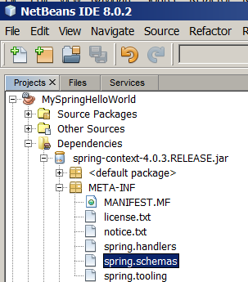
This is the file with mappings of those XSDs which are in this jar. It looks like that:
http\://www.springframework.org/schema/context/spring-context-2.5.xsd=org/springframework/context/config/spring-context-2.5.xsd
http\://www.springframework.org/schema/context/spring-context-3.0.xsd=org/springframework/context/config/spring-context-3.0.xsd
http\://www.springframework.org/schema/context/spring-context-3.1.xsd=org/springframework/context/config/spring-context-3.1.xsd
http\://www.springframework.org/schema/context/spring-context-3.2.xsd=org/springframework/context/config/spring-context-3.2.xsd
http\://www.springframework.org/schema/context/spring-context-4.0.xsd=org/springframework/context/config/spring-context-4.0.xsd
(...)
As we can see, the mirror of http://www.springframework.org/schema/context/spring-context-4.0.xsd is in org/springframework/context/config/spring-context-4.0.xsd. I look in this file (it is in the same jar):
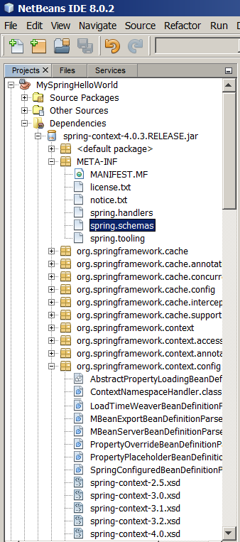
It looks like that:
<?xml version="1.0" encoding="UTF-8"?>
<xsd:schema xmlns="http://www.springframework.org/schema/context"
xmlns:xsd="http://www.w3.org/2001/XMLSchema"
xmlns:beans="http://www.springframework.org/schema/beans"
xmlns:tool="http://www.springframework.org/schema/tool"
targetNamespace="http://www.springframework.org/schema/context"
elementFormDefault="qualified"
attributeFormDefault="unqualified">
<xsd:import namespace="http://www.springframework.org/schema/beans" schemaLocation="http://www.springframework.org/schema/beans/spring-beans-4.0.xsd"/>
<xsd:import namespace="http://www.springframework.org/schema/tool" schemaLocation="http://www.springframework.org/schema/tool/spring-tool-4.0.xsd"/>
Well, it's just an XSD – nothing special.
Sometimes it's important – for instance because if in our XML configuration file we mention newer versions of XSDs than we have in our jars (for instance because we copied those configs from the web) Spring will actually download them. On stackoverflow there are many questions about problems people have with this behaviour, like:
- https://stackoverflow.com/questions/10680000/you-dont-have-permission-to-access-schema-beans-spring-beans-3-1-xsd-on-this-s
- https://stackoverflow.com/questions/10681864/spring-beans-schema-no-longer-available-on-the-web
Now in this XML configuration file I just created (the one called myconfig.xml) I will describe some configurations of some factories. Such named configuration of a factory is called bean. Or sometimes this definition is called bean definition and the object created by this factory is called bean.
I write:
<?xml version="1.0" encoding="UTF-8"?>
<beans xmlns="http://www.springframework.org/schema/beans"
xmlns:xsi="http://www.w3.org/2001/XMLSchema-instance"
xmlns:context="http://www.springframework.org/schema/context"
xmlns:p="http://www.springframework.org/schema/p"

xsi:schemaLocation="http://www.springframework.org/schema/beans http://www.springframework.org/schema/beans/spring-beans-4.0.xsd
http://www.springframework.org/schema/context http://www.springframework.org/schema/context/spring-context-4.0.xsd
">
<bean id="primaaprilis" class="java.util.Date">
<property name="year" value="115" />
<property name="month" value="3" />
<property name="date" value="1" />
</bean>
</beans>
Now in Main I comment out the fragment creating Date object and replace it with this:
package pl.kuku.myspringhelloworld;
import java.util.Date;
import org.springframework.context.ApplicationContext;
import org.springframework.context.support.ClassPathXmlApplicationContext;
public class Main {
public static void main(String[] args) {
// Date d = new Date();
// d.setYear(115);
// d.setMonth(2);
// d.setDate(23);
ApplicationContext context = new ClassPathXmlApplicationContext("/myconfig.xml");
Date d = (Date) context.getBean("primaaprilis");
DateProducer producer = new DateProducer();
producer.setDate(d);
DatePrinter printer = new DatePrinter();
MyProgram mp = new MyProgram();
mp.setProducer(producer);
mp.setPrinter(printer);
mp.run();
}
}
If in the XML configuration file we only have one bean on some class, the method getBean can also be given class of the bean – this way we don't need explicit typecast, which gives us type safety:
package pl.kuku.myspringhelloworld;
import java.util.Date;
import org.springframework.context.ApplicationContext;
import org.springframework.context.support.ClassPathXmlApplicationContext;
public class Main {
public static void main(String[] args) {
ApplicationContext context = new ClassPathXmlApplicationContext("/myconfig.xml");
Date d = context.getBean(Date.class);
DateProducer producer = new DateProducer();
producer.setDate(d);
DatePrinter printer = new DatePrinter();
MyProgram mp = new MyProgram();
mp.setProducer(producer);
mp.setPrinter(printer);
mp.run();
}
}
We can also provide getBean method both bean's name and class:
package pl.kuku.myspringhelloworld;
import java.util.Date;
import org.springframework.context.ApplicationContext;
import org.springframework.context.support.ClassPathXmlApplicationContext;
public class Main {
public static void main(String[] args) {
ApplicationContext context = new ClassPathXmlApplicationContext("/myconfig.xml");
Date d = context.getBean("primaaprilis", Date.class);
DateProducer producer = new DateProducer();
producer.setDate(d);
DatePrinter printer = new DatePrinter();
MyProgram mp = new MyProgram();
mp.setProducer(producer);
mp.setPrinter(printer);
mp.run();
}
}
I make sure that the program still works.
Now in the XML configuration file I write the configuration of DateProducer and DatePrinter. This time I have to use ref instead of value – when we use value, the value of value is used to set the property (using editor – see http://docs.oracle.com/javase/7/docs/api/java/beans/PropertyEditor.html ), when we use ref, the property is set to the object whose name is given in ref.
This is what I write:
<?xml version="1.0" encoding="UTF-8"?>
<beans xmlns="http://www.springframework.org/schema/beans"
xmlns:xsi="http://www.w3.org/2001/XMLSchema-instance"
xmlns:context="http://www.springframework.org/schema/context"
xmlns:p="http://www.springframework.org/schema/p"
xsi:schemaLocation="http://www.springframework.org/schema/beans http://www.springframework.org/schema/beans/spring-beans-4.0.xsd
http://www.springframework.org/schema/context http://www.springframework.org/schema/context/spring-context-4.0.xsd
">
<bean id="primaaprilis" class="java.util.Date">
<property name="year" value="115" />
<property name="month" value="3" />
<property name="date" value="1" />
</bean>
<bean id="myproducer" class="pl.kuku.myspringhelloworld.DateProducer">
<property name="date" ref="primaaprilis" />
</bean>
<bean id="myprinter" class="pl.kuku.myspringhelloworld.DatePrinter" />
</beans>
Now in Main I write the code which gets DateProducer and DatePrinter from the context.
Now in Main I don't need any more getting the Date from context, so I can comment out this line:
Date d = context.getBean("primaaprilis", Date.class);
So now Main looks like that:
package pl.kuku.myspringhelloworld;
import java.util.Date;
import org.springframework.context.ApplicationContext;
import org.springframework.context.support.ClassPathXmlApplicationContext;
public class Main {
public static void main(String[] args) {
ApplicationContext context = new ClassPathXmlApplicationContext("/myconfig.xml");
DateProducer producer = context.getBean("myproducer", DateProducer.class);
DatePrinter printer = context.getBean("myprinter", DatePrinter.class);
MyProgram mp = new MyProgram();
mp.setProducer(producer);
mp.setPrinter(printer);
mp.run();
}
}
I make sure that the program still works.
Now I define MyProgram bean in myconfig.xml. I use the other syntax to provide values of properties – using attributes from the p namespace. I also use the init-method property to make Spring run the run method on MyProgram after creating its instance:
<?xml version="1.0" encoding="UTF-8"?>
<beans xmlns="http://www.springframework.org/schema/beans"
xmlns:xsi="http://www.w3.org/2001/XMLSchema-instance"
xmlns:context="http://www.springframework.org/schema/context"
xmlns:p="http://www.springframework.org/schema/p"

xsi:schemaLocation="http://www.springframework.org/schema/beans http://www.springframework.org/schema/beans/spring-beans-4.0.xsd
http://www.springframework.org/schema/context http://www.springframework.org/schema/context/spring-context-4.0.xsd
">
<bean id="primaaprilis" class="java.util.Date">
<property name="year" value="115" />
<property name="month" value="3" />
<property name="date" value="1" />
</bean>
<bean id="myproducer" class="pl.kuku.myspringhelloworld.DateProducer">
<property name="date" ref="primaaprilis" />
</bean>
<bean id="myprinter" class="pl.kuku.myspringhelloworld.DatePrinter" />
<bean id="mymyprogram" class="pl.kuku.myspringhelloworld.MyProgram"
init-method="run"
p:producer-ref="myproducer"
p:printer-ref="myprinter"
/>
</beans>
Now I don't need to get any objects from the context in Main – I only have to create the context. So now Main is very simple:
package pl.kuku.myspringhelloworld;
import java.util.Date;
import org.springframework.context.ApplicationContext;
import org.springframework.context.support.ClassPathXmlApplicationContext;
public class Main {
public static void main(String[] args) {
new ClassPathXmlApplicationContext("/myconfig.xml");
}
}
Now my program has one big advantage – it is possible to configure it without recompiling it. I'll try it. I will reconfigure it to show current date. In myconfig.xml I write:
<?xml version="1.0" encoding="UTF-8"?>
<beans xmlns="http://www.springframework.org/schema/beans"
xmlns:xsi="http://www.w3.org/2001/XMLSchema-instance"
xmlns:context="http://www.springframework.org/schema/context"
xmlns:p="http://www.springframework.org/schema/p"
xsi:schemaLocation="http://www.springframework.org/schema/beans http://www.springframework.org/schema/beans/spring-beans-4.0.xsd
http://www.springframework.org/schema/context http://www.springframework.org/schema/context/spring-context-4.0.xsd
">
<bean id="primaaprilis" class="java.util.Date">
<property name="year" value="115" />
<property name="month" value="3" />
<property name="date" value="1" />
</bean>
<bean id="current_date" class="java.util.Date" />
<bean id="myproducer" class="pl.kuku.myspringhelloworld.DateProducer">
<!-- <property name="date" ref="primaaprilis" /> -->
<property name="date" ref="current_date" />
</bean>
<bean id="myprinter" class="pl.kuku.myspringhelloworld.DatePrinter" />
<bean id="mymyprogram" class="pl.kuku.myspringhelloworld.MyProgram"
init-method="run"
p:producer-ref="myproducer"
p:printer-ref="myprinter"
/>
</beans>
I make sure that the program works – it does.

what if I get the same bean's object several times?
Now I will try to get several times the same bean and I will check whether it is the same object. In Main I write:
package pl.kuku.myspringhelloworld;
import java.util.Date;
import org.springframework.context.ApplicationContext;
import org.springframework.context.support.ClassPathXmlApplicationContext;
public class Main {
public static void main(String[] args) {
ApplicationContext context = new ClassPathXmlApplicationContext("/myconfig.xml");
Date d1 = (Date) context.getBean("primaaprilis");
Date d2 = (Date) context.getBean("primaaprilis");
Date d3 = (Date) context.getBean("primaaprilis");
System.out.println(String.format("dates' hashcodes: %h, %h, %h", System.identityHashCode(d1), System.identityHashCode(d2), System.identityHashCode(d3)));
}
}
The result of this program looks like that:
date: Tue Mar 24 10:15:26 CET 2015
dates' hashcodes: d4004b, d4004b, d4004b
It proves that when I get several times the same bean, I get the same object.

More details on application context configuration

I create basic Java project using Spring
Sometimes I want to do some simple Spring experiments, so I need a simple Netbeans java project using Spring. This chapter describes how to create such project. The project I create in this chapter is a project called BasicSpringProject.
I create in NetBeans a new project of type maven -> Java application. I call it BasicSpringProject.
I add Spring Framework as a dependency of my project. I add following fragment to the pom.xml file of my project:
<?xml version="1.0" encoding="UTF-8"?>
<project xmlns="http://maven.apache.org/POM/4.0.0" xmlns:xsi="http://www.w3.org/2001/XMLSchema-instance" xsi:schemaLocation="http://maven.apache.org/POM/4.0.0 http://maven.apache.org/xsd/maven-4.0.0.xsd">
<modelVersion>4.0.0</modelVersion>
<groupId>com.mycompany</groupId>
<artifactId>MySpringHelloWorld</artifactId>
<version>1.0-SNAPSHOT</version>
<packaging>jar</packaging>
<properties>
<project.build.sourceEncoding>UTF-8</project.build.sourceEncoding>
<maven.compiler.source>1.7</maven.compiler.source>
<maven.compiler.target>1.7</maven.compiler.target>
</properties>
<dependencies>
<dependency>
<groupId>org.springframework</groupId>
<artifactId>spring-context</artifactId>
<version>4.0.3.RELEASE</version>
</dependency>
</dependencies>
</project>
Now in Netbeans I go to files tab and there I create file src/main/resources/myconfig.xml – I create it as a file of type Spring XML config, with p and config namespaces (I could also enable more namespaces – maybe all of them? – just in case I need them later):
In this src/main/resources/myconfig.xml file I create a simple bean:
<?xml version="1.0" encoding="UTF-8"?>
<beans xmlns="http://www.springframework.org/schema/beans"
xmlns:xsi="http://www.w3.org/2001/XMLSchema-instance"
xmlns:context="http://www.springframework.org/schema/context"
xmlns:p="http://www.springframework.org/schema/p"
xsi:schemaLocation="http://www.springframework.org/schema/beans http://www.springframework.org/schema/beans/spring-beans-4.0.xsd
http://www.springframework.org/schema/context http://www.springframework.org/schema/context/spring-context-4.0.xsd
">
<bean id="primaaprilis" class="java.util.Date">
<property name="year" value="115" />
<property name="month" value="3" />
<property name="date" value="1" />
</bean>
</beans>
In the pl.kuku.basicspringproject package I create such MyClass class:
package pl.kuku.basicspringproject;

import java.util.Date;
import org.springframework.context.ApplicationContext;
import org.springframework.context.support.ClassPathXmlApplicationContext;

public class MyClass {
public static void main(String[] args) {
ApplicationContext context = new ClassPathXmlApplicationContext("/myconfig.xml");
Date d = (Date) context.getBean("primaaprilis");
System.out.println("date: " + d);
}
}
I run the project. It works and prints out something like:
date: Wed Apr 01 17:41:12 CEST 2015
And this is the basic Netbeans project using Spring. I will use it in some later chapters.

how to set properties of different types
The program I write in this chapter and in following chapters is in the project called SpringSettingProperties.

informal, inclomplete and simplified but useful grammar of the configuration of an application context
There are several ways to define an object in the configuration of an application context: using a bean, value, null, ref, idref, array, map, list, set or props element.
Of those, only bean elements can have a name, so on the top level of the configuration of an application context we put only bean elements.
Inside a bean we can put property elements. A property element must have a name attribute and must contain some object definition (it is, a bean, value, null, ref, idref, array, map, list, set or props element).
An array and a list work the same – inside them I put any number of object definitions.
A map element may contain any number of entry elements. Each such entry element produces one key-value pair. Each such entry element must contain one key element (which produces the key of this key-value pair) and one object definition (which produces the value of this key-value pair). The key element must contain one object definition.
There are many shortcut ways to write things – often we can use attributes instead of children elements.

examples
I do a copy of BasicSpringProject project. I call it SpringSettingProperties.
I create is this project such class:
package pl.kuku.basicspringproject;

public class Person {
private String name;
private int age;
}
I generate in it getters, setters and toString:
package pl.kuku.basicspringproject;

public class Person {
private String name;
private int age;

public String getName() {
return name;
}

public void setName(String name) {
this.name = name;
}

public int getAge() {
return age;
}

public void setAge(int age) {
this.age = age;
}

@Override
public String toString() {
return "Person{" + "name=" + name + ", age=" + age + '}';
}

}
I also create such class:
package pl.kuku.basicspringproject;

import java.util.List;
import java.util.Map;

public class JustATest {
private int someNumber;
private Person somePerson;
private Person anotherPerson;
private int[] arrayOfInts;
private List<String> listOfStrings;
private List<Person> listOfPersons;
private Map<String, String> mapOfStringsAndStrings;
private Map<String, Person> mapOfStringAndPersons;
private Map<String, List<Person>> mapOfStringsAndListsOfPersons;

public int getSomeNumber() {
return someNumber;
}

public void setSomeNumber(int someNumber) {
this.someNumber = someNumber;
}

public Person getSomePerson() {
return somePerson;
}

public void setSomePerson(Person somePerson) {
this.somePerson = somePerson;
}

public Person getAnotherPerson() {
return anotherPerson;
}

public void setAnotherPerson(Person anotherPerson) {
this.anotherPerson = anotherPerson;
}

public int[] getArrayOfInts() {
return arrayOfInts;
}

public void setArrayOfInts(int[] arrayOfInts) {
this.arrayOfInts = arrayOfInts;
}

public List<String> getListOfStrings() {
return listOfStrings;
}

public void setListOfStrings(List<String> listOfStrings) {
this.listOfStrings = listOfStrings;
}

public List<Person> getListOfPersons() {
return listOfPersons;
}

public void setListOfPersons(List<Person> listOfPersons) {
this.listOfPersons = listOfPersons;
}

public Map<String, String> getMapOfStringsAndStrings() {
return mapOfStringsAndStrings;
}

public void setMapOfStringsAndStrings(Map<String, String> mapOfStringsAndStrings) {
this.mapOfStringsAndStrings = mapOfStringsAndStrings;
}

public Map<String, Person> getMapOfStringAndPersons() {
return mapOfStringAndPersons;
}

public void setMapOfStringAndPersons(Map<String, Person> mapOfStringAndPersons) {
this.mapOfStringAndPersons = mapOfStringAndPersons;
}

public Map<String, List<Person>> getMapOfStringsAndListsOfPersons() {
return mapOfStringsAndListsOfPersons;
}

public void setMapOfStringsAndListsOfPersons(Map<String, List<Person>> mapOfStringsAndListsOfPersons) {
this.mapOfStringsAndListsOfPersons = mapOfStringsAndListsOfPersons;
}

@Override
public String toString() {
String ints = "";
if (arrayOfInts == null) {
ints = "null";
} else {
for (int i : arrayOfInts) {
ints += i + " ";
}
}
return "JustATest{" + "someNumber=" + someNumber + ", somePerson=" + somePerson + ", anotherPerson=" + anotherPerson + ", arrayOfInts=" + ints + ", listOfStrings=" + listOfStrings + ", listOfPersons=" + listOfPersons + ", mapOfStringsAndStrings=" + mapOfStringsAndStrings + ", mapOfStringAndPersons=" + mapOfStringAndPersons + ", mapOfStringsAndListsOfPersons=" + mapOfStringsAndListsOfPersons + '}';
}

}
Most of this class is generated by Netbeans. I only wrote private attributes and altered the toString method so it prints out all numbers of the arrayOfInts.
Now I will create a bean of type JustATest and I will set all those properties.
In MyClass class I get a bean named parrot (I haven't defined it yet in myconfig.xml, but I will do it very soon) from the application context and I print it:
package pl.kuku.basicspringproject;

import org.springframework.context.ApplicationContext;
import org.springframework.context.support.ClassPathXmlApplicationContext;

public class MyClass {
public static void main(String[] args) {
ApplicationContext context = new ClassPathXmlApplicationContext("/myconfig.xml");
JustATest t = (JustATest) context.getBean("parrot");
System.out.println("the bean is: " + t);
}
}
So now I can try (in myconfig.xml) different ways of defining this parrot bean and just run my program to check if it works.
First I try (in myconfig.xml) to set the someNumber property. I can do it this way:
<bean name="parrot" class="pl.kuku.basicspringproject.JustATest">
<property name="someNumber">
<value>57005</value>
</property>
</bean>
Or this way:
<bean name="parrot" class="pl.kuku.basicspringproject.JustATest">
<property name="someNumber" value="57005" />
</bean>
Or this way:
<bean name="parrot" class="pl.kuku.basicspringproject.JustATest" p:someNumber="57005" />
In Spring there are many ways to define properties. Here I will not show all of them.
Then I try (in myconfig.xml) to set the somePerson property. I can't do this using value element. I can do it this way, by putting element bean in the place where it is needed:
<bean name="parrot" class="pl.kuku.basicspringproject.JustATest">
<property name="somePerson">
<bean class="pl.kuku.basicspringproject.Person" p:name="Piotr" p:age="40" />
</property>
</bean>
Or I can define it elsewhere and define refer to it using element ref:
<bean name="p1" class="pl.kuku.basicspringproject.Person" p:name="Piotr" p:age="40" />
<bean name="parrot" class="pl.kuku.basicspringproject.JustATest">
<property name="somePerson">
<ref bean="p1" />
</property>
</bean>
There is a shortcut for it:
<bean name="p1" class="pl.kuku.basicspringproject.Person" p:name="Piotr" p:age="40" />
<bean name="parrot" class="pl.kuku.basicspringproject.JustATest">
<property name="somePerson" ref="p1" />
</bean>
As we can see, when I need somewhere a bean, I can put element bean in place, or I can refer to some bean defined elsewhere using a ref element.
As we can see, when I write the configuration file of an application context and I need to produce an object, I can use value, bean or ref.
Now I try (in myconfig.xml) to set the arrayOfInts property. I can do it with an array element into which I put many value elements:
<?xml version="1.0" encoding="UTF-8"?>
<beans (...)>
<bean name="parrot" class="pl.kuku.basicspringproject.JustATest">
<property name="arrayOfInts">
<array>
<value>3</value>
<value>5</value>
<value>7</value>
</array>
</property>
</bean>
</beans>
(now I run my program and I can see that it works).
I can also not use an array element but a list element:
<?xml version="1.0" encoding="UTF-8"?>
<beans (...)>
<bean name="parrot" class="pl.kuku.basicspringproject.JustATest">
<property name="arrayOfInts">
<list>
<value>3</value>
<value>5</value>
<value>7</value>
</list>
</property>
</bean>
</beans>
(now I run my program and I can see that it works).
When I read the official Spring documentation, I could not find there anything about the array element. However, I can find an XSD file for the http://www.springframework.org/schema/beans namespace – it is in spring-beans-4.0.3.RELEASE.jar, in the org.springframework.beans.factory.xml namespace, in spring-beans-4.0.xsd file. In this XSD file I can find that an element property is of type propertyType:
<xsd:element name="property" type="propertyType">
<xsd:annotation>
<xsd:documentation><![CDATA[
Bean definitions can have zero or more properties.
Property elements correspond to JavaBean setter methods exposed
by the bean classes. Spring supports primitives, references to other
beans in the same or related factories, lists, maps and properties.
]]></xsd:documentation>
</xsd:annotation>
</xsd:element>
And in the definition of this type I read:
<xsd:complexType name="propertyType">
<xsd:sequence>
<xsd:element ref="description" minOccurs="0"/>
<xsd:choice minOccurs="0" maxOccurs="1">
<xsd:element ref="meta"/>
<xsd:element ref="bean"/>
<xsd:element ref="ref"/>
<xsd:element ref="idref"/>
<xsd:element ref="value"/>
<xsd:element ref="null"/>
<xsd:element ref="array"/>
<xsd:element ref="list"/>
<xsd:element ref="set"/>
<xsd:element ref="map"/>
<xsd:element ref="props"/>
<xsd:any namespace="##other" processContents="strict"/>
</xsd:choice>
</xsd:sequence>
And the definition of the array element says:
<xsd:element name="array">
<xsd:annotation>
<xsd:documentation><![CDATA[
An array can contain multiple inner bean, ref, collection, or value elements.
This configuration element will always result in an array, even when being
defined e.g. as a value for a map with value type Object.
]]></xsd:documentation>
</xsd:annotation>
<xsd:complexType>
<xsd:complexContent>
<xsd:extension base="listOrSetType">
<xsd:attribute name="merge" default="default" type="defaultable-boolean">
<xsd:annotation>
<xsd:documentation><![CDATA[
Enables/disables merging for collections when using parent/child beans.
]]></xsd:documentation>
</xsd:annotation>
</xsd:attribute>
</xsd:extension>
</xsd:complexContent>
</xsd:complexType>
</xsd:element>
And in the definition of the list element I read:
<xsd:element name="list">
<xsd:annotation>
<xsd:documentation><![CDATA[
A list can contain multiple inner bean, ref, collection, or value elements.
A list can also map to an array type; the necessary conversion is performed automatically.
]]></xsd:documentation>
</xsd:annotation>
<xsd:complexType>
<xsd:complexContent>
<xsd:extension base="listOrSetType">
<xsd:attribute name="merge" default="default" type="defaultable-boolean">
<xsd:annotation>
<xsd:documentation><![CDATA[
Enables/disables merging for collections when using parent/child beans.
]]></xsd:documentation>
</xsd:annotation>
</xsd:attribute>
</xsd:extension>
</xsd:complexContent>
</xsd:complexType>
</xsd:element>
This explains a lot. The syntax of array and list is the same. The documentation inlined in XSD says that we can use the list element to initialize arrays.
As we can see, even though XSD files generally define only syntax and not semantics, they can be useful.
Now I set the listOfStrings property with a list element (again, with many value elements in it):
<?xml version="1.0" encoding="UTF-8"?>
<beans (...)>
<bean name="parrot" class="pl.kuku.basicspringproject.JustATest">
<property name="listOfStrings">
<list>
<value>Jalisco</value>
<value>Chihuahua</value>
<value>Durango</value>
</list>
</property>
</bean>
</beans>
However, I can also initialize a list with an array element:
<bean name="parrot" class="pl.kuku.basicspringproject.JustATest">
<property name="listOfStrings">
<array>
<value>Jalisco</value>
<value>Chihuahua</value>
<value>Durango</value>
</array>
</property>
</bean>
Now I will set the listOfPersons property. Of course, I can't do it using value elements:
<bean name="parrot" class="pl.kuku.basicspringproject.JustATest">
<property name="listOfPersons">
<list>
<value>Jalisco</value>
<value>Chihuahua</value>
<value>Durango</value>
</list>
</property>
</bean>
This will produce such error:
(...) Cannot convert value of type [java.lang.String] to required type [pl.kuku.basicspringproject.Person] for property 'listOfPersons[0]': no matching editors or conversion strategy found (...)
As usual with types that are not convertable from Strings, I can define persons outside of a parrot bean and then use ref elements:
<bean name="person1" class="pl.kuku.basicspringproject.Person" p:name="Piotr" p:age="40" />
<bean name="person2" class="pl.kuku.basicspringproject.Person" p:name="Zosia" p:age="6" />
<bean name="parrot" class="pl.kuku.basicspringproject.JustATest">
<property name="listOfPersons">
<list>
<ref bean="person1" />
<ref bean="person2" />
</list>
</property>
</bean>
I can also use nested bean elements:
<bean name="parrot" class="pl.kuku.basicspringproject.JustATest">
<property name="listOfPersons">
<list>
<bean class="pl.kuku.basicspringproject.Person" p:name="Piotr" p:age="40" />
<bean class="pl.kuku.basicspringproject.Person" p:name="Zosia" p:age="6" />
</list>
</property>
</bean>
Now I will set the mapOfStringsAndStrings property. I can do it this way:
<bean name="parrot" class="pl.kuku.basicspringproject.JustATest">
<property name="mapOfStringsAndStrings">
<map>
<entry>
<key><value>red</value></key>
<value>vermelho</value>
</entry>
</map>
</property>
</bean>
or this way:
<bean name="parrot" class="pl.kuku.basicspringproject.JustATest">
<property name="mapOfStringsAndStrings">
<map>
<entry key="red">
<value>vermelho</value>
</entry>
</map>
</property>
</bean>
Then I set the mapOfStringAndPersons property. I can do it for instance this way:
<bean name="parrot" class="pl.kuku.basicspringproject.JustATest">
<property name="mapOfStringAndPersons">
<map>
<entry key="red">
<bean class="pl.kuku.basicspringproject.Person">
<property name="age">
<value>40</value>
</property>
<property name="name">
<value>Piotr</value>
</property>
</bean>
</entry>
</map>
</property>
</bean>
Then I set the mapOfStringsAndListsOfPersons property. I can do it for instance this way:
<bean name="parrot" class="pl.kuku.basicspringproject.JustATest">
<property name="mapOfStringsAndListsOfPersons">
<map>
<entry key="red">
<list>
<bean class="pl.kuku.basicspringproject.Person">
<property name="age">
<value>40</value>
</property>
<property name="name">
<value>Piotr</value>
</property>
</bean>
<bean class="pl.kuku.basicspringproject.Person" p:name="Zosia" p:age="6" />
</list>
</entry>
</map>
</property>
</bean>

Using a DataSource
The program I write in this chapter and in following chapters is in the project MySpringHelloWorld – the same project I was using several chapters before.

I create and use a DataSource
Now I will create a DataSource, and then I will use Spring to create it.
To pom.xml's dependencies I add DBCP and Derby client:
<?xml version="1.0" encoding="UTF-8"?>
<project xmlns="http://maven.apache.org/POM/4.0.0" xmlns:xsi="http://www.w3.org/2001/XMLSchema-instance" xsi:schemaLocation="http://maven.apache.org/POM/4.0.0 http://maven.apache.org/xsd/maven-4.0.0.xsd">
<modelVersion>4.0.0</modelVersion>
<groupId>com.mycompany</groupId>
<artifactId>MySpringHelloWorld</artifactId>
<version>1.0-SNAPSHOT</version>
<packaging>jar</packaging>
<properties>
<project.build.sourceEncoding>UTF-8</project.build.sourceEncoding>
<maven.compiler.source>1.7</maven.compiler.source>
<maven.compiler.target>1.7</maven.compiler.target>
</properties>
<dependencies>
<dependency>
<groupId>org.springframework</groupId>
<artifactId>spring-context</artifactId>
<version>4.0.3.RELEASE</version>
</dependency>
<dependency>
<groupId>org.apache.commons</groupId>
<artifactId>commons-dbcp2</artifactId>
<version>2.1</version>
</dependency>
<dependency>
<groupId>org.apache.derby</groupId>
<artifactId>derbyclient</artifactId>
<version>10.11.1.1</version>
</dependency>
</dependencies>
</project>
I make sure JavaDB (Derby) database server is running. Now in Main I write:
package pl.kuku.myspringhelloworld;
import java.sql.Connection;
import java.sql.ResultSet;
import java.sql.Statement;
import java.util.Date;
import org.apache.commons.dbcp2.BasicDataSource;
import org.springframework.context.ApplicationContext;
import org.springframework.context.support.ClassPathXmlApplicationContext;
public class Main {
public static void main(String[] args) throws Exception {
BasicDataSource source = new BasicDataSource();
source.setUrl("jdbc:derby://localhost:1527/sample");
source.setUsername("app");
source.setPassword("app");
Connection connection = source.getConnection();
Statement st = connection.createStatement();
ResultSet r = st.executeQuery("select * from customer");
r.next();
System.out.println("name = " + r.getString("name"));
r.next();
System.out.println("name = " + r.getString("name"));
}
}
I run it, it works.
Now I move creating this datasource to myconfig.xml. In myconfig.xml I write:
<?xml version="1.0" encoding="UTF-8"?>
<beans xmlns="http://www.springframework.org/schema/beans"
xmlns:xsi="http://www.w3.org/2001/XMLSchema-instance"
xmlns:context="http://www.springframework.org/schema/context"
xmlns:p="http://www.springframework.org/schema/p"

xsi:schemaLocation="http://www.springframework.org/schema/beans http://www.springframework.org/schema/beans/spring-beans-4.0.xsd
http://www.springframework.org/schema/context http://www.springframework.org/schema/context/spring-context-4.0.xsd
">
<bean id="primaaprilis" class="java.util.Date">
<property name="year" value="115" />
<property name="month" value="3" />
<property name="date" value="1" />
</bean>
<bean id="current_date" class="java.util.Date" />
<bean id="myproducer" class="pl.kuku.myspringhelloworld.DateProducer">
<!-- <property name="date" ref="primaaprilis" /> -->
<property name="date" ref="current_date" />
</bean>
<bean id="myprinter" class="pl.kuku.myspringhelloworld.DatePrinter" />
<bean id="mymyprogram" class="pl.kuku.myspringhelloworld.MyProgram"
init-method="run"
p:producer-ref="myproducer"
p:printer-ref="myprinter"
/>
<bean id="mydatasource" class="org.apache.commons.dbcp2.BasicDataSource"
p:url="jdbc:derby://localhost:1527/sample"
p:username="app"
p:password="app"
/>
</beans>
I change Main like that:
package pl.kuku.myspringhelloworld;
import java.sql.Connection;
import java.sql.ResultSet;
import java.sql.Statement;
import java.util.Date;
import org.apache.commons.dbcp2.BasicDataSource;
import org.springframework.context.ApplicationContext;
import org.springframework.context.support.ClassPathXmlApplicationContext;
public class Main {
public static void main(String[] args) throws Exception {
ClassPathXmlApplicationContext context = new ClassPathXmlApplicationContext("/myconfig.xml");
BasicDataSource source = context.getBean(BasicDataSource.class);
Connection connection = source.getConnection();
Statement st = connection.createStatement();
ResultSet r = st.executeQuery("select * from customer");
r.next();
System.out.println("name = " + r.getString("name"));
r.next();
System.out.println("name = " + r.getString("name"));
}
}
Now I will move connection parameters to parameters file. In src/main/resources (in Netbeans it is in other sources) I create a new file of type other -> properties file and I call it myproperties.properties:
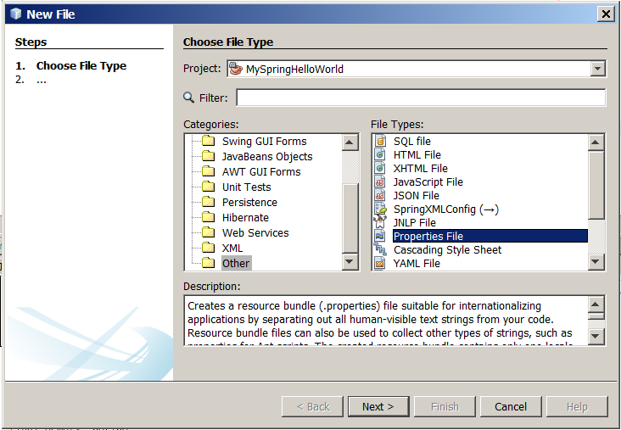
In this file I write:
jdbc.url = jdbc\:derby\://localhost:1527/sample
jdbc.username = app
jdbc.password = app
As we can see, I had to escape colons.
Now in myconfig.xml I write:
<?xml version="1.0" encoding="UTF-8"?>
<beans xmlns="http://www.springframework.org/schema/beans"
xmlns:xsi="http://www.w3.org/2001/XMLSchema-instance"
xmlns:context="http://www.springframework.org/schema/context"
xmlns:p="http://www.springframework.org/schema/p"

xsi:schemaLocation="http://www.springframework.org/schema/beans http://www.springframework.org/schema/beans/spring-beans-4.0.xsd
http://www.springframework.org/schema/context http://www.springframework.org/schema/context/spring-context-4.0.xsd
">
<bean id="primaaprilis" class="java.util.Date">
<property name="year" value="115" />
<property name="month" value="3" />
<property name="date" value="1" />
</bean>
<bean id="current_date" class="java.util.Date" />
<bean id="myproducer" class="pl.kuku.myspringhelloworld.DateProducer">
<!-- <property name="date" ref="primaaprilis" /> -->
<property name="date" ref="current_date" />
</bean>
<bean id="myprinter" class="pl.kuku.myspringhelloworld.DatePrinter" />
<bean id="mymyprogram" class="pl.kuku.myspringhelloworld.MyProgram"
init-method="run"
p:producer-ref="myproducer"
p:printer-ref="myprinter"
/>
<context:property-placeholder location="classpath:myproperties.properties" />
<bean id="mydatasource" class="org.apache.commons.dbcp2.BasicDataSource"
p:url="${jdbc.url}"
p:username="${jdbc.username}"
p:password="${jdbc.password}"
/>
</beans>
I run the program, it works.
What we have done so far with this datasource can be useful by itself – I could define datasource in Spring config and then use it in DAOs (let's remember that objects created by Spring are singletons). Or even more: I could also create DAOs using Spring and inject them into Swing widgets. But let's be careful – probably it wouldn't work in EDT (depends on how careful would I do that).
Now I create in my project a persistence unit (it is, a persistence.xml file):
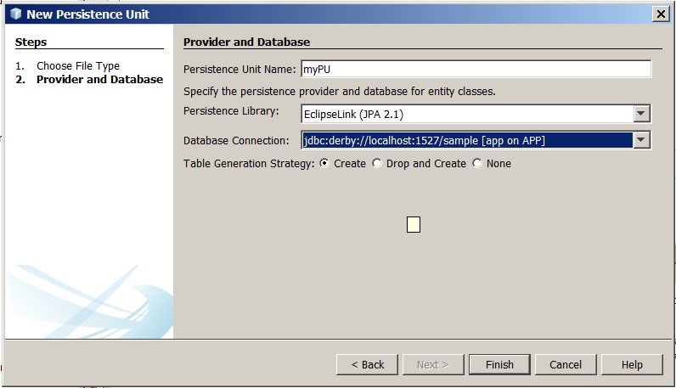
The contents of this persistence.xml file is:
<?xml version="1.0" encoding="UTF-8"?>
<persistence version="2.1" xmlns="http://xmlns.jcp.org/xml/ns/persistence" xmlns:xsi="http://www.w3.org/2001/XMLSchema-instance" xsi:schemaLocation="http://xmlns.jcp.org/xml/ns/persistence http://xmlns.jcp.org/xml/ns/persistence/persistence_2_1.xsd">
<persistence-unit name="myPU" transaction-type="RESOURCE_LOCAL">
<provider>org.eclipse.persistence.jpa.PersistenceProvider</provider>
<properties>
<property name="javax.persistence.jdbc.url" value="jdbc:derby://localhost:1527/sample"/>
<property name="javax.persistence.jdbc.user" value="app"/>
<property name="javax.persistence.jdbc.driver" value="org.apache.derby.jdbc.ClientDriver"/>
<property name="javax.persistence.jdbc.password" value="app"/>
<property name="javax.persistence.schema-generation.database.action" value="create"/>
</properties>
</persistence-unit>
</persistence>
As we can see, I use the connection which is already defined in Eclipse. This is the connection to the sample, testing Derby database which, for instance, contains Customer table. I will use that table soon.
Now in my project, in pl.kuku.myspringhelloworld.entities package, I create entity classes from the database:
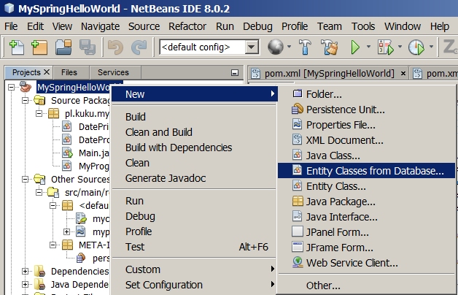
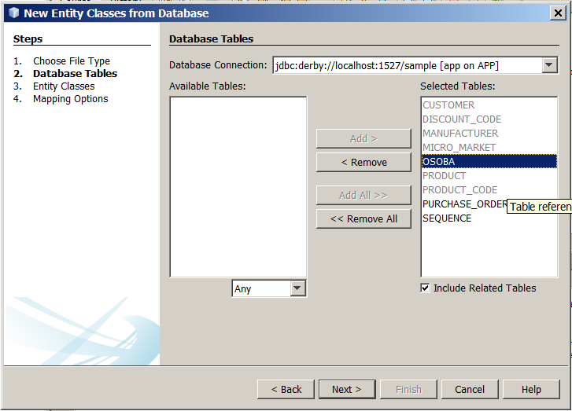
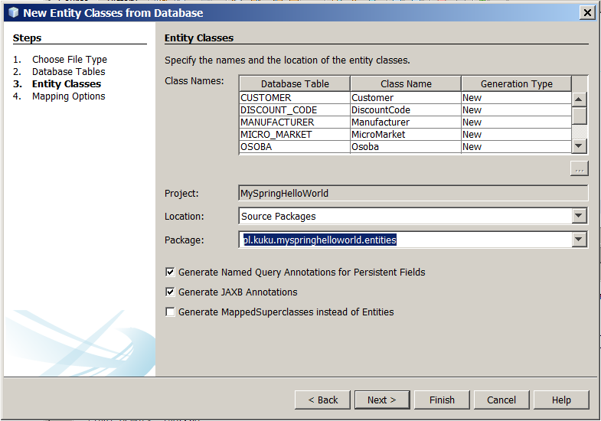
In Main I write a piece of code which displays names of all customers using EntityManager:
package pl.kuku.myspringhelloworld;
import java.sql.Connection;
import java.sql.ResultSet;
import java.sql.Statement;
import java.util.Date;
import java.util.List;
import javax.persistence.EntityManager;
import javax.persistence.EntityManagerFactory;
import javax.persistence.Persistence;
import org.apache.commons.dbcp2.BasicDataSource;
import org.springframework.context.ApplicationContext;
import org.springframework.context.support.ClassPathXmlApplicationContext;
import org.springframework.orm.jpa.LocalEntityManagerFactoryBean;
import pl.kuku.myspringhelloworld.entities.Customer;
public class Main {
public static void main(String[] args) throws Exception {
EntityManager em = Persistence.createEntityManagerFactory("myPU").createEntityManager();
List<Customer> result = em.createQuery("select c from Customer c").getResultList();
for (Customer c : result) {
System.out.println(c.getName());
}
}
}
So, now my program asks the Persistence class to create entity manager factory. This Persistence class takes a look at persistence.xml and learns from it that it has to use EclipseLink's persistence provider:
<provider>org.eclipse.persistence.jpa.PersistenceProvider</provider>
So it call some method on the org.eclipse.persistence.jpa.PersistenceProvider. Then org.eclipse.persistence.jpa.PersistenceProvider takes a look at persistence.xml and learns from it what JDBC driver it should use to connect to a database etc:
<properties>
<property name="javax.persistence.jdbc.url" value="jdbc:derby://localhost:1527/sample"/>
<property name="javax.persistence.jdbc.user" value="app"/>
<property name="javax.persistence.jdbc.driver" value="org.apache.derby.jdbc.ClientDriver"/>
<property name="javax.persistence.jdbc.password" value="app"/>
<property name="javax.persistence.schema-generation.database.action" value="create"/>
</properties>
So EclipseLink library uses PostgreSQL JDBC driver to connect to database.
To make sure is is really this way I'm going to debug the program. I write somewhere the line:
org.apache.derby.jdbc.ClientDriver tmp;
I need it only to open the org.apache.derby.jdbc.ClientDriver class in Netbeans. So I ctrl+click this class name so it opens in Netbeans' editor and then I remove this line. In ClientDriver I find the connect method and I put breakpoint on it. Then I run my program in debug mode and when it stops on the breakpoint I read the stacktrace:
org.apache.derby.jdbc.ClientDriver.connect
java.sql.DriverManager.getConnection(DriverManager.java:664)
java.sql.DriverManager.getConnection(DriverManager.java:208)
org.eclipse.persistence.sessions.DefaultConnector.connect(DefaultConnector.java:98)
org.eclipse.persistence.sessions.DatasourceLogin.connectToDatasource(DatasourceLogin.java:162)
org.eclipse.persistence.internal.sessions.DatabaseSessionImpl.setOrDetectDatasource(DatabaseSessionImpl.java:204)
org.eclipse.persistence.internal.sessions.DatabaseSessionImpl.loginAndDetectDatasource(DatabaseSessionImpl.java:741)
org.eclipse.persistence.internal.jpa.EntityManagerFactoryProvider.login(EntityManagerFactoryProvider.java:239)
org.eclipse.persistence.internal.jpa.EntityManagerSetupImpl.deploy(EntityManagerSetupImpl.java:685)
org.eclipse.persistence.internal.jpa.EntityManagerFactoryDelegate.getAbstractSession(EntityManagerFactoryDelegate.java:204)
org.eclipse.persistence.internal.jpa.EntityManagerFactoryDelegate.getDatabaseSession(EntityManagerFactoryDelegate.java:182)
org.eclipse.persistence.internal.jpa.EntityManagerFactoryImpl.getDatabaseSession(EntityManagerFactoryImpl.java:527)
org.eclipse.persistence.jpa.PersistenceProvider.createEntityManagerFactoryImpl(PersistenceProvider.java:140)
org.eclipse.persistence.jpa.PersistenceProvider.createEntityManagerFactory(PersistenceProvider.java:177)
javax.persistence.Persistence.createEntityManagerFactory(Persistence.java:79)
javax.persistence.Persistence.createEntityManagerFactory(Persistence.java:54)
pl.kuku.myspringhelloworld.Main.main(Main.java:57)
Main's line 57 mentioned in this stacktrace is:
EntityManagerFactory emf = Persistence.createEntityManagerFactory("myPU");

how does <property-placeholder /> work
Now let's understand how it is that property-placeholder element works. There is nothing special in this tag, Spring by itself does not know this tag. Spring has a general and flexible mechanism that allows anyone to invent his own XML namespace, create its XSD and declare Java classess whose methods will be called when a bean factory will find this element in an XML file. Authors of property-placeholder used this mechanism.
In Netbeans I look at dependencies -> spring-context-VERSION.jar -> spring.handlers. In this file it is declared what class is responsible for context namespace:
http\://www.springframework.org/schema/context=org.springframework.context.config.ContextNamespaceHandler
(...)
The source of org.springframework.context.config.ContextNamespaceHandler I can find at grepcode.com ( http://grepcode.com/file/repository.springsource.com/org.springframework/org.springframework.context/2.5.4/org/springframework/context/config/ContextNamespaceHandler.java ).
This class says:
package org.springframework.context.config;
public ContextNamespaceHandler extends NamespaceHandlerSupport {
public void init() {
registerBeanDefinitionParser("property-placeholder", new PropertyPlaceholderBeanDefinitionParser());
(...)
It means that it is the class PropertyPlaceholderBeanDefinitionParser that handles context:property-placeholder element. This class (I view its sources at grepcode) extends AbstractPropertyLoadingBeanDefinitionParser, which looks like that:
package org.springframework.context.config;
import org.w3c.dom.Element;
import org.springframework.beans.factory.config.BeanDefinition;
import org.springframework.beans.factory.support.BeanDefinitionBuilder;
import org.springframework.beans.factory.xml.AbstractSingleBeanDefinitionParser;
import org.springframework.util.StringUtils;
abstract class AbstractPropertyLoadingBeanDefinitionParser extends AbstractSingleBeanDefinitionParser {
(...)
@Override
protected void doParse(Element element, BeanDefinitionBuilder builder) {
String location = element.getAttribute("location");
if (StringUtils.hasLength(location)) {
String[] locations = StringUtils.commaDelimitedListToStringArray(location);
builder.addPropertyValue("locations", locations);
}
(...)
Here we can see the code that handles location attribute of <context:property-placeholder /> element.
This is how it works.

InitializingBean interface, interface injection
Before we continue, let's look at one detail.
Sometimes we have some bean which wants to do after it has all properties set. If a bean implements the InitializingBean interface and has a method called afterPropertiesSet, Spring calls this method after it sets all properties on this bean.
Let's try it.
I create such bean:
package pl.kuku.myspringhelloworld;
import org.springframework.beans.factory.InitializingBean;
public class MyBean implements InitializingBean {
private int x;
public int getX() {
return x;
}
public void setX(int x) {
System.out.println("setter is called");
this.x = x;
}
@Override
public void afterPropertiesSet() {
System.out.println("method afterPropertiesSet is called");
}
}
In myconfig.xml I write:
<?xml version="1.0" encoding="UTF-8"?>
<beans xmlns="http://www.springframework.org/schema/beans"
xmlns:xsi="http://www.w3.org/2001/XMLSchema-instance"
xmlns:context="http://www.springframework.org/schema/context"
xmlns:p="http://www.springframework.org/schema/p"

xsi:schemaLocation="http://www.springframework.org/schema/beans http://www.springframework.org/schema/beans/spring-beans-4.0.xsd
http://www.springframework.org/schema/context http://www.springframework.org/schema/context/spring-context-4.0.xsd
">
<bean id="mymybean" class="pl.kuku.myspringhelloworld.MyBean"
p:x="3"
/>
</beans>
In Main I just create the Spring context:
package pl.kuku.myspringhelloworld;
import java.sql.Connection;
import java.sql.ResultSet;
import java.sql.Statement;
import java.util.Date;
import java.util.List;
import javax.persistence.EntityManager;
import javax.persistence.EntityManagerFactory;
import javax.persistence.Persistence;
import javax.persistence.Query;
import org.apache.commons.dbcp2.BasicDataSource;
import org.springframework.context.ApplicationContext;
import org.springframework.context.support.ClassPathXmlApplicationContext;
import org.springframework.orm.jpa.LocalEntityManagerFactoryBean;
import pl.kuku.myspringhelloworld.entities.Customer;
public class Main {
public static void main(String[] args) throws Exception {
new ClassPathXmlApplicationContext("/myconfig.xml");
}
}
I run this program. It displays:
setter is called
method afterPropertiesSet is called
In Spring there are more such interfaces. There are some interfaces – their names use to end with aware – such that if a bean implements this interface, Spring calls a method of this interface in some special situation. This mechanizm is called interface injection.

LocalEntityManagerFactoryBean
Now I will create this EntityManagerFactory using Spring. But there is one problem with it: EntityManagerFactory is not a Java bean. There is the reason Spring authors created LocalEntityManagerFactoryBean class – it is a bean wrapping EntityManagerFactory.
Well, actually it is also possible to use Spring to create objects that are not beans, but the common practice in Spring is to use this class. FIXME: why?
First I instantiate this class without using Spring's context. This class implements InitializingBean, co after we set its properties we must call afterPropertiesSet on it.
In Main I write:
package pl.kuku.myspringhelloworld;
import java.sql.Connection;
import java.sql.ResultSet;
import java.sql.Statement;
import java.util.Date;
import java.util.List;
import javax.persistence.EntityManager;
import javax.persistence.EntityManagerFactory;
import javax.persistence.Persistence;
import javax.persistence.Query;
import org.apache.commons.dbcp2.BasicDataSource;
import org.springframework.context.ApplicationContext;
import org.springframework.context.support.ClassPathXmlApplicationContext;
import org.springframework.orm.jpa.LocalEntityManagerFactoryBean;
import pl.kuku.myspringhelloworld.entities.Customer;
public class Main {
public static void main(String[] args) throws Exception {
LocalEntityManagerFactoryBean lemfb = new LocalEntityManagerFactoryBean();
lemfb.setPersistenceUnitName("myPU");
lemfb.afterPropertiesSet();
EntityManagerFactory emf = lemfb.getNativeEntityManagerFactory();
EntityManager em = emf.createEntityManager();
List<Customer> result = em.createQuery("select c from Customer c").getResultList();
for (Customer c : result) {
System.out.println(c.getName());
}
}
}
I run this program. It works.
Now I move instantiation and configuration of LocalEntityManagerFactoryBean to myconfig.xml. In myconfig.xml I write:
<?xml version="1.0" encoding="UTF-8"?>
<beans xmlns="http://www.springframework.org/schema/beans"
xmlns:xsi="http://www.w3.org/2001/XMLSchema-instance"
xmlns:context="http://www.springframework.org/schema/context"
xmlns:p="http://www.springframework.org/schema/p"

xsi:schemaLocation="http://www.springframework.org/schema/beans http://www.springframework.org/schema/beans/spring-beans-4.0.xsd
http://www.springframework.org/schema/context http://www.springframework.org/schema/context/spring-context-4.0.xsd
">
<bean id="primaaprilis" class="java.util.Date">
<property name="year" value="115" />
<property name="month" value="3" />
<property name="date" value="1" />
</bean>
<bean id="current_date" class="java.util.Date" />
<bean id="myproducer" class="pl.kuku.myspringhelloworld.DateProducer">
<!-- <property name="date" ref="primaaprilis" /> -->
<property name="date" ref="current_date" />
</bean>
<bean id="myprinter" class="pl.kuku.myspringhelloworld.DatePrinter" />
<bean id="mymyprogram" class="pl.kuku.myspringhelloworld.MyProgram"
init-method="run"
p:producer-ref="myproducer"
p:printer-ref="myprinter"
/>
<!--
<bean id="mydatasource" class="org.apache.commons.dbcp2.BasicDataSource"
p:url="jdbc:derby://localhost:1527/sample"
p:username="app"
p:password="app"
/>
-->
<context:property-placeholder location="classpath:myproperties.properties" />
<bean id="mydatasource" class="org.apache.commons.dbcp2.BasicDataSource"
p:url="${jdbc.url}"
p:username="${jdbc.username}"
p:password="${jdbc.password}"
/>
<!-- <bean id="mymybean" class="pl.kuku.myspringhelloworld.MyBean"
p:x="3"
/> -->
<bean class="org.springframework.orm.jpa.LocalEntityManagerFactoryBean"
p:persistenceUnitName="myPU"
/>
</beans>
In Main I write:
package pl.kuku.myspringhelloworld;
import java.sql.Connection;
import java.sql.ResultSet;
import java.sql.Statement;
import java.util.Date;
import java.util.List;
import javax.persistence.EntityManager;
import javax.persistence.EntityManagerFactory;
import javax.persistence.Persistence;
import javax.persistence.Query;
import org.apache.commons.dbcp2.BasicDataSource;
import org.springframework.context.ApplicationContext;
import org.springframework.context.support.ClassPathXmlApplicationContext;
import org.springframework.orm.jpa.LocalEntityManagerFactoryBean;
import pl.kuku.myspringhelloworld.entities.Customer;
public class Main {
public static void main(String[] args) throws Exception {
ApplicationContext context = new ClassPathXmlApplicationContext("/myconfig.xml");
LocalEntityManagerFactoryBean lemfb = context.getBean(LocalEntityManagerFactoryBean.class);
EntityManagerFactory emf = lemfb.getNativeEntityManagerFactory();
EntityManager em = emf.createEntityManager();
List<Customer> result = em.createQuery("select c from Customer c").getResultList();
for (Customer c : result) {
System.out.println(c.getName());
}
}
}
I run this program. It works.

now I move as much code as possible out of Main
Now I will refactor my program to be more modular. The code that gets data from database and displays it I will move away from Main. So Main will be just a oneliner creating Spring context.
I create a class called DBDataDisplayer:
package pl.kuku.myspringhelloworld;
import java.util.List;
import javax.persistence.EntityManager;
import javax.persistence.EntityManagerFactory;
import org.springframework.orm.jpa.LocalEntityManagerFactoryBean;
import pl.kuku.myspringhelloworld.entities.Customer;
public class DBDataDisplayer {
private LocalEntityManagerFactoryBean lemfb;
public LocalEntityManagerFactoryBean getLemfb() {
return lemfb;
}
public void setLemfb(LocalEntityManagerFactoryBean lemfb) {
this.lemfb = lemfb;
}
public void doWhatMustBeDone() {
EntityManagerFactory emf = lemfb.getNativeEntityManagerFactory();
EntityManager em = emf.createEntityManager();
List<Customer> result = em.createQuery("select c from Customer c").getResultList();
for (Customer c : result) {
System.out.println(c.getName());
}
}
}
In Main I write:
package pl.kuku.myspringhelloworld;
import java.sql.Connection;
import java.sql.ResultSet;
import java.sql.Statement;
import java.util.Date;
import java.util.List;
import javax.persistence.EntityManager;
import javax.persistence.EntityManagerFactory;
import javax.persistence.Persistence;
import javax.persistence.Query;
import org.apache.commons.dbcp2.BasicDataSource;
import org.springframework.context.ApplicationContext;
import org.springframework.context.support.ClassPathXmlApplicationContext;
import org.springframework.orm.jpa.LocalEntityManagerFactoryBean;
import pl.kuku.myspringhelloworld.entities.Customer;
public class Main {
public static void main(String[] args) throws Exception {
ClassPathXmlApplicationContext cx = new ClassPathXmlApplicationContext("/myconfig.xml");
}
}
In myconfig.xml I wrote:
<?xml version="1.0" encoding="UTF-8"?>
<beans xmlns="http://www.springframework.org/schema/beans"
xmlns:xsi="http://www.w3.org/2001/XMLSchema-instance"
xmlns:context="http://www.springframework.org/schema/context"
xmlns:p="http://www.springframework.org/schema/p"

xsi:schemaLocation="http://www.springframework.org/schema/beans http://www.springframework.org/schema/beans/spring-beans-4.0.xsd
http://www.springframework.org/schema/context http://www.springframework.org/schema/context/spring-context-4.0.xsd
">
<bean id="primaaprilis" class="java.util.Date">
<property name="year" value="115" />
<property name="month" value="3" />
<property name="date" value="1" />
</bean>
<bean id="current_date" class="java.util.Date" />
<bean id="myproducer" class="pl.kuku.myspringhelloworld.DateProducer">
<!-- <property name="date" ref="primaaprilis" /> -->
<property name="date" ref="current_date" />
</bean>
<bean id="myprinter" class="pl.kuku.myspringhelloworld.DatePrinter" />
<bean id="mymyprogram" class="pl.kuku.myspringhelloworld.MyProgram"
init-method="run"
p:producer-ref="myproducer"
p:printer-ref="myprinter"
/>
<!--
<bean id="mydatasource" class="org.apache.commons.dbcp2.BasicDataSource"
p:url="jdbc:derby://localhost:1527/sample"
p:username="app"
p:password="app"
/>
-->
<context:property-placeholder location="classpath:myproperties.properties" />
<bean id="mydatasource" class="org.apache.commons.dbcp2.BasicDataSource"
p:url="${jdbc.url}"
p:username="${jdbc.username}"
p:password="${jdbc.password}"
/>
<!-- <bean id="mymybean" class="pl.kuku.myspringhelloworld.MyBean"
p:x="3"
/> -->
<bean id="mylemfb" class="org.springframework.orm.jpa.LocalEntityManagerFactoryBean"
p:persistenceUnitName="myPU"
/>
<bean class="pl.kuku.myspringhelloworld.DBDataDisplayer"
p:lemfb-ref="mylemfb"
init-method="doWhatMustBeDone"
/>
</beans>
However, when I try to run this program, it throws an exception:
(...)
Caused by: java.lang.IllegalStateException: Cannot convert value of type [com.sun.proxy.$Proxy3 implementing javax.persistence.EntityManagerFactory,javax.persistence.PersistenceUnitUtil,org.eclipse.persistence.jpa.JpaEntityManagerFactory,org.springframework.orm.jpa.EntityManagerFactoryInfo] to required type [org.springframework.orm.jpa.LocalEntityManagerFactoryBean] for property 'lemfb': no matching editors or conversion strategy found
(...)
It seems that the object that Spring tries to put into the lemfb attribute of DBDataDisplayer is not an object of type LocalEntityManagerFactoryBean. Let's investigate it.
First I comment out this fragment of myconfig.xml, so my program runs:
(...)
<bean id="mylemfb" class="org.springframework.orm.jpa.LocalEntityManagerFactoryBean"
p:persistenceUnitName="myPU"
/>
<!--
<bean class="pl.kuku.myspringhelloworld.DBDataDisplayer"
p:lemfb-ref="mylemfb"
init-method="doWhatMustBeDone"
/>
-->
</beans>
In Main I write such test:
package pl.kuku.myspringhelloworld;
import java.sql.Connection;
import java.sql.ResultSet;
import java.sql.Statement;
import java.util.Date;
import java.util.List;
import javax.persistence.EntityManager;
import javax.persistence.EntityManagerFactory;
import javax.persistence.Persistence;
import javax.persistence.Query;
import org.apache.commons.dbcp2.BasicDataSource;
import org.springframework.context.ApplicationContext;
import org.springframework.context.support.ClassPathXmlApplicationContext;
import org.springframework.orm.jpa.LocalEntityManagerFactoryBean;
import pl.kuku.myspringhelloworld.entities.Customer;
public class Main {
public static void main(String[] args) throws Exception {
ClassPathXmlApplicationContext ctx = new ClassPathXmlApplicationContext("/myconfig.xml");
Object b1 = ctx.getBean("mylemfb");
System.out.println("first bean type is:" + b1.getClass().getName() + ", this type instanceof LocalEntityManagerFactoryBean: " + (b1 instanceof LocalEntityManagerFactoryBean) + ", this type instanceof EntityManagerFactory: " + (b1 instanceof EntityManagerFactory));
Object b2 = ctx.getBean(LocalEntityManagerFactoryBean.class);
System.out.println("second bean type is " + b2.getClass().getName() + ", this type instanceof LocalEntityManagerFactoryBean: " + (b2 instanceof LocalEntityManagerFactoryBean) + ", this type instanceof EntityManagerFactory: " + (b2 instanceof EntityManagerFactory));
}
}
I run this program and it prints:
first bean type is:com.sun.proxy.$Proxy3, this type instanceof LocalEntityManagerFactoryBean: false, this type instanceof EntityManagerFactory: true
second bean type is org.springframework.orm.jpa.LocalEntityManagerFactoryBean, this type instanceof LocalEntityManagerFactoryBean: true, this type instanceof EntityManagerFactory: false
It means that – due to some magic, done with interface injection – when I try to get the bean using class, I get the object of type LocalEntityManagerFactoryBean (so everything is normal), but when I try to get the bean using name, I get another object, which is of type com.sun.proxy.$Proxy3. This class com.sun.proxy.$Proxy3 does not extend LocalEntityManagerFactoryBean but it implements EntityManagerFactory.
So Spring tries to inject an EntityManagerFactory instance into DBDataDisplayer. Well, that's even better.
I change DBDataDisplayer:
package pl.kuku.myspringhelloworld;
import java.util.List;
import javax.persistence.EntityManager;
import javax.persistence.EntityManagerFactory;
import org.springframework.orm.jpa.LocalEntityManagerFactoryBean;
import pl.kuku.myspringhelloworld.entities.Customer;
public class DBDataDisplayer {
private EntityManagerFactory emf;
public EntityManagerFactory getEmf() {
return emf;
}
public void setEmf(EntityManagerFactory emf) {
this.emf = emf;
}
public void doWhatMustBeDone() {
// EntityManagerFactory emf = lemfb.getNativeEntityManagerFactory();
EntityManager em = emf.createEntityManager();
List<Customer> result = em.createQuery("select c from Customer c").getResultList();
for (Customer c : result) {
System.out.println(c.getName());
}
}
}
Then in myconfig.xml I uncomment the definition of pl.kuku.myspringhelloworld.DBDataDisplayer and modify it a little:
<?xml version="1.0" encoding="UTF-8"?>
<beans xmlns="http://www.springframework.org/schema/beans"
xmlns:xsi="http://www.w3.org/2001/XMLSchema-instance"
xmlns:context="http://www.springframework.org/schema/context"
xmlns:p="http://www.springframework.org/schema/p"

xsi:schemaLocation="http://www.springframework.org/schema/beans http://www.springframework.org/schema/beans/spring-beans-4.0.xsd
http://www.springframework.org/schema/context http://www.springframework.org/schema/context/spring-context-4.0.xsd
">
<bean id="primaaprilis" class="java.util.Date">
<property name="year" value="115" />
<property name="month" value="3" />
<property name="date" value="1" />
</bean>
<bean id="current_date" class="java.util.Date" />
<bean id="myproducer" class="pl.kuku.myspringhelloworld.DateProducer">
<!-- <property name="date" ref="primaaprilis" /> -->
<property name="date" ref="current_date" />
</bean>
<bean id="myprinter" class="pl.kuku.myspringhelloworld.DatePrinter" />
<bean id="mymyprogram" class="pl.kuku.myspringhelloworld.MyProgram"
init-method="run"
p:producer-ref="myproducer"
p:printer-ref="myprinter"
/>
<!--
<bean id="mydatasource" class="org.apache.commons.dbcp2.BasicDataSource"
p:url="jdbc:derby://localhost:1527/sample"
p:username="app"
p:password="app"
/>
-->
<context:property-placeholder location="classpath:myproperties.properties" />
<bean id="mydatasource" class="org.apache.commons.dbcp2.BasicDataSource"
p:url="${jdbc.url}"
p:username="${jdbc.username}"
p:password="${jdbc.password}"
/>
<!-- <bean id="mymybean" class="pl.kuku.myspringhelloworld.MyBean"
p:x="3"
/> -->
<bean id="mylemfb" class="org.springframework.orm.jpa.LocalEntityManagerFactoryBean"
p:persistenceUnitName="myPU"
/>
<bean class="pl.kuku.myspringhelloworld.DBDataDisplayer"
p:emf-ref="mylemfb"
init-method="doWhatMustBeDone"
/>
</beans>
In Main I write:
package pl.kuku.myspringhelloworld;
import java.sql.Connection;
import java.sql.ResultSet;
import java.sql.Statement;
import java.util.Date;
import java.util.List;
import javax.persistence.EntityManager;
import javax.persistence.EntityManagerFactory;
import javax.persistence.Persistence;
import javax.persistence.Query;
import org.apache.commons.dbcp2.BasicDataSource;
import org.springframework.context.ApplicationContext;
import org.springframework.context.support.ClassPathXmlApplicationContext;
import org.springframework.orm.jpa.LocalEntityManagerFactoryBean;
import pl.kuku.myspringhelloworld.entities.Customer;
public class Main {
public static void main(String[] args) throws Exception {
new ClassPathXmlApplicationContext("/myconfig.xml");
}
}
I run the program. It works.

postprocessors
Soon I will further simplify my program. But before we have to look at one mechanism.
I create class MyBeanPostProcessor:
package pl.kuku.myspringhelloworld;
import org.springframework.beans.BeansException;
import org.springframework.beans.factory.config.BeanPostProcessor;
public class MyBeanPostProcessor implements BeanPostProcessor {
@Override
public Object postProcessBeforeInitialization(Object o, String name) throws BeansException {
System.out.println("postProcessBeforeInitialization is called with name=" + name + " and object=" + o);
return o;
}
@Override
public Object postProcessAfterInitialization(Object o, String name) throws BeansException {
System.out.println("postProcessAfterInitialization is called with name=" + name + " and object=" + o);
return o;
}
}
In myconfig.xml I register this class:
<?xml version="1.0" encoding="UTF-8"?>
<beans (...)>
(...)
<bean class="pl.kuku.myspringhelloworld.MyBeanPostProcessor" />
</beans>
I run the program. This is the result:
postProcessBeforeInitialization is called with name=primaaprilis and object=Wed Apr 01 13:43:23 CEST 2015
postProcessAfterInitialization is called with name=primaaprilis and object=Wed Apr 01 13:43:23 CEST 2015
postProcessBeforeInitialization is called with name=current_date and object=Sun Mar 29 13:43:23 CEST 2015
postProcessAfterInitialization is called with name=current_date and object=Sun Mar 29 13:43:23 CEST 2015
postProcessBeforeInitialization is called with name=myproducer and object=pl.kuku.myspringhelloworld.DateProducer@24f60b
postProcessAfterInitialization is called with name=myproducer and object=pl.kuku.myspringhelloworld.DateProducer@24f60b
postProcessBeforeInitialization is called with name=myprinter and object=pl.kuku.myspringhelloworld.DatePrinter@1e2203c
postProcessAfterInitialization is called with name=myprinter and object=pl.kuku.myspringhelloworld.DatePrinter@1e2203c
postProcessBeforeInitialization is called with name=mymyprogram and object=pl.kuku.myspringhelloworld.MyProgram@b6cbcc
date: Sun Mar 29 13:43:23 CEST 2015
postProcessAfterInitialization is called with name=mymyprogram and object=pl.kuku.myspringhelloworld.MyProgram@b6cbcc
postProcessBeforeInitialization is called with name=mydatasource and object=org.apache.commons.dbcp2.BasicDataSource@33cc44
postProcessAfterInitialization is called with name=mydatasource and object=org.apache.commons.dbcp2.BasicDataSource@33cc44
mar 29, 2015 1:43:23 PM org.springframework.orm.jpa.LocalEntityManagerFactoryBean createNativeEntityManagerFactory
INFO: Building JPA EntityManagerFactory for persistence unit 'myPU'
postProcessBeforeInitialization is called with name=mylemfb and object=org.springframework.orm.jpa.LocalEntityManagerFactoryBean@1c7e1bb
[EL Info]: 2015-03-29 13:43:26.205--ServerSession(2297529)--EclipseLink, version: Eclipse Persistence Services - 2.5.2.v20140319-9ad6abd
[EL Info]: connection: 2015-03-29 13:43:28.921--ServerSession(2297529)--file:/C:/Users/admin/Documents/NetBeansProjects/MySpringHelloWorld/target/classes/_myPU login successful
postProcessAfterInitialization is called with name=mylemfb and object=org.springframework.orm.jpa.LocalEntityManagerFactoryBean@1c7e1bb
postProcessAfterInitialization is called with name=mylemfb and object=org.springframework.orm.jpa.LocalEntityManagerFactoryBean@1c7e1bb
postProcessBeforeInitialization is called with name=pl.kuku.myspringhelloworld.DBDataDisplayer#0 and object=pl.kuku.myspringhelloworld.DBDataDisplayer@13b58ca
Jumbo Eagle Corp
New Enterprises
Wren Computers
Small Bill Company
Bob Hosting Corp.
Early CentralComp
John Valley Computers
Big Network Systems
West Valley Inc.
Zed Motor Co
Big Car Parts
Old Media Productions
Yankee Computer Repair Ltd
postProcessAfterInitialization is called with name=pl.kuku.myspringhelloworld.DBDataDisplayer#0 and object=pl.kuku.myspringhelloworld.DBDataDisplayer@13b58ca
As we can see, for each bean both methods of MyBeanPostProcessor are called. One is called before the bean's object is configured and one after. This is how BeanPostProcessor interface work. It is not the only Spring's postprocessor – another is, for instance, BeanFactoryPostProcessor ( http://docs.spring.io/spring/docs/current/javadoc-api/org/springframework/beans/factory/config/BeanFactoryPostProcessor.html ).

if we didn't use ClassPathXmlApplicationContext we would have to do more to make this example work
The class ClassPathXmlApplicationContext is not the only Spring bean container. There are more basic containers, like XmlBeanFactory. All Spring bean containers implement BeanFactory interface. In normal circumstances there is no reason not to use ClassPathXmlApplicationContext, but it is good to understand what ClassPathXmlApplicationContext gives us.
So, let's try to use XmlBeanFactory instead of ClassPathXmlApplicationContext. I leave myconfig.xml as it is:
<?xml version="1.0" encoding="UTF-8"?>
<beans xmlns="http://www.springframework.org/schema/beans"
xmlns:xsi="http://www.w3.org/2001/XMLSchema-instance"
xmlns:context="http://www.springframework.org/schema/context"
xmlns:p="http://www.springframework.org/schema/p"

xsi:schemaLocation="http://www.springframework.org/schema/beans http://www.springframework.org/schema/beans/spring-beans-4.0.xsd
http://www.springframework.org/schema/context http://www.springframework.org/schema/context/spring-context-4.0.xsd
">
<bean id="primaaprilis" class="java.util.Date">
<property name="year" value="115" />
<property name="month" value="3" />
<property name="date" value="1" />
</bean>
<bean id="current_date" class="java.util.Date" />
<bean id="myproducer" class="pl.kuku.myspringhelloworld.DateProducer">
<!-- <property name="date" ref="primaaprilis" /> -->
<property name="date" ref="current_date" />
</bean>
<bean id="myprinter" class="pl.kuku.myspringhelloworld.DatePrinter" />
<bean id="mymyprogram" class="pl.kuku.myspringhelloworld.MyProgram"
init-method="run"
p:producer-ref="myproducer"
p:printer-ref="myprinter"
/>
<!--
<bean id="mydatasource" class="org.apache.commons.dbcp2.BasicDataSource"
p:url="jdbc:derby://localhost:1527/sample"
p:username="app"
p:password="app"
/>
-->
<context:property-placeholder location="classpath:myproperties.properties" />
<bean id="mydatasource" class="org.apache.commons.dbcp2.BasicDataSource"
p:url="${jdbc.url}"
p:username="${jdbc.username}"
p:password="${jdbc.password}"
/>
<!-- <bean id="mymybean" class="pl.kuku.myspringhelloworld.MyBean"
p:x="3"
/>-->
<bean id="mylemfb" class="org.springframework.orm.jpa.LocalEntityManagerFactoryBean"
p:persistenceUnitName="myPU"
/>
<bean class="pl.kuku.myspringhelloworld.DBDataDisplayer"
p:emf-ref="mylemfb"
init-method="doWhatMustBeDone"
/>
<bean class="pl.kuku.myspringhelloworld.MyBeanPostProcessor" />
</beans>
Details are not very important in this experiment – what is important is just that I define some beans.
In Main I write:
package pl.kuku.myspringhelloworld;
import org.springframework.beans.factory.xml.XmlBeanFactory;
import org.springframework.core.io.ClassPathResource;
public class Main {
public static void main(String[] args) throws Exception {
XmlBeanFactory xbf = new XmlBeanFactory(new ClassPathResource("myconfig.xml"));
}
}
I run the program. Nothing happens.
It is because ClassPathXmlApplicationContext – which we used before – create all beans' objects on start, but XmlBeanFactory – which we use now – creates them only on demans. So I add one line to Main:
package pl.kuku.myspringhelloworld;
import org.springframework.beans.factory.xml.XmlBeanFactory;
import org.springframework.core.io.ClassPathResource;
public class Main {
public static void main(String[] args) throws Exception {
XmlBeanFactory xbf = new XmlBeanFactory(new ClassPathResource("myconfig.xml"));
xbf.getBean(DBDataDisplayer.class);
}
}
I run the program. It displays:
Jumbo Eagle Corp
New Enterprises
Wren Computers
Small Bill Company
Bob Hosting Corp.
Early CentralComp
John Valley Computers
Big Network Systems
West Valley Inc.
Zed Motor Co
Big Car Parts
Old Media Productions
Yankee Computer Repair Ltd
As we can see, now DBDataDisplayer works. But MyBeanPostProcessor does not work. It is because in ClassPathXmlApplicationContext – which we used before – bean postprocessors work if they are registered in the config file, but in XmlBeanFactory – which we use now – we must explicitly imperatively register them. So I add one more line in Main:
package pl.kuku.myspringhelloworld;
import org.springframework.beans.factory.xml.XmlBeanFactory;
import org.springframework.core.io.ClassPathResource;
public class Main {
public static void main(String[] args) throws Exception {
XmlBeanFactory xbf = new XmlBeanFactory(new ClassPathResource("myconfig.xml"));
xbf.addBeanPostProcessor(new MyBeanPostProcessor());
xbf.getBean(DBDataDisplayer.class);
}
}
I remove (or just comment out) my postprocessor's definition from myconfig.xml – it is not necessary there any more:
<?xml version="1.0" encoding="UTF-8"?>
<beans (...)>
(...)
<!--<bean class="pl.kuku.myspringhelloworld.MyBeanPostProcessor" />-->
</beans>
Now I run this program. It displays:
mar 29, 2015 4:56:20 PM org.springframework.beans.factory.xml.XmlBeanDefinitionReader loadBeanDefinitions
INFO: Loading XML bean definitions from class path resource [myconfig.xml]
postProcessBeforeInitialization is called with name=mylemfb and object=org.springframework.orm.jpa.LocalEntityManagerFactoryBean@ee68d8
mar 29, 2015 4:56:20 PM org.springframework.orm.jpa.LocalEntityManagerFactoryBean createNativeEntityManagerFactory
INFO: Building JPA EntityManagerFactory for persistence unit 'myPU'
[EL Info]: 2015-03-29 16:56:24.043--ServerSession(24140775)--EclipseLink, version: Eclipse Persistence Services - 2.5.2.v20140319-9ad6abd
[EL Info]: connection: 2015-03-29 16:56:25.243--ServerSession(24140775)--file:/C:/Users/admin/Documents/NetBeansProjects/MySpringHelloWorld/target/classes/_myPU login successful
postProcessAfterInitialization is called with name=mylemfb and object=org.springframework.orm.jpa.LocalEntityManagerFactoryBean@ee68d8
postProcessAfterInitialization is called with name=mylemfb and object=org.springframework.orm.jpa.LocalEntityManagerFactoryBean@ee68d8
postProcessBeforeInitialization is called with name=pl.kuku.myspringhelloworld.DBDataDisplayer#0 and object=pl.kuku.myspringhelloworld.DBDataDisplayer@1ed560f
Jumbo Eagle Corp
New Enterprises
Wren Computers
Small Bill Company
Bob Hosting Corp.
Early CentralComp
John Valley Computers
Big Network Systems
West Valley Inc.
Zed Motor Co
Big Car Parts
Old Media Productions
Yankee Computer Repair Ltd
postProcessAfterInitialization is called with name=pl.kuku.myspringhelloworld.DBDataDisplayer#0 and object=pl.kuku.myspringhelloworld.DBDataDisplayer@1ed560f
It means that my postprocessor works.

autowiring with annotations
The process of putting some objects' references into other objects' attributes – so objects has each other references – is called in Spring wiring. There is a postprocessor which allows to do wiring by annotations. This postprocessor is called org.springframework.beans.factory.annotation.AutowiredAnnotationBeanPostProcessor. I will use it.
I edit DBDataDisplayer adding Autowired annotation to the emf attribute:
package pl.kuku.myspringhelloworld;
import java.util.List;
import javax.persistence.EntityManager;
import javax.persistence.EntityManagerFactory;
import org.springframework.beans.factory.annotation.Autowired;
import pl.kuku.myspringhelloworld.entities.Customer;
public class DBDataDisplayer {
@Autowired
private EntityManagerFactory emf;
public void doWhatMustBeDone() {
EntityManager em = emf.createEntityManager();
List<Customer> result = em.createQuery("select c from Customer c").getResultList();
for (Customer c : result) {
System.out.println(c.getName());
}
}
}
Then I edit myconfig.xml. I remove p:emf-ref from the definition of DBDataDisplayer's bean and I add the definition of AutowiredAnnotationBeanPostProcessor's bean:
<?xml version="1.0" encoding="UTF-8"?>
<beans xmlns="http://www.springframework.org/schema/beans"
xmlns:xsi="http://www.w3.org/2001/XMLSchema-instance"
xmlns:context="http://www.springframework.org/schema/context"
xmlns:p="http://www.springframework.org/schema/p"

xsi:schemaLocation="http://www.springframework.org/schema/beans http://www.springframework.org/schema/beans/spring-beans-4.0.xsd
http://www.springframework.org/schema/context http://www.springframework.org/schema/context/spring-context-4.0.xsd
">
<context:property-placeholder location="classpath:myproperties.properties" />
<bean id="mydatasource" class="org.apache.commons.dbcp2.BasicDataSource"
p:url="${jdbc.url}"
p:username="${jdbc.username}"
p:password="${jdbc.password}"
/>
<bean id="mylemfb" class="org.springframework.orm.jpa.LocalEntityManagerFactoryBean"
p:persistenceUnitName="myPU"
/>
<bean class="pl.kuku.myspringhelloworld.DBDataDisplayer"
init-method="doWhatMustBeDone"
/>
<bean class="org.springframework.beans.factory.annotation.AutowiredAnnotationBeanPostProcessor" />
</beans>
I run the program. It works.

some experiments with injecting using annotations
Now I will do some experiments with injecting using annotations.
As we remember, several chapters ago I had two beans of class Date. I put them again in myconfig.xml:
<?xml version="1.0" encoding="UTF-8"?>
<beans xmlns="http://www.springframework.org/schema/beans"
xmlns:xsi="http://www.w3.org/2001/XMLSchema-instance"
xmlns:context="http://www.springframework.org/schema/context"
xmlns:p="http://www.springframework.org/schema/p"
xsi:schemaLocation="http://www.springframework.org/schema/beans http://www.springframework.org/schema/beans/spring-beans-4.0.xsd
http://www.springframework.org/schema/context http://www.springframework.org/schema/context/spring-context-4.0.xsd
">
<bean id="primaaprilis" class="java.util.Date">
<property name="year" value="115" />
<property name="month" value="3" />
<property name="date" value="1" />
</bean>
<bean id="current_date" class="java.util.Date" />
</beans>
Now I create a simple class into which I will inject a date, I call it HereIWillInjectADate:
package pl.kuku.myspringhelloworld;
import java.util.Date;
import org.springframework.beans.factory.annotation.Autowired;
public class HereIWillInjectADate {
@Autowired
private Date date;
public void callMe() {
System.out.println("date=" + date);
}
}
As we can see, I use @Autowired to inject any bean of type Date into the date attribute.
Now in myconfig.xml I define a bean of type HereIWillInjectADate and add AutowiredAnnotationBeanPostProcessor:
<?xml version="1.0" encoding="UTF-8"?>
<beans xmlns="http://www.springframework.org/schema/beans"
xmlns:xsi="http://www.w3.org/2001/XMLSchema-instance"
xmlns:context="http://www.springframework.org/schema/context"
xmlns:p="http://www.springframework.org/schema/p"
xsi:schemaLocation="http://www.springframework.org/schema/beans http://www.springframework.org/schema/beans/spring-beans-4.0.xsd
http://www.springframework.org/schema/context http://www.springframework.org/schema/context/spring-context-4.0.xsd
">
<bean id="primaaprilis" class="java.util.Date">
<property name="year" value="115" />
<property name="month" value="3" />
<property name="date" value="1" />
</bean>
<bean id="current_date" class="java.util.Date" />
<bean class="pl.kuku.myspringhelloworld.HereIWillInjectADate"
init-method="callMe"
/>
<bean class="org.springframework.beans.factory.annotation.AutowiredAnnotationBeanPostProcessor" />
</beans>
I try to run the program, but I get an exception:
Caused by: org.springframework.beans.factory.NoUniqueBeanDefinitionException: No qualifying bean of type [java.util.Date] is defined: expected single matching bean but found 2: primaaprilis,current_date
It is because in HereIWillInjectADate I ask to inject a bean of type Date, but I have two beans of this type.
According to stackoverflow and many other tutorials and docs I could provide the bean name using @Qualifier. I try to do it in HereIWillInjectADate:
package pl.kuku.myspringhelloworld;
import java.util.Date;
import org.springframework.beans.factory.annotation.Autowired;
import org.springframework.beans.factory.annotation.Qualifier;
public class HereIWillInjectADate {
@Autowired
@Qualifier("primaaprilis")
private Date date;
public void callMe() {
System.out.println("date=" + date);
}
}
But it doesn't work – I still get the same exception:
Caused by: org.springframework.beans.factory.NoUniqueBeanDefinitionException: No qualifying bean of type [java.util.Date] is defined: expected single matching bean but found 2: primaaprilis,current_date
However, if the name of the attribute matches the name of some bean, this bean is injected. I edit HereIWillInjectADate:
package pl.kuku.myspringhelloworld;
import java.util.Date;
import org.springframework.beans.factory.annotation.Autowired;
public class HereIWillInjectADate {
@Autowired
private Date primaaprilis;
public void callMe() {
System.out.println("date=" + primaaprilis);
}
}
I run the program and it works, it displays:
date=Wed Apr 01 11:44:45 CEST 2015
Now I comment out (from myconfig.xml) one bean of type Date, so I have only one bean of type Date:
<?xml version="1.0" encoding="UTF-8"?>
<beans xmlns="http://www.springframework.org/schema/beans"
xmlns:xsi="http://www.w3.org/2001/XMLSchema-instance"
xmlns:context="http://www.springframework.org/schema/context"
xmlns:p="http://www.springframework.org/schema/p"
xsi:schemaLocation="http://www.springframework.org/schema/beans http://www.springframework.org/schema/beans/spring-beans-4.0.xsd http://www.springframework.org/schema/context http://www.springframework.org/schema/context/spring-context-4.0.xsd
">
<bean id="primaaprilis" class="java.util.Date">
<property name="year" value="115" />
<property name="month" value="3" />
<property name="date" value="1" />
</bean>
<bean class="pl.kuku.myspringhelloworld.HereIWillInjectADate"
init-method="callMe"
/>
<bean class="org.springframework.beans.factory.annotation.AutowiredAnnotationBeanPostProcessor" />
</beans>
In HereIWillInjectADate I again rename the attribute:
package pl.kuku.myspringhelloworld;
import java.util.Date;
import org.springframework.beans.factory.annotation.Autowired;
public class HereIWillInjectADate {
@Autowired
private Date date;
public void callMe() {
System.out.println("date=" + date);
}
}
I run the program. It works without problems – there is only one bean of type Date and I inject it.
Spring also understands standard java annotation @Inject.
I edit pom.xml:
<?xml version="1.0" encoding="UTF-8"?>
<project xmlns="http://maven.apache.org/POM/4.0.0" xmlns:xsi="http://www.w3.org/2001/XMLSchema-instance" xsi:schemaLocation="http://maven.apache.org/POM/4.0.0 http://maven.apache.org/xsd/maven-4.0.0.xsd">
<modelVersion>4.0.0</modelVersion>
<groupId>com.mycompany</groupId>
<artifactId>MySpringHelloWorld</artifactId>
<version>1.0-SNAPSHOT</version>
<packaging>jar</packaging>
<properties>
<project.build.sourceEncoding>UTF-8</project.build.sourceEncoding>
<maven.compiler.source>1.7</maven.compiler.source>
<maven.compiler.target>1.7</maven.compiler.target>
</properties>
<dependencies>
<dependency>
<groupId>org.springframework</groupId>
<artifactId>spring-orm</artifactId>
<version>4.0.3.RELEASE</version>
</dependency>
<dependency>
<groupId>org.springframework</groupId>
<artifactId>spring-context</artifactId>
<version>4.0.3.RELEASE</version>
</dependency>
<dependency>
<groupId>org.apache.commons</groupId>
<artifactId>commons-dbcp2</artifactId>
<version>2.1</version>
</dependency>
<dependency>
<groupId>org.apache.derby</groupId>
<artifactId>derbyclient</artifactId>
<version>10.11.1.1</version>
</dependency>
<dependency>
<groupId>org.eclipse.persistence</groupId>
<artifactId>eclipselink</artifactId>
<version>2.5.2</version>
</dependency>
<dependency>
<groupId>org.eclipse.persistence</groupId>
<artifactId>org.eclipse.persistence.jpa.modelgen.processor</artifactId>
<version>2.5.2</version>
<scope>provided</scope>
</dependency>
<dependency>
<groupId>javax.inject</groupId>
<artifactId>javax.inject</artifactId>
<version>1</version>
</dependency>
</dependencies>
</project>
I edit HereIWillInjectADate:
package pl.kuku.myspringhelloworld;
import java.util.Date;
import javax.inject.Inject;
public class HereIWillInjectADate {
@Inject
private Date date;
public void callMe() {
System.out.println("date=" + date);
}
}
I run the program. It works.

turning on AutowiredAnnotationBeanPostProcessor with context:annotation-config
Now I come back to my program using LocalEntityManagerFactoryBean. In myconfig.xml I put everything this program needs:
<?xml version="1.0" encoding="UTF-8"?>
<beans xmlns="http://www.springframework.org/schema/beans"
xmlns:xsi="http://www.w3.org/2001/XMLSchema-instance"
xmlns:context="http://www.springframework.org/schema/context"
xmlns:p="http://www.springframework.org/schema/p"
xsi:schemaLocation="http://www.springframework.org/schema/beans http://www.springframework.org/schema/beans/spring-beans-4.0.xsd
http://www.springframework.org/schema/context http://www.springframework.org/schema/context/spring-context-4.0.xsd
">
<bean id="mylemfb" class="org.springframework.orm.jpa.LocalEntityManagerFactoryBean"
p:persistenceUnitName="myPU"
/>
<bean class="pl.kuku.myspringhelloworld.DBDataDisplayer"
init-method="doWhatMustBeDone"
/>
<bean class="org.springframework.beans.factory.annotation.AutowiredAnnotationBeanPostProcessor" />
</beans>
I make sure DBDataDisplayer looks like that:
package pl.kuku.myspringhelloworld;
import java.util.List;
import javax.persistence.EntityManager;
import javax.persistence.EntityManagerFactory;
import org.springframework.beans.factory.annotation.Autowired;
import pl.kuku.myspringhelloworld.entities.Customer;
public class DBDataDisplayer {
@Autowired
private EntityManagerFactory emf;
public void doWhatMustBeDone() {
EntityManager em = emf.createEntityManager();
List<Customer> result = em.createQuery("select c from Customer c").getResultList();
for (Customer c : result) {
System.out.println(c.getName());
}
}
}
I run the program. It works.
When I want to do autowiring with annotations, I don't have to declare AutowiredAnnotationBeanPostProcessor bean – there is a shortcut for it. It uses the same mechanism as context:property-placeholder. Instead of declaring AutowiredAnnotationBeanPostProcessor bean in Spring's XML configuration file I can put there element <context:annotation-config />.
So, in myconfig.xml I write:
<?xml version="1.0" encoding="UTF-8"?>
<beans xmlns="http://www.springframework.org/schema/beans"
xmlns:xsi="http://www.w3.org/2001/XMLSchema-instance"
xmlns:context="http://www.springframework.org/schema/context"
xmlns:p="http://www.springframework.org/schema/p"
xsi:schemaLocation="http://www.springframework.org/schema/beans http://www.springframework.org/schema/beans/spring-beans-4.0.xsd
http://www.springframework.org/schema/context http://www.springframework.org/schema/context/spring-context-4.0.xsd
">
<bean id="mylemfb" class="org.springframework.orm.jpa.LocalEntityManagerFactoryBean"
p:persistenceUnitName="myPU"
/>
<bean class="pl.kuku.myspringhelloworld.DBDataDisplayer"
init-method="doWhatMustBeDone"
/>
<context:annotation-config />
</beans>
I run the program. It works.

context:component-scan
There is also another postprocessor, switched on by XML element context:component-scan. This postprocessor does what context:annotation-config do – injects bean objects in places annotated with @Autowired. It also does something more: it scans packages, finds classes annotated with special annotation and registers them in the application context.
I will use context:component-scan in my program. I have to annotate DBDataDisplayer with some annotation. I can annotate it with @org.springframework.stereotype.Component or with any annotation metaannotated with @org.springframework.stereotype.Component. There are three standard Spring annotations metaannotated with @org.springframework.stereotype.Component: @Repository, @Controller and @Named. The postprocessor treats all these four annotations exactly the same, but they have different meaning – I mean, there is a convention which says for what types of classes what annotation should be used ( source: http://stackoverflow.com/questions/6827752/whats-the-difference-between-component-repository-service-annotations-in ):
- @Component - generic stereotype for any Spring-managed component,
- @Repository - stereotype for persistence layer,
- @Service - stereotype for service layer,
- @Controller - stereotype for presentation layer (spring-mvc).
There is also another annotation that Spring understands. If annotate a method with a standard Java @javax.annotation.PostConstruct annotation, the method will be run after this bean is configured.
So I edit DBDataDisplayer:
package pl.kuku.myspringhelloworld;
import java.util.List;
import javax.annotation.PostConstruct;
import javax.persistence.EntityManager;
import javax.persistence.EntityManagerFactory;
import org.springframework.beans.factory.annotation.Autowired;
import org.springframework.stereotype.Component;
import pl.kuku.myspringhelloworld.entities.Customer;
@Component
public class DBDataDisplayer {
@Autowired
private EntityManagerFactory emf;
@PostConstruct
public void doWhatMustBeDone() {
EntityManager em = emf.createEntityManager();
List<Customer> result = em.createQuery("select c from Customer c").getResultList();
for (Customer c : result) {
System.out.println(c.getName());
}
}
}
I also edit myconfig.xml:
<?xml version="1.0" encoding="UTF-8"?>
<beans xmlns="http://www.springframework.org/schema/beans"
xmlns:xsi="http://www.w3.org/2001/XMLSchema-instance"
xmlns:context="http://www.springframework.org/schema/context"
xmlns:p="http://www.springframework.org/schema/p"
xsi:schemaLocation="http://www.springframework.org/schema/beans http://www.springframework.org/schema/beans/spring-beans-4.0.xsd
http://www.springframework.org/schema/context http://www.springframework.org/schema/context/spring-context-4.0.xsd
">
<bean class="org.springframework.orm.jpa.LocalEntityManagerFactoryBean"
p:persistenceUnitName="myPU"
/>
<context:component-scan base-package="pl.kuku.myspringhelloworld" />
</beans>
I run the program – it works.

@PersistenceUnit and @PersistenceContext
Spring understands JPA's annotations @PersistenceUnit and @PersistenceContext. So I can change DBDataDisplayer this way:
package pl.kuku.myspringhelloworld;
import java.util.List;
import javax.annotation.PostConstruct;
import javax.persistence.EntityManager;
import javax.persistence.EntityManagerFactory;
import javax.persistence.PersistenceUnit;
import org.springframework.stereotype.Component;
import pl.kuku.myspringhelloworld.entities.Customer;
@Component
public class DBDataDisplayer {
@PersistenceUnit
private EntityManagerFactory emf;
@PostConstruct
public void doWhatMustBeDone() {
EntityManager em = emf.createEntityManager();
List<Customer> result = em.createQuery("select c from Customer c").getResultList();
for (Customer c : result) {
System.out.println(c.getName());
}
}
}
I run the program, it works.
I can also insert persistence context (it is, entity manager). I edit DBDataDisplayer:
package pl.kuku.myspringhelloworld;
import java.util.List;
import javax.annotation.PostConstruct;
import javax.persistence.EntityManager;
import javax.persistence.PersistenceContext;
import org.springframework.stereotype.Component;
import pl.kuku.myspringhelloworld.entities.Customer;
@Component
public class DBDataDisplayer {
@PersistenceContext
private EntityManager em;
@PostConstruct
public void doWhatMustBeDone() {
List<Customer> result = em.createQuery("select c from Customer c").getResultList();
for (Customer c : result) {
System.out.println(c.getName());
}
}
}
I run the program. It works.
Hm, but is it a good idea to have entity manager injected? As we already know, all beans' objects that Spring creates are singletons – Spring creates them on application context start and then keeps a single instance of them. So if two threads simultaneously run some method on my class which has entity manager injected, they will – I may suspect – act on the same entity manager, but entity manager is not thread safe.
Fortunately, what we have injected is not just an entity manager. I edit DBDataDisplayer:
package pl.kuku.myspringhelloworld;
import java.util.List;
import javax.annotation.PostConstruct;
import javax.persistence.EntityManager;
import javax.persistence.PersistenceContext;
import org.springframework.stereotype.Component;
import pl.kuku.myspringhelloworld.entities.Customer;
@Component
public class DBDataDisplayer {
@PersistenceContext
private EntityManager em;
@PostConstruct
public void doWhatMustBeDone() {
System.out.println("entity manager classname: " + em.getClass().getName());
List<Customer> result = em.createQuery("select c from Customer c").getResultList();
for (Customer c : result) {
System.out.println(c.getName());
}
}
}
I run the program. It prints out:
entity manager classname: com.sun.proxy.$Proxy7
Jumbo Eagle Corp
New Enterprises
Wren Computers
(...)
As we can see, what we have injected in the em attribute is some proxy. It is a proxy that keeps actual entity manager in thread local and delegates all method to it – so if many threads access this proxy, each thread has and uses its own entity manager.
TODO: weaving.

Spring MVC
The program I write in this chapter and in following chapters is in the project MySpringMVCProject.

I install and configure Tomcat
I install Tomcat the usual way.
I edit its apache-tomcat-8.0.21/conf/tomcat-users.xml file, I add a user there:
<tomcat-users (...)>
<role rolename="manager-gui"/>
<role rolename="manager-script"/>
<user username="admin" password="bigaiM4o" roles="manager-gui,manager-script" />
</tomcat-users>
I start Tomcat the usual way.

I create a new project and deploy it in Tomcat
In NetBeans I create a new project of type maven -> java application. I call it MySpringMVCProject.
Now I prepare this application do be deployed to Tomcat.
I configure maven so it knows Tomcat's username and password. I am under Windows now, so I edit maven's configuration file c:\Users\admin\.m2\settings.xml. I write there:
<settings xmlns="http://maven.apache.org/SETTINGS/1.0.0"
xmlns:xsi="http://www.w3.org/2001/XMLSchema-instance"
xsi:schemaLocation="http://maven.apache.org/SETTINGS/1.0.0
http://maven.apache.org/xsd/settings-1.0.0.xsd">
<servers>
<server>
<id>TomcatServer</id>
<username>admin</username>
<password>bigaiM4o</password>
</server>
</servers>
</settings>
Now I edit my project's pom file. I add there configuration for the tomcat7-maven-plugin plugin:
<?xml version="1.0" encoding="UTF-8"?>
<project xmlns="http://maven.apache.org/POM/4.0.0" xmlns:xsi="http://www.w3.org/2001/XMLSchema-instance" xsi:schemaLocation="http://maven.apache.org/POM/4.0.0 http://maven.apache.org/xsd/maven-4.0.0.xsd">
(...)
<build>
<finalName>${project.artifactId}</finalName>
<plugins>
<plugin>
<groupId>org.apache.tomcat.maven</groupId>
<artifactId>tomcat7-maven-plugin</artifactId>
<version>2.2</version>
<configuration>
<url>http://localhost:8080/manager/text</url>
<server>TomcatServer</server>
<path>/ink</path>
</configuration>
</plugin>
</plugins>
</build>
</project>
Now I right click on pom.xml, do run maven -> goals:
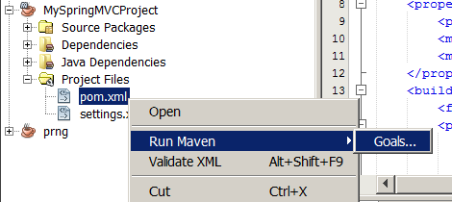
I run tomcat7:deploy (or tomcat7:redeploy, if I deployed this application before):
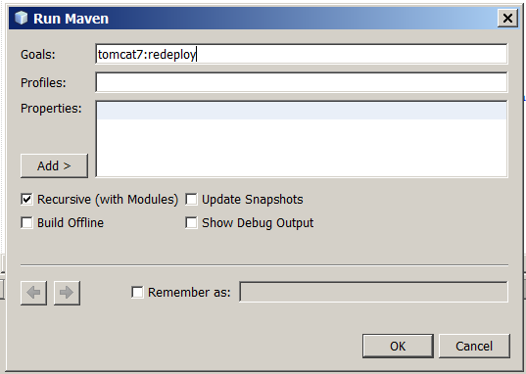
I get such warnings:
--- maven-jar-plugin:2.3.2:jar (default-jar) @ MySpringMVCProject ---
JAR will be empty - no content was marked for inclusion!
Building jar: C:\Users\admin\Documents\NetBeansProjects\MySpringMVCProject\target\MySpringMVCProject.jar

<<< tomcat7-maven-plugin:2.2:redeploy (default-cli) @ MySpringMVCProject <<<

--- tomcat7-maven-plugin:2.2:redeploy (default-cli) @ MySpringMVCProject ---
Skipping non-war project
It is because project's pom.xml contains this:
<?xml version="1.0" encoding="UTF-8"?>
<project xmlns="http://maven.apache.org/POM/4.0.0" xmlns:xsi="http://www.w3.org/2001/XMLSchema-instance" xsi:schemaLocation="http://maven.apache.org/POM/4.0.0 http://maven.apache.org/xsd/maven-4.0.0.xsd">
<modelVersion>4.0.0</modelVersion>
<groupId>pl.kuku</groupId>
<artifactId>MySpringMVCProject</artifactId>
<version>1.0-SNAPSHOT</version>
<packaging>jar</packaging>
So, my project's gets packed to jar. I edit project's pom.xml:
<?xml version="1.0" encoding="UTF-8"?>
<project xmlns="http://maven.apache.org/POM/4.0.0" xmlns:xsi="http://www.w3.org/2001/XMLSchema-instance" xsi:schemaLocation="http://maven.apache.org/POM/4.0.0 http://maven.apache.org/xsd/maven-4.0.0.xsd">
<modelVersion>4.0.0</modelVersion>
<groupId>pl.kuku</groupId>
<artifactId>MySpringMVCProject</artifactId>
<version>1.0-SNAPSHOT</version>
<packaging>war</packaging>
I again deploy my application (by running tomcat7:redeploy goal).
I will use this goal quite often, so it may make sense to make netbeans remember this goal:
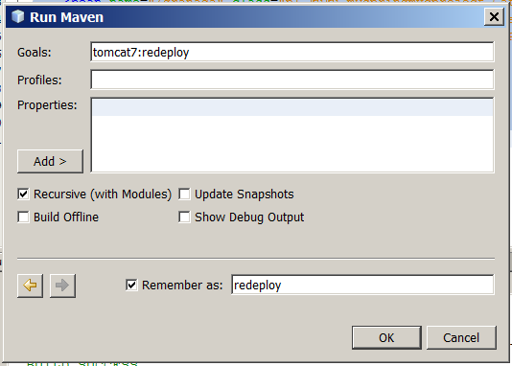
Now, after I redeployed the application, I get this error message:
Failed to execute goal org.apache.maven.plugins:maven-war-plugin:2.1.1:war (default-war) on project MySpringMVCProject: Error assembling WAR: webxml attribute is required (or pre-existing WEB-INF/web.xml if executing in update mode) -> [Help 1]
It is because my project does not contain web.xml. In eclipse I go to the files tab and there I create src/main/webapp/WEB-INF/web.xml file:
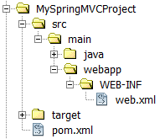
In this web.xml file I write:
<web-app xmlns="http://java.sun.com/xml/ns/javaee"
xmlns:xsi="http://www.w3.org/2001/XMLSchema-instance"
xsi:schemaLocation="http://java.sun.com/xml/ns/javaee http://java.sun.com/xml/ns/javaee/web-app_3_0.xsd"
version="3.0">
</web-app>
I again deploy my application (by running tomcat7:redeploy goal).
Now the application gets deployed. I can see it in Eclipse's output window:
--- tomcat7-maven-plugin:2.2:redeploy (default-cli) @ MySpringMVCProject ---
Deploying war to http://localhost:8080/ink
SLF4J: Failed to load class "org.slf4j.impl.StaticLoggerBinder".
SLF4J: Defaulting to no-operation (NOP) logger implementation
SLF4J: See http://www.slf4j.org/codes.html#StaticLoggerBinder for further details.
Uploading: http://localhost:8080/manager/text/deploy?path=%2Fink&update=true
Uploaded: http://localhost:8080/manager/text/deploy?path=%2Fink&update=true (3 KB at 111.9 KB/sec)
tomcatManager status code:200, ReasonPhrase:OK
OK - Deployed application at context path /ink
I also take a look at Tomcat's apache-tomcat-8.0.21/logs/catalina.2015-05-06.log file:
06-May-2015 19:45:46.764 INFO [http-nio-8080-exec-130] org.apache.catalina.startup.HostConfig.undeploy Undeploying context [/ink]
06-May-2015 19:45:47.167 INFO [http-nio-8080-exec-130] org.springframework.context.support.AbstractApplicationContext.doClose Closing WebApplicationContext for namespace 'dispatcher-servlet': startup date [Tue May 05 20:21:37 CEST 2015]; root of context hierarchy
06-May-2015 19:45:49.249 INFO [http-nio-8080-exec-130] org.apache.catalina.startup.HostConfig.deployWAR Deploying web application archive D:\programfiles\apache-tomcat-8.0.21\webapps\ink.war
06-May-2015 19:45:51.225 INFO [http-nio-8080-exec-130] org.apache.catalina.startup.HostConfig.deployWAR Deployment of web application archive D:\programfiles\apache-tomcat-8.0.21\webapps\ink.war has finished in 1,940 ms
Great! It means my application is deployed.

dispatcher servlet
The main thing in Spring MVC is a dispatcher servlet. It is a servlet written by the authors of Spring – it is the class org.springframework.web.servlet.DispatcherServlet. We configure the servlet containers so that some requests are passed to it.
Then we need handlers. A handler is an object which can produce a response to the request. It can be an object of any type, containing any methods, receiving any arguments and producing result of any type. When the dispatcher servlet gets some HTTP request, it consults all registered handler mappings and asks them if they can give him a handler for this request. One of handler mappings produces handler and now dispatcher servlet has to forward the HTTP request to this handler, so the handler produces the result and the dispatcher servlet can send this result back to the client. Ok, actually the previous sentence was an oversimplification. Actually, handler mapping does not produce handler – it produces a handler execution chain, which is a container containing one handler and any number of interceptors. However, in first, simple experiments we will not care about interceptors.
But the handler can be any object with any method, so how can dispatcher servlet call the handler? And that's why in Spring MVC there are handler adapters. Dispatcher servlet calls all registered handler adapters and asks them if they can help him to call this handler. One of handler adapters – probably written by the same author that wrote the handler mapping that produced the handler – answers that it can call this handler. So the dispatcher servlet calls this handler adapter and passes it request, response and handler objects. In this moment handler adapter can do one of two things. Handler adapter has a response object (it got it from the dispatcher servlet), so it can write the response directly to this response object. But there is also the other thing that handler adapter can do (and this second thing is more typical). Handler adapter can return (to the dispatcher servlet, which called it) a ModelAndView object. This ModelAndView is just a thin container containing two objects: a model, which contains data produced by the handler, and a either a view (which is an object that can render the data that are in the model) or the name of the view (that name will be later used to find the view). The model has to be an object of type ModelMap, which is just a map whose keys are strings and values are any objects. The view has to be an object of type View. The view name has to be a String. So each ModelView object has two fields: one contains a Model and the other contains either a View or a String being a logical name of some view. If now you wonder what does it mean a logical name of some view, hold on – I will explain it soon.
When the dispatcher servlet has the model and the view produced by the handler adapter from the result produced by the handler, it has to call the view's method handle and pass it the model, the request object and the response object – so that the view can produce a text representation of the model and write it to the response object. So the dispatcher servlet needs a view. If the ModelAndView object returned by the handler adapter contains the view object, the dispatcher servlet has the view object. If the ModelAndView object returned by the handler adapter does not contain the view object but only the logical name of the view, the dispatcher servlet consults all registered view resolver if any of them can give the view for this logical view name.
As we can see, dispatcher servlet processes the request using several objects: handler mapping, handler, handler adapter, model, view and view adapter. Some of that objects – handler and view – do not depend on Spring and can be objects of any type. Some of objects – handler mapping, handler adapter, model and view adapter – depend on Spring and act as a bridge between Spring independent beans (handler and view) and Spring. Such design gives great flexibility. Thanks to it we can use any views and handlers with Spring.
So, if I want that the dispatcher servlet answers to some URLs, I have to have in application context four beans: handler mapping, handler, handler adapter and view adapter. In typical situations we write only handlers, and we use handler mapping, handler adapter and view resolver that authors of Spring MVC prepared for us. However, it may be a good idea to begin with writing my own very simple handler mapping, handler adapter and view resolver.

I do the basic configuration of the dispatcher servlet
Now I edit the web.xml file so that all requests to any URL are served by Spring's dispatcher servlet:
<web-app xmlns="http://java.sun.com/xml/ns/javaee"
xmlns:xsi="http://www.w3.org/2001/XMLSchema-instance"
xsi:schemaLocation="http://java.sun.com/xml/ns/javaee http://java.sun.com/xml/ns/javaee/web-app_3_0.xsd"
version="3.0">
<servlet>
<servlet-name>dispatcher</servlet-name>
<servlet-class>
org.springframework.web.servlet.DispatcherServlet
</servlet-class>
<load-on-startup>1</load-on-startup>
</servlet>
<servlet-mapping>
<servlet-name>dispatcher</servlet-name>
<url-pattern>/*</url-pattern>
</servlet-mapping>
</web-app>
I redeploy it (by running Maven's tomcat7:redeploy goal). I test it by visiting http://127.0.0.1:8080/ink/ . I get 404 error. I take a look at Tomcat's apache-tomcat-8.0.21/logs/localhost.2015-05-08.log log file, where I can see this:
08-May-2015 23:30:01.262 INFO [http-nio-8080-exec-139] org.apache.catalina.core.ApplicationContext.log Marking servlet dispatcher as unavailable
08-May-2015 23:30:01.262 SEVERE [http-nio-8080-exec-139] org.apache.catalina.core.StandardContext.loadOnStartup Servlet [dispatcher] in web application [/ink] threw load() exception
java.lang.ClassNotFoundException: org.springframework.web.servlet.DispatcherServlet
(...)
So it does not work, because my war does not contain Spring's DispatcherServlet class. I edit Tomcat's pom.xml, adding there a dependency on Spring MVC:
<?xml version="1.0" encoding="UTF-8"?>
<project xmlns="http://maven.apache.org/POM/4.0.0" xmlns:xsi="http://www.w3.org/2001/XMLSchema-instance" xsi:schemaLocation="http://maven.apache.org/POM/4.0.0 http://maven.apache.org/xsd/maven-4.0.0.xsd">
<modelVersion>4.0.0</modelVersion>
<groupId>pl.kuku</groupId>
<artifactId>MySpringMVCProject</artifactId>
<version>1.0-SNAPSHOT</version>
<packaging>war</packaging>
<properties>
<project.build.sourceEncoding>UTF-8</project.build.sourceEncoding>
<maven.compiler.source>1.7</maven.compiler.source>
<maven.compiler.target>1.7</maven.compiler.target>
</properties>
<build>
<finalName>${project.artifactId}</finalName>
<plugins>
<plugin>
<groupId>org.apache.tomcat.maven</groupId>
<artifactId>tomcat7-maven-plugin</artifactId>
<version>2.2</version>
<configuration>
<url>http://localhost:8080/manager/text</url>
<server>TomcatServer</server>
<path>/ink</path>
</configuration>
</plugin>
</plugins>
</build>
<dependencies>
<dependency>
<groupId>org.springframework</groupId>
<artifactId>spring-webmvc</artifactId>
<version>4.0.1.RELEASE</version>
</dependency>
</dependencies>
</project>
I redeploy it (by running Maven's tomcat7:redeploy goal). I test it by visiting http://127.0.0.1:8080/ink/ . I get 500 error with the message:
(...)
java.io.FileNotFoundException: Could not open ServletContext resource [/WEB-INF/dispatcher-servlet.xml]
(...)
It is because this servlet needs the configuration file /WEB-INF/dispatcher-servlet.xml. Where the name of this config file comes from? Let's do an experiment. I edit pom.xml:
<web-app xmlns="http://java.sun.com/xml/ns/javaee"
xmlns:xsi="http://www.w3.org/2001/XMLSchema-instance"
xsi:schemaLocation="http://java.sun.com/xml/ns/javaee http://java.sun.com/xml/ns/javaee/web-app_3_0.xsd"
version="3.0">
<servlet>
<servlet-name>mydispatcher</servlet-name>
<servlet-class>
org.springframework.web.servlet.DispatcherServlet
</servlet-class>
<load-on-startup>1</load-on-startup>
</servlet>
<servlet-mapping>
<servlet-name>mydispatcher</servlet-name>
<url-pattern>/*</url-pattern>
</servlet-mapping>
</web-app>
I redeploy it (by running Maven's tomcat7:redeploy goal). I test it by visiting http://127.0.0.1:8080/ink/ . I get 500 error with the message:
(...)
java.io.FileNotFoundException: Could not open ServletContext resource [/WEB-INF/mydispatcher-servlet.xml]
(...)
As we can see, the name of the configuration file is based on the name of servlet's configuration.
So now I create this configuration file – /WEB-INF/mydispatcher-servlet.xml . I right click on my project's WEB-INF and choose new -> spring XML configuration file:
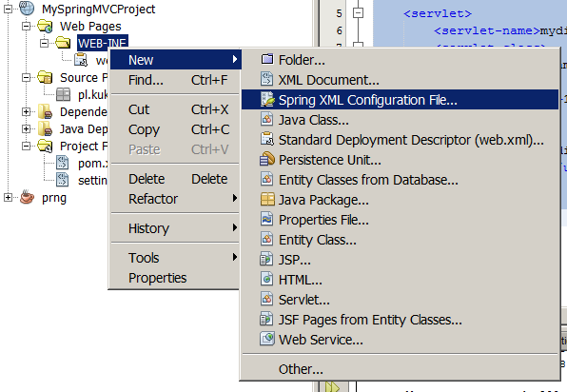
I call the file mydispatcher-servlet.xml. I choose to use only one namespace – the context namespace.
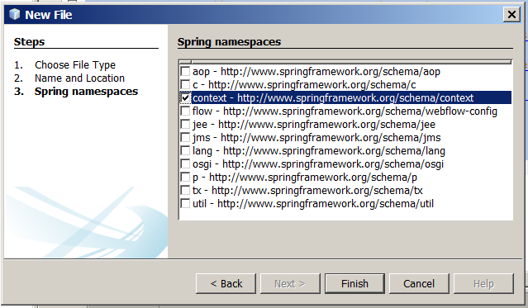
I leave this config file as it is generated by Netbeans, I don't write anything in it:
<?xml version="1.0" encoding="UTF-8"?>
<beans xmlns="http://www.springframework.org/schema/beans"
xmlns:xsi="http://www.w3.org/2001/XMLSchema-instance"
xmlns:context="http://www.springframework.org/schema/context"
xsi:schemaLocation="http://www.springframework.org/schema/beans http://www.springframework.org/schema/beans/spring-beans-4.0.xsd
http://www.springframework.org/schema/context http://www.springframework.org/schema/context/spring-context-4.0.xsd
">
</beans>
I redeploy the application (by running Maven's tomcat7:redeploy goal). I test it by visiting http://127.0.0.1:8080/ink/ . I get the 404 error. When I take a look at logs, in apache-tomcat-8.0.21/logs/host-manager.2015-05-04.log I can see:
11-May-2015 10:35:24.869 WARNING [http-nio-8080-exec-6] org.springframework.web.servlet.DispatcherServlet.noHandlerFound No mapping found for HTTP request with URI [/ink/] in DispatcherServlet with name 'mydispatcher'
It's normal – dispatcher servlet has not found mapping for that URL. I will take care of it later. Now I will check if Spring will create beans if I define them in mydispatcher-servlet.xml.
So, I create a class called pl.kuku.myspringmvcproject.Dog:
package pl.kuku.myspringmvcproject;
public class Dog {
public Dog() {
throw new RuntimeException("hau hau!");
}
}
In /WEB-INF/mydispatcher-servlet.xml I write:
<?xml version="1.0" encoding="UTF-8"?>
<beans xmlns="http://www.springframework.org/schema/beans"
xmlns:xsi="http://www.w3.org/2001/XMLSchema-instance"
xmlns:context="http://www.springframework.org/schema/context"
xsi:schemaLocation="http://www.springframework.org/schema/beans http://www.springframework.org/schema/beans/spring-beans-4.0.xsd
http://www.springframework.org/schema/context http://www.springframework.org/schema/context/spring-context-4.0.xsd
">
<bean class="pl.kuku.myspringmvcproject.Dog" lazy-init="false"></bean>
</beans>
I redeploy the application. When I take a look at logs, in apache-tomcat-8.0.21/logs/host-manager.2015-05-04.log I can see:
11-May-2015 11:08:23.422 SEVERE [http-nio-8080-exec-9] org.springframework.web.servlet.FrameworkServlet.initServletBean Context initialization failed
org.springframework.beans.factory.BeanCreationException: Error creating bean with name 'pl.kuku.myspringmvcproject.Dog#0' defined in ServletContext resource [/WEB-INF/mydispatcher-servlet.xml]: Instantiation of bean failed; nested exception is org.springframework.beans.BeanInstantiationException: Could not instantiate bean class [pl.kuku.myspringmvcproject.Dog]: Constructor threw exception; nested exception is java.lang.RuntimeException: hau hau!
It means that Spring has instantiated my bean.

I configure the dispatcher servlet so that some URLs are handled by some handlers and produce some HTTP response
Now I will configure the dispatcher servlet so that some URLs are handled by some handlers.

I write a hello world handler mapper
First I will write a basic handler mapper, which does nothing, but only throws a runtime exception – so that I can see that the dispatcher servlet really calls it.
So, I write such class:
package pl.kuku.myspringmvcproject;
import javax.servlet.http.HttpServletRequest;
import org.springframework.web.servlet.HandlerExecutionChain;
import org.springframework.web.servlet.HandlerMapping;
public class VerySimpleHandlerMapping implements HandlerMapping {
@Override
public HandlerExecutionChain getHandler(HttpServletRequest request) throws Exception {
throw new RuntimeException("Hello! I'm your handler mapping!");
}
}
If I want that the dispatcher servlet uses it, I just have to define its bean in the context of dispatcher servlet (in /WEB-INF/mydispatcher-servlet.xml):
<?xml version="1.0" encoding="UTF-8"?>
<beans xmlns="http://www.springframework.org/schema/beans"
xmlns:xsi="http://www.w3.org/2001/XMLSchema-instance"
xmlns:context="http://www.springframework.org/schema/context" xsi:schemaLocation="http://www.springframework.org/schema/beans http://www.springframework.org/schema/beans/spring-beans-4.0.xsd
http://www.springframework.org/schema/context http://www.springframework.org/schema/context/spring-context-4.0.xsd
">
<bean class="pl.kuku.myspringmvcproject.VerySimpleHandlerMapping" />
</beans>
However, the type ServletHttpRequest – which my handler adapter will get from dispatcher servlet and then will pass to my handler (implementing my interface) – is not defined in Spring, it is a part of servlet API. So in order to use it in my project I have to add some implementation of servlet API to maven dependencies of my project.
So I edit my project's pom.xml adding there a dependency on org.jboss.spec.javax.servlet:jboss-servlet-api_3.0_spec :
<?xml version="1.0" encoding="UTF-8"?>
<project xmlns="http://maven.apache.org/POM/4.0.0" xmlns:xsi="http://www.w3.org/2001/XMLSchema-instance" xsi:schemaLocation="http://maven.apache.org/POM/4.0.0 http://maven.apache.org/xsd/maven-4.0.0.xsd">
<modelVersion>4.0.0</modelVersion>
<groupId>pl.kuku</groupId>
<artifactId>MySpringMVCProject</artifactId>
<version>1.0-SNAPSHOT</version>
<packaging>war</packaging>
<properties>
<project.build.sourceEncoding>UTF-8</project.build.sourceEncoding>
<maven.compiler.source>1.7</maven.compiler.source>
<maven.compiler.target>1.7</maven.compiler.target>
</properties>
<build>
<finalName>${project.artifactId}</finalName>
<plugins>
<plugin>
<groupId>org.apache.tomcat.maven</groupId>
<artifactId>tomcat7-maven-plugin</artifactId>
<version>2.2</version>
<configuration>
<url>http://localhost:8080/manager/text</url>
<server>TomcatServer</server>
<path>/ink</path>
</configuration>
</plugin>
</plugins>
</build>
<dependencies>
<dependency>
<groupId>org.springframework</groupId>
<artifactId>spring-webmvc</artifactId>
<version>4.0.1.RELEASE</version>
</dependency>
<dependency>
<groupId>org.jboss.spec.javax.servlet</groupId>
<artifactId>jboss-servlet-api_3.0_spec</artifactId>
<version>1.0.2.Final</version>
</dependency>
</dependencies>
</project>
I redeploy the application (by running Maven's tomcat7:redeploy goal). I test it by visiting http://127.0.0.1:8080/ink/ . I get such error:
org.springframework.web.util.NestedServletException: Request processing failed; nested exception is java.lang.RuntimeException: Hello! I'm your handler mapping!
It means my handler mapping works.

I write some real handler and its handler mapping and handler adapter
When I write my own handler mapping and my own handler adapter, I can freely choose how will my handlers look like – what methods they will have, what arguments they will receive and what type of answer they will produce. So I choose that – for this experiment – my handlers will have a method called doYourDuty, receiving (as an argument) an ServletHttpRequest and returning just a String with a text of the response.
So I create an interface called MyTypeOfHandler:
package pl.kuku.myspringmvcproject;
import javax.servlet.http.HttpServletRequest;
public interface MyTypeOfHandler {
String doYourDuty(HttpServletRequest req);
}
I also create a HandlerMapping called MyHandlerMapping. It will be very simple. It will have one handler and no matter what the URL is, it will always return this one handler:
package pl.kuku.myspringmvcproject;

import javax.servlet.http.HttpServletRequest;
import org.springframework.web.servlet.HandlerExecutionChain;
import org.springframework.web.servlet.HandlerMapping;

public class MyHandlerMapping implements HandlerMapping {
private MyTypeOfHandler handler;

public void setHandler(MyTypeOfHandler handler) {
this.handler = handler;
}

@Override
public HandlerExecutionChain getHandler(HttpServletRequest request) throws Exception {
return new HandlerExecutionChain(handler);
}
}
Now I create a handler of a type MyTypeOfHandler, I call it MySimpleHandler. It is simple – all it does is to return the string hello world:
package pl.kuku.myspringmvcproject;
import javax.servlet.http.HttpServletRequest;
public class MySimpleHandler implements MyTypeOfHandler {
@Override
public String doYourDuty(HttpServletRequest req) {
return "hello world";
}
}
Now I configure the Spring so that it uses my handler mapper which produces my handler. In /WEB-INF/mydispatcher-servlet.xml I write:
<?xml version="1.0" encoding="UTF-8"?>
<beans xmlns="http://www.springframework.org/schema/beans"
xmlns:xsi="http://www.w3.org/2001/XMLSchema-instance"
xmlns:context="http://www.springframework.org/schema/context"
xsi:schemaLocation="http://www.springframework.org/schema/beans http://www.springframework.org/schema/beans/spring-beans-4.0.xsd
http://www.springframework.org/schema/context http://www.springframework.org/schema/context/spring-context-4.0.xsd
">
<bean id="myhandler" class="pl.kuku.myspringmvcproject.MySimpleHandler" />
<bean class="pl.kuku.myspringmvcproject.MyHandlerMapping">
<property name="handler" ref="myhandler" />
</bean>
</beans>
I redeploy the application (by running Maven's tomcat7:redeploy goal). I test it by visiting http://127.0.0.1:8080/ink/ . I get such error:
javax.servlet.ServletException: No adapter for handler [pl.kuku.myspringmvcproject.MySimpleHandler@74cc94]: The DispatcherServlet configuration needs to include a HandlerAdapter that supports this handler
As we can see, I lack the handler adapter which can run handlers of type MyTypeOfHandler. I write such handler adapter, I call it MyVerySimpleHandlerAdapter:
package pl.kuku.myspringmvcproject;

import javax.servlet.http.HttpServletRequest;
import javax.servlet.http.HttpServletResponse;
import org.springframework.web.servlet.HandlerAdapter;
import org.springframework.web.servlet.ModelAndView;

public class MyVerySimpleHandlerAdapter implements HandlerAdapter {

@Override
public boolean supports(Object handler) {
return handler instanceof MyTypeOfHandler;
}

@Override
public ModelAndView handle(HttpServletRequest request, HttpServletResponse response, Object handler) throws Exception {
String result = ((MyTypeOfHandler) handler).doYourDuty(request);
throw new RuntimeException(result);
}

@Override
public long getLastModified(HttpServletRequest request, Object handler) {
return -1;
}

}
As we can see, it is really very simple – when it gets the result text from the handler, it throws a runtime exception with this result text.
I put the bean of type MyVerySimpleHandlerAdapter in the mydispatcher-servlet.xml file:
<?xml version="1.0" encoding="UTF-8"?>
<beans xmlns="http://www.springframework.org/schema/beans"
xmlns:xsi="http://www.w3.org/2001/XMLSchema-instance"
xmlns:context="http://www.springframework.org/schema/context"
xsi:schemaLocation="http://www.springframework.org/schema/beans http://www.springframework.org/schema/beans/spring-beans-4.0.xsd
http://www.springframework.org/schema/context http://www.springframework.org/schema/context/spring-context-4.0.xsd
">
<bean id="myhandler" class="pl.kuku.myspringmvcproject.MySimpleHandler" />
<bean class="pl.kuku.myspringmvcproject.MyHandlerMapping">
<property name="handler" ref="myhandler" />
</bean>
<bean class="pl.kuku.myspringmvcproject.MyVerySimpleHandlerAdapter" />
</beans>
I redeploy the application (by running Maven's tomcat7:redeploy goal). I test it by visiting http://127.0.0.1:8080/ink/ . I get such error:
java.lang.RuntimeException: hello world
pl.kuku.myspringmvcproject.MyVerySimpleHandlerAdapter.handle(MyVerySimpleHandlerAdapter.java:18)
It means that my handler and handler adapter work.
Now I will make my handler adapter really work. I mean, I will make it actually send some pretty text to the browser and not just throw an exception.
I could make the handler adapter write directly to the HttpServletResponse object, which the handle method receives from the dispatcher servlet. But it's not typical, normal handler adapters don't work that way. So instead I will make my handler adapter return ModelAndView. The model will contain the text that the handler produced and the View will write the model's text to response. So I create the handler adapter called MySecondHandlerAdapter:
package pl.kuku.myspringmvcproject;

import java.io.PrintWriter;
import java.util.HashMap;
import java.util.Map;
import javax.servlet.http.HttpServletRequest;
import javax.servlet.http.HttpServletResponse;
import org.springframework.web.servlet.HandlerAdapter;
import org.springframework.web.servlet.ModelAndView;
import org.springframework.web.servlet.View;

public class MySecondHandlerAdapter implements HandlerAdapter {
@Override
public boolean supports(Object handler) {
return handler instanceof MyTypeOfHandler;
}

@Override
public ModelAndView handle(HttpServletRequest request, HttpServletResponse response, Object handler) throws Exception {
String result = ((MyTypeOfHandler) handler).doYourDuty(request);
Map<String, String> model = new HashMap<>();
model.put("result", result);
View view = new View() {
@Override
public String getContentType() {
return "text/html";
}
@Override
public void render(Map<String, ?> model, HttpServletRequest request, HttpServletResponse response) throws Exception {
response.setContentType("text/html");
PrintWriter writer = response.getWriter();
writer.write((String) model.get("result"));
writer.close();
}
};
return new ModelAndView(view, model);
}

@Override
public long getLastModified(HttpServletRequest request, Object handler) {
return -1;
}

}
I edit mydispatcher-servlet.xml to use this handler adapter instead of the previous one:
<?xml version="1.0" encoding="UTF-8"?>
<beans xmlns="http://www.springframework.org/schema/beans"
xmlns:xsi="http://www.w3.org/2001/XMLSchema-instance"
xmlns:context="http://www.springframework.org/schema/context"
xsi:schemaLocation="http://www.springframework.org/schema/beans http://www.springframework.org/schema/beans/spring-beans-4.0.xsd
http://www.springframework.org/schema/context http://www.springframework.org/schema/context/spring-context-4.0.xsd
">
<bean id="myhandler" class="pl.kuku.myspringmvcproject.MySimpleHandler" />
<bean class="pl.kuku.myspringmvcproject.MyHandlerMapping">
<property name="handler" ref="myhandler" />
</bean>
<bean class="pl.kuku.myspringmvcproject.MySecondHandlerAdapter" />
</beans>
I redeploy the application (by running Maven's tomcat7:redeploy goal). I test it by visiting http://127.0.0.1:8080/ink/ . This time I don't gent an error but just the text:
hello world
However, it's still not the way normal handler adapters work. Normal adapters don't produce the view. Normal adapters just return the logical view name and it's the job of a view resolver to produce the view for a given logical view name.
So I create the class called MySimpleView and I copy there some code from MySecondHandlerAdapter:
package pl.kuku.myspringmvcproject;

import java.io.PrintWriter;
import java.util.Map;
import javax.servlet.http.HttpServletRequest;
import javax.servlet.http.HttpServletResponse;
import org.springframework.web.servlet.View;

public class MySimpleView implements View {

@Override
public String getContentType() {
return "text/html";
}

@Override
public void render(Map<String, ?> model, HttpServletRequest request, HttpServletResponse response) throws Exception {
response.setContentType("text/html");
PrintWriter writer = response.getWriter();
writer.write((String) model.get("result"));
writer.close();
}

}
I also create a copy of MySecondHandlerAdapter called MyThirdHandlerAdapter. I edit it so that it does not put the view itself into the ModelAndView but only the view's logical name. That name can be any string, so I make it bialystok:
package pl.kuku.myspringmvcproject;

import java.util.HashMap;
import java.util.Map;
import javax.servlet.http.HttpServletRequest;
import javax.servlet.http.HttpServletResponse;
import org.springframework.web.servlet.HandlerAdapter;
import org.springframework.web.servlet.ModelAndView;

public class MyThirdHandlerAdapter implements HandlerAdapter {

@Override
public boolean supports(Object handler) {
return handler instanceof MyTypeOfHandler;
}

@Override
public ModelAndView handle(HttpServletRequest request, HttpServletResponse response, Object handler) throws Exception {
String result = ((MyTypeOfHandler) handler).doYourDuty(request);
Map<String, String> model = new HashMap<>();
model.put("result", result);
return new ModelAndView("bialystok", model);
}

@Override
public long getLastModified(HttpServletRequest request, Object handler) {
return -1;
}

}
I also create a view resolver – the class called MyViewResolver:
package pl.kuku.myspringmvcproject;

import java.util.Locale;
import org.springframework.web.servlet.View;
import org.springframework.web.servlet.ViewResolver;

public class MyViewResolver implements ViewResolver {

@Override
public View resolveViewName(String viewName, Locale locale) throws Exception {
return viewName.equals("bialystok") ? new MySimpleView() : null;
}

}
I edit mydispatcher-servlet.xml to use the new handler adapter and the new view resolver:
<?xml version="1.0" encoding="UTF-8"?>
<beans xmlns="http://www.springframework.org/schema/beans"
xmlns:xsi="http://www.w3.org/2001/XMLSchema-instance"
xmlns:context="http://www.springframework.org/schema/context"
xsi:schemaLocation="http://www.springframework.org/schema/beans http://www.springframework.org/schema/beans/spring-beans-4.0.xsd
http://www.springframework.org/schema/context http://www.springframework.org/schema/context/spring-context-4.0.xsd
">
<bean id="myhandler" class="pl.kuku.myspringmvcproject.MySimpleHandler" />
<bean class="pl.kuku.myspringmvcproject.MyHandlerMapping">
<property name="handler" ref="myhandler" />
</bean>
<bean class="pl.kuku.myspringmvcproject.MyThirdHandlerAdapter" />
<bean class="pl.kuku.myspringmvcproject.MyViewResolver" />
</beans>
I redeploy the application (by running Maven's tomcat7:redeploy goal). I test it by visiting http://127.0.0.1:8080/ink/ . I see the text:
hello world
It means everything works.

I use handler adapter and handler interface written by authors of Spring MVC
In practice we usually don't write all those classes by ourselves. Of course, we have to write our own handlers – they are the controllers of our application – but we can use handler interfaces, handler mappers and handler adapters that the authors of Spring MVC have created.

I use a handler interface called Controller
There is a handler interface called Controller. There is also a handler adapter which can use handlers of type Controller – it is called SimpleControllerHandlerAdapter. The Controller interface is very simple, similar to our MyTypeOfHandler. It has just one method, called handleRequest, which expects to receive HttpServletRequest and HttpServletResponse methods. This method must return ModelAndView.
When talking about classes implementing the Controller interface and their instances, I will call them just controllers.
Spring MVC authors decided that there are some basic things we probably want to do in every controller. For instance, to synchronize on session (so our controller can use session in multiple threads) or to take care about caching. Spring MVC authors have created a class implementing all that functionality. This is the abstract class called AbstractController. This class uses template method design pattern – it has an abstract handleRequestInternal method that we have to override.
So I create a simple controller extending AbstractController – class pl.kuku.myspringmvcproject.CatController:
package pl.kuku.myspringmvcproject;
import javax.servlet.http.HttpServletRequest;
import javax.servlet.http.HttpServletResponse;
import org.springframework.web.servlet.ModelAndView;
import org.springframework.web.servlet.mvc.AbstractController;
public class CatController extends AbstractController {
@Override
protected ModelAndView handleRequestInternal(HttpServletRequest hsr, HttpServletResponse hsr1) throws Exception {
throw new RuntimeException("miau!");
}
}
As we can see, so far it is very simple – it does not return any model or view, it just throws an exception.

I use SimpleUrlHandlerMapping to map some URLs to the CatController
In order to map some URLs to my controller I have to use some handler mapping. There are several ready made handler mappings that I can use. One simple handler mapping is SimpleUrlHandlerMapping. It is a class whose objects keep a dictionary mapping URL patterns to objects or bean names. When this handler mapping is asked to provide a handler for a given URL, it compares that URL with patterns and returns the object of the pattern that matched. In the pattern we can use the syntax of the AntPathMatcher ( http://docs.spring.io/spring-framework/docs/2.5.6/api/org/springframework/util/AntPathMatcher.html ).
So in mydispatcher-servlet.xml I configure three bean definitions: a definition of CatController, a definition of SimpleUrlHandlerMapping and a definition of org.springframework.web.servlet.mvc.SimpleControllerHandler (this is the handler adapter which can call controllers).
<?xml version="1.0" encoding="UTF-8"?>
<beans (...)>
<bean class="org.springframework.web.servlet.handler.SimpleUrlHandlerMapping">
<property name="urlMap">
<map>
<entry key="/saragossa">
<bean class="pl.kuku.myspringmvcproject.CatController" />
</entry>
</map>
</property>
</bean>
<bean class="org.springframework.web.servlet.mvc.SimpleControllerHandlerAdapter" />
</beans>
I redeploy the application (by running Maven's tomcat7:redeploy goal). I test it by visiting http://127.0.0.1:8080/ink/saragossa . I get a runtime error:
java.lang.RuntimeException: miau!
pl.kuku.myspringmvcproject.CatController.handleRequestInternal(CatController.java:12)
It means that my controller was found and used.

I try if I really can put a bean name – and not a handler itself – in the configuration of SimpleUrlHandlerMapping. I change mydispatcher-servlet.xml this way:
<bean id="cat" class="pl.kuku.myspringmvcproject.CatController" />
<bean class="org.springframework.web.servlet.handler.SimpleUrlHandlerMapping">
<property name="urlMap">
<map>
<entry key="/saragossa">
<value>cat</value>
</entry>
</map>
</property>
</bean>
<bean class="org.springframework.web.servlet.mvc.SimpleControllerHandlerAdapter" />
I redeploy the application (by running Maven's tomcat7:redeploy goal). I test it by visiting http://127.0.0.1:8080/ink/saragossa . I get the same runtime error as before.
I could also configure SimpleUrlHandlerMapping by setting its mappings property instead of urlMap property. The difference between those two properties is that the mappings property is a property of type java.util.Properties, which in practice means that it is a little bit less to write to set the mappings property (FIXME: czy to jedyna praktyczna różnica między nimi?).
Now I improve the CatController so that it returns some data and some view name:
package pl.kuku.myspringmvcproject;

import java.util.HashMap;
import javax.servlet.http.HttpServletRequest;
import javax.servlet.http.HttpServletResponse;
import org.springframework.web.servlet.ModelAndView;
import org.springframework.web.servlet.mvc.AbstractController;

public class CatController extends AbstractController {

@Override
protected ModelAndView handleRequestInternal(HttpServletRequest hsr, HttpServletResponse hsr1) throws Exception {
return new ModelAndView("myView", new HashMap<String, Integer>() {{
put("myNumber", 3 * 7);
}});
}
}
I redeploy the application (by running Maven's tomcat7:redeploy goal). I test it by visiting http://127.0.0.1:8080/ink/saragossa . I get a 404 error. It is (I suppose) because none of registered view resolvers could resolve myView to a working view.

I use the InternalResourceViewResolver view resolver to display the model using a JSP template
I also need some view resolver to resolve this logical view name into the view itself. I will use the org.springframework.web.servlet.view.InternalResourceViewResolver view resolver. It is the view resolver that regardless of the logical view name always does the same. It produces the view (usually of type InternalResourceView, but subclasses of InternalResourceViewResolver can override it by overriding the requiredViewClass method) that takes the logical view name, prepends to it some prefix (which we can configure), appends to it some postfix (which we can also configure) and then forwards the request to this string. Actually, the InternalResourceView view can either forward or include. By default, it forwards, but it is possible to configure the InternalResourceView (using its setAlwaysInclude method) to make it always include. Before the forward data from model are put into the request so that the servlet to which the request is forwarded can display them (it is done by the method AbstractView#exposeModelAsRequestAttributes, which calls setAttribute on the request object).
I will use it the very typical way – to redirect everything to some JSP template.
So first I create the mytemplate.jsp in the Netbeans pseudodirectory called Web Pages:
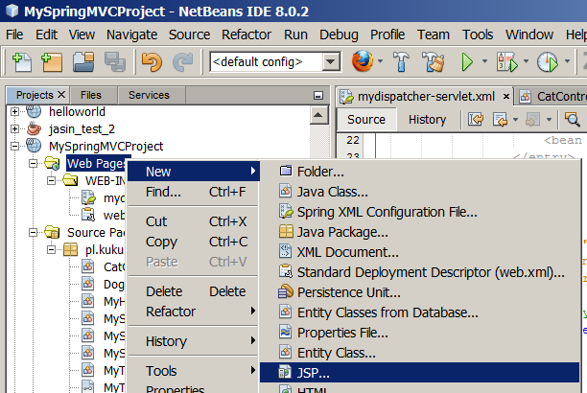
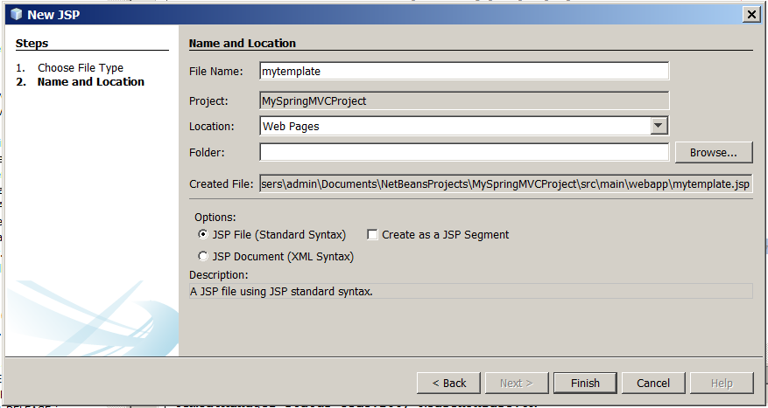
In this file netbeans automatically puts this content:
<%--
Document : mytemplate
Created on : 2015-05-22, 18:15:37
Author : admin
--%>

<%@page contentType="text/html" pageEncoding="UTF-8"%>
<!DOCTYPE html>
<html>
<head>
<meta http-equiv="Content-Type" content="text/html; charset=UTF-8">
<title>JSP Page</title>
</head>
<body>
<h1>Hello World!</h1>
</body>
</html>
However, at the very first line netbeans displays this error:
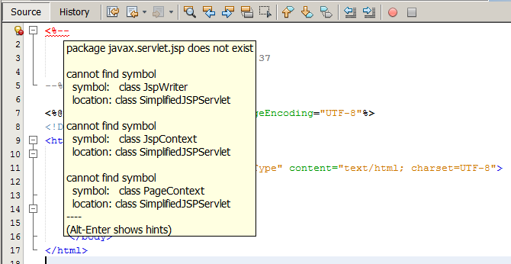
So I have to put in maven dependencies of my project a dependency with JSP API.
So, in the pom.xml of my project, in it dependencies section I add this:
<dependency>
<groupId>javax.servlet</groupId>
<artifactId>jsp-api</artifactId>
<version>2.0</version>
</dependency>
The error disappears.
Now I edit the mytemplate.jsp file:
<%--
Document : mytemplate
Created on : 2015-05-22, 18:15:37
Author : admin
--%>

<%@page contentType="text/html" pageEncoding="UTF-8"%>
<!DOCTYPE html>
<html>
<head>
<meta http-equiv="Content-Type" content="text/html; charset=UTF-8">
<title>JSP Page</title>
</head>
<body>
${2*2*2*2}
</body>
</html>
I redeploy the application (by running Maven's tomcat7:redeploy goal). I test it by visiting http://127.0.0.1:8080/ink/mytemplate.jsp . I get 404 error.
Let's see whether the war that is created and deployed by maven. In netbeans I go to files tab, and there in the target folder i take a look at the MySpringMVCProject.war:
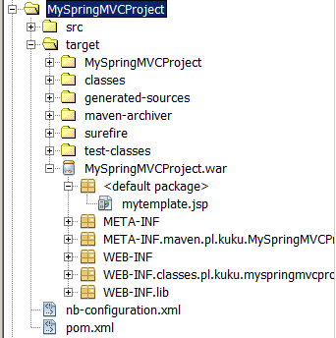
Hm, so why the mytemplate.jsp is not found and gives a 404 error? It is because the url http://127.0.0.1:8080/ink/mytemplate.jsp is matched by the pattern /* in the web.xml file:
<servlet-mapping>
<servlet-name>mydispatcher</servlet-name>
<url-pattern>/*</url-pattern>
</servlet-mapping>
I change the web.xml so that the dispatcher servlet is only the default and not catching everything:
<servlet-mapping>
<servlet-name>mydispatcher</servlet-name>
<url-pattern>/</url-pattern>
</servlet-mapping>
I redeploy the application (by running Maven's tomcat7:redeploy goal). I test it by visiting http://127.0.0.1:8080/ink/mytemplate.jsp . This time I get 500 error:
org.apache.jasper.JasperException: Unable to compile class for JSP:
An error occurred at line: [52] in the generated java file: [D:\programfiles\apache-tomcat-8.0.21\work\Catalina\localhost\ink\org\apache\jsp\mytemplate_jsp.java]
The method getJspApplicationContext(ServletContext) is undefined for the type JspFactory
To understand why we have this error, we must understand what happens when the browsers requests the /ink/mytemplate.jsp from the Tomcat. Our project does not have in its web.xml any pattern matching the /ink/mytemplate.jsp path. However, Tomcat has a global web.xml file in the apache-tomcat-8.0.21/conf/web.xml file. This file says:
(...)
<servlet>
<servlet-name>jsp</servlet-name>
<servlet-class>org.apache.jasper.servlet.JspServlet</servlet-class>
(...)
</servlet>
(...)
<servlet-mapping>
<servlet-name>jsp</servlet-name>
<url-pattern>*.jsp</url-pattern>
<url-pattern>*.jspx</url-pattern>
</servlet-mapping>
(...)
It means that when the path of the resource that the browser has requested ends with .jsp or .jspx it is served by the org.apache.jasper.servlet.JspServlet servlet. This class is not in the jsp-api-2.0.jar that we added to our project when we added the JSP api to its maven dependencies:
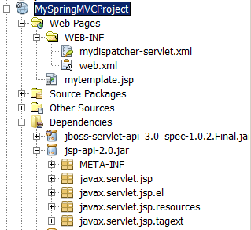
That makes sense – the JSP API is in javax.servlet.jsp package and its subpackages (notice: it begins with javax, so it is an official package). The org.apache.jasper.servlet package name sounds like it is a part of some JSP implementation (notice: it begins with some domain name, so it is not an official package). So our application needs a jar with this JSP implementation. Tomcat has a jar with this JSP implementation in the apache-tomcat-8.0.21/lib/jasper.jar file. That makes sense – if Tomcat by default is configured to use some particular JSP implementation, it must have this implementation's jar.
The reason of this error is that the org.apache.jasper.servlet.JspServlet servlet tries to call the method getJspApplicationContext on some object of type JspFactory. The error message does not say that, but I know that this class qualified (full) name is javax.servlet.jsp.JspFactory. During the runtime our application has on its classpath two definitions of this class, because it has two jars with the JSP API. One jar is a jar that Tomcat has by default in the apache-tomcat-8.0.21/lib/jsp-api.jar file. The other jar is the jar that we added to our project when we added the JSP api to its maven dependencies. When we take a look at the Tomcat's jar at the definition of the javax.servlet.jsp.JspFactory class, we can see that it has the getJspApplicationContext method:
public abstract class javax.servlet.jsp.JspFactory {
(...)
public abstract javax.servlet.jsp.JspApplicationContext getJspApplicationContext(javax.servlet.ServletContext);
However, if we take a look at the jar that maven added to our project at the definition of the javax.servlet.jsp.JspFactory class, we can see that it does not have the getJspApplicationContext method. I don't know why these two definitions of this class differ. Maybe those are two different versions of the JSP API (I mean, one is earlier and the other one is later)? I don't know. However, it is the cause of the problem.
So the cause of the problem is that we have two jars with JSP API. The jar that Maven has added to our project is not needed during the runtime, so I change the scope of this dependency in the pom.xml of my project:
<dependency>
<groupId>javax.servlet</groupId>
<artifactId>jsp-api</artifactId>
<version>2.0</version>
<scope>provided</scope>
</dependency>
I redeploy the application by running Maven's clean tomcat7:redeploy goals (notice that we have to use the clean keyword here, so that the result of previous builds is deleted). I test it by visiting http://127.0.0.1:8080/ink/mytemplate.jsp . Now I don't get any error, but I see the result of my JSP template – the number 16.
Now I will configure the InternalResourceViewResolver view resolver so that when my controller ends his job and returns model and view, the view resolver will call my JSP template. The logical view name that my CatController controller returns is myView. So I rename my JSP template from mytemplate.jsp to myView.jsp. Then in mydispatcher-servlet.xml I configure the bean of class InternalResourceViewResolver:
<?xml version="1.0" encoding="UTF-8"?>
<beans (...)>
<bean id="cat" class="pl.kuku.myspringmvcproject.CatController" />
<bean class="org.springframework.web.servlet.handler.SimpleUrlHandlerMapping">
<property name="urlMap">
<map>
<entry key="/saragossa">
<value>cat</value>
</entry>
</map>
</property>
</bean>
<bean class="org.springframework.web.servlet.mvc.SimpleControllerHandlerAdapter" />
<bean class="org.springframework.web.servlet.view.InternalResourceViewResolver">
<property name="prefix" value="" />
<property name="suffix" value=".jsp" />
</bean>
</beans>
I redeploy the application (by running Maven's tomcat7:redeploy goal). I test it by visiting http://127.0.0.1:8080/ink/saragossa . I see the result of my JSP template – the number 16.
I change the template so that it displays the model produced by the controller:
<%--
Document : mytemplate
Created on : 2015-05-23, 06:40:21
Author : admin
--%>

<%@page contentType="text/html" pageEncoding="UTF-8"%>
<!DOCTYPE html>
<html>
<head>
<meta http-equiv="Content-Type" content="text/html; charset=UTF-8">
<title>JSP Page</title>
</head>
<body>
${myNumber}
</body>
</html>
I redeploy the application (by running Maven's tomcat7:redeploy goal). I test it by visiting http://127.0.0.1:8080/ink/saragossa . I see the result of the controller – the number 21.
Now I will move this JSP template to such directory that it will not be possible for a browser to request it directly. I will do it, because the official Spring documentation advices it. So I move this JSP template to the WEB-INF folder.
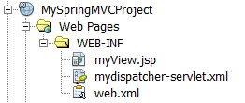
I also have to change the InternalResourceViewResolver's prefix in mydispatcher-servlet.xml:
<?xml version="1.0" encoding="UTF-8"?>
<beans (...)>
<bean id="cat" class="pl.kuku.myspringmvcproject.CatController" />
<bean class="org.springframework.web.servlet.handler.SimpleUrlHandlerMapping">
<property name="urlMap">
<map>
<entry key="/saragossa">
<value>cat</value>
</entry>
</map>
</property>
</bean>
<bean class="org.springframework.web.servlet.mvc.SimpleControllerHandlerAdapter" />
<bean class="org.springframework.web.servlet.view.InternalResourceViewResolver">
<property name="prefix" value="WEB-INF/" />
<property name="suffix" value=".jsp" />
</bean>
</beans>
I redeploy the application (by running Maven's tomcat7:redeploy goal). I test it by visiting http://127.0.0.1:8080/ink/saragossa . It still works.

I use the BeanNameUrlHandlerMapping handler mapping
Now I will use another handler mapping created by authors of Spring MVC – the BeanNameUrlHandlerMapping handler mapping. This is the mapping that is somehow similar to SimpleUrlHandlerMapping. It also has a mapping from URL patterns to beans. The difference is that we don't have to explicitly configure the mapping. Instead, the values of the mapping are all beans in the application context and the keys are the beans' names. Only those beans are included in the mapping whose bean names begin with a slash. In the pattern we can use the syntax of the AntPathMatcher ( http://docs.spring.io/spring-framework/docs/2.5.6/api/org/springframework/util/AntPathMatcher.html ).
So I edit the mydispatcher-servlet.xml. I define there a bean of class BeanNameUrlHandlerMapping. I also change the bean name of my controller.
<?xml version="1.0" encoding="UTF-8"?>
<beans (...)>
<bean name="/granada" class="pl.kuku.myspringmvcproject.CatController" />
<bean class="org.springframework.web.servlet.handler.BeanNameUrlHandlerMapping" />
<bean class="org.springframework.web.servlet.mvc.SimpleControllerHandlerAdapter" />
<bean class="org.springframework.web.servlet.view.InternalResourceViewResolver">
<property name="prefix" value="WEB-INF/" />
<property name="suffix" value=".jsp" />
</bean>
</beans>
I redeploy the application (by running Maven's tomcat7:redeploy goal). I test it by visiting http://127.0.0.1:8080/ink/granada . It works, it shows the number 21.
Now I will try whether I can use BeanNameUrlHandlerMapping with handlers which are not controllers (I mean, which do not implement the Controller interface). I edit the mydispatcher-servlet.xml. I define there a bean of class BeanNameUrlHandlerMapping and a bean of type pl.kuku.myspringmvcproject.MySimpleHandler (remember? this is the simple handler I wrote several chapters before, it is an implementation of my own interface pl.kuku.myspringmvcproject.MyTypeOfHandler).
<?xml version="1.0" encoding="UTF-8"?>
<beans (...)>
<bean name="/algeciras" class="pl.kuku.myspringmvcproject.MySimpleHandler" />
<bean class="org.springframework.web.servlet.handler.BeanNameUrlHandlerMapping" />
</beans>
I redeploy the application (by running Maven's tomcat7:redeploy goal). I test it by visiting http://127.0.0.1:8080/ink/algeciras . I get an error:
javax.servlet.ServletException: No adapter for handler [pl.kuku.myspringmvcproject.MySimpleHandler@139f83c]: The DispatcherServlet configuration needs to include a HandlerAdapter that supports this handler
Sure, when I use my own type of handler, I must provide my own of handler adapter. I will add (to the mydispatcher-servlet.xml file) the definition of a bean of type MyVerySimpleHandlerAdapter. Remember? This is the very simple handler adapter that can adapt handler of type MyTypeOfHandler. It just calls this handler and then throws the result of the handler.
So I edit mydispatcher-servlet.xml and I add there the handler adapter:
<?xml version="1.0" encoding="UTF-8"?>
<beans (...)>
<bean name="/algeciras" class="pl.kuku.myspringmvcproject.MySimpleHandler" />
<bean class="org.springframework.web.servlet.handler.BeanNameUrlHandlerMapping" />
<bean class="pl.kuku.myspringmvcproject.MyVerySimpleHandlerAdapter" />
</beans>
I redeploy the application (by running Maven's tomcat7:redeploy goal). I test it by visiting http://127.0.0.1:8080/ink/algeciras . It works, it throws an exception with a message hello world:
Request processing failed; nested exception is java.lang.RuntimeException: hello world
It confirms that I can use BeanNameUrlHandlerMapping with handlers which are not controllers.

I use the DefaultAnnotationHandlerMapping handler mapping and the AnnotationMethodHandlerAdapter handler adapter
Now I will play with the DefaultAnnotationHandlerMapping handler mapping and the AnnotationMethodHandlerAdapter handler adapter.
DefaultAnnotationHandlerMapping and AnnotationMethodHandlerAdapter are deprecated in favor of RequestMappingHandlerMapping and RequestMappingHandlerAdapter. However, it is still useful to know these two depecated classes. It is useful to know them because they are still enabled by default in DispatcherServlet.properties (I will talk about DispatcherServlet.properties later). It is also useful to know them in oder to know what are their problems and to understand how their successors – RequestMappingHandlerMapping and RequestMappingHandlerAdapter – fixed that problems.
DefaultAnnotationHandlerMapping and AnnotationMethodHandlerAdapter are very often used together. However, when learning about them it is a good idea to use them separately fist, because otherwise it wouldn't be easy to understand that does DefaultAnnotationHandlerMapping and what does AnnotationMethodHandlerAdapter.

I use the DefaultAnnotationHandlerMapping handler mapping
DefaultAnnotationHandlerMapping is another mapping which has a map where keys are URL patterns and values are handlers. However, we do not configure this mapping by calling some setter on the object of DefaultAnnotationHandlerMapping class. Instead, we annotate handlers with a @RequestMapping controller, and in the value parameter of this annotation we set the URL pattern. We can use this handler mapping with any type of handler.
In order to test it, I create a copy of CatController, I uncomment in it the line that throws a runtime exception (so that I don't have to think about the view) and I annotate this controller appropriately:
package pl.kuku.myspringmvcproject;

import java.util.HashMap;
import javax.servlet.http.HttpServletRequest;
import javax.servlet.http.HttpServletResponse;
import org.springframework.web.bind.annotation.RequestMapping;
import org.springframework.web.servlet.ModelAndView;
import org.springframework.web.servlet.mvc.AbstractController;

@RequestMapping("/cadiz")
public class CatControllerAnnotated extends AbstractController {

@Override
protected ModelAndView handleRequestInternal(HttpServletRequest hsr, HttpServletResponse hsr1) throws Exception {
throw new RuntimeException("hello from CatControllerAnnotated!");
}
}
Now I configure application context (in file mydispatcher-servlet.xml). I create three beans: CatControllerAnnotated which will serve as a handler, DefaultAnnotationHandlerMapping which will map requests to it and SimpleControllerHandlerAdapter which knows how to execute controllers (it is, handlers of type Controller):
<?xml version="1.0" encoding="UTF-8"?>
<beans (...)>
<bean class="pl.kuku.myspringmvcproject.CatControllerAnnotated" />
<bean class="org.springframework.web.servlet.mvc.annotation.DefaultAnnotationHandlerMapping" />
<bean class="org.springframework.web.servlet.mvc.SimpleControllerHandlerAdapter" />
</beans>
I redeploy the application (by running Maven's tomcat7:redeploy goal). I test it by visiting http://127.0.0.1:8080/ink/cadiz . It works, it throws an exception with a message hello from CatControllerAnnotated!:
Request processing failed; nested exception is java.lang.RuntimeException: hello from CatControllerAnnotated!

I use the AnnotationMethodHandlerAdapter handler adapter
The AnnotationMethodHandlerAdapter handler adapter is a handler adapter which can execute handlers which can be of any type, which do not have to implement any special interface, but which must have some methods annotated with an org.springframework.web.bind.annotation.RequestMapping annotation – the same same annotation that we use on classes so that DefaultAnnotationHandlerMapping finds them. Such handler is usually annotated with RequestMapping and mapped by DefaultAnnotationHandlerMapping. However, it is not compulsory – AnnotationMethodHandlerAdapter can execute a handler found by any handler mapping.
I write a simple handler with an annotated method, I call it CowControllerWithAnnotatedMethod:
package pl.kuku.myspringmvcproject;

import org.springframework.web.bind.annotation.RequestMapping;

public class CowControllerWithAnnotatedMethod {
@RequestMapping
public void firstMethod() {
throw new RuntimeException("muuu");
}
}
Now I configure application context. I create three beans: CowControllerWithAnnotatedMethod which will serve as a handler, SimpleUrlHandlerMapping which will map requests to this handler and AnnotationMethodHandlerAdapter which knows how to handlers with methods annotated with RequestMapping:
<?xml version="1.0" encoding="UTF-8"?>
<beans (...)>
<bean id="cow" class="pl.kuku.myspringmvcproject.CowControllerWithAnnotatedMethod" />
<bean class="org.springframework.web.servlet.handler.SimpleUrlHandlerMapping">
<property name="urlMap">
<map>
<entry key="/velez-malaga">
<value>cow</value>
</entry>
</map>
</property>
</bean>
<bean class="org.springframework.web.servlet.mvc.annotation.AnnotationMethodHandlerAdapter" />
</beans>
I redeploy the application (by running Maven's tomcat7:redeploy goal). I test it by visiting http://127.0.0.1:8080/ink/velez-malaga . It works, it throws an exception with a message muuu:
Request processing failed; nested exception is java.lang.RuntimeException: muuu
Now I'm going to see what will happen when I have in my handler two annotated methods. I add the second method to CowControllerWithAnnotatedMethod:
package pl.kuku.myspringmvcproject;

import org.springframework.web.bind.annotation.RequestMapping;

public class CowControllerWithAnnotatedMethod {
@RequestMapping
public void firstMethod() {
throw new RuntimeException("muuu");
}
@RequestMapping
public void secondMethod() {
throw new RuntimeException("mooo");
}
}
I redeploy the application (by running Maven's tomcat7:redeploy goal). I test it by visiting http://127.0.0.1:8080/ink/velez-malaga . I get 404 error. I take a look at Tomcat's log, at the file apache-tomcat-8.0.21/logs/catalina.2015-05-27.log and there I see this:
27-May-2015 10:30:33.986 WARNING [http-nio-8080-exec-156] org.springframework.web.servlet.mvc.support.DefaultHandlerExceptionResolver.handleNoSuchRequestHandlingMethod No matching handler method found for servlet request: path '/velez-malaga', method 'GET', parameters map[[empty]]
But I can have two methods in a handler adapted by AnnotationMethodHandlerAdapter – if RequestMapping annotations on methods provide URL patterns in such way that the current request matches only one of them.
So, I edit file mydispatcher-servlet.xml changing the URL pattern of the CowControllerWithAnnotatedMethod (notice that I added an asterisk to that pattern):
<?xml version="1.0" encoding="UTF-8"?>
<beans (...)>
<bean id="cow" class="pl.kuku.myspringmvcproject.CowControllerWithAnnotatedMethod" />
<bean class="org.springframework.web.servlet.handler.SimpleUrlHandlerMapping">
<property name="urlMap">
<map>
<entry key="/velez-malaga/*">
<value>cow</value>
</entry>
</map>
</property>
</bean>
<bean class="org.springframework.web.servlet.mvc.annotation.AnnotationMethodHandlerAdapter" />
</beans>
Then I edit CowControllerWithAnnotatedMethod adding URL patterns to methods:
package pl.kuku.myspringmvcproject;

import org.springframework.web.bind.annotation.RequestMapping;

public class CowControllerWithAnnotatedMethod {
@RequestMapping("/velez-malaga/pl")
public void firstMethod() {
throw new RuntimeException("muuu");
}
@RequestMapping("/velez-malaga/en")
public void secondMethod() {
throw new RuntimeException("mooo");
}
}
I redeploy the application (by running Maven's tomcat7:redeploy goal). I test it by visiting http://127.0.0.1:8080/ink/velez-malaga/pl . It works, it throws an exception with a message muuu:
Request processing failed; nested exception is java.lang.RuntimeException: muuu
Then I test it by visiting http://127.0.0.1:8080/ink/velez-malaga/en . It works, it throws an exception with a message mooo:
Request processing failed; nested exception is java.lang.RuntimeException: mooo

I use the DefaultAnnotationHandlerMapping handler mapping and the AnnotationMethodHandlerAdapter handler adapter together
Now I will use those two things – the DefaultAnnotationHandlerMapping handler mapping and the AnnotationMethodHandlerAdapter handler adapter – together.
In this experiment I will use JSP templates as views.
So I will use:
- DefaultAnnotationHandlerMapping as a handler mapping,
- handlers written by me, annotated appropriately,
- AnnotationMethodHandlerAdapter as a handler adapter,
- InternalResourceViewResolver as a view resolver.

I write a JSP template
I create a JSP template displaying some string and some number from the model.
In Web Pages -> WEB-INF I create a JSP template called secondView.jsp:
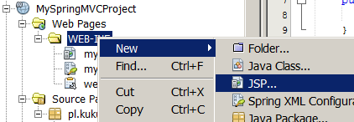
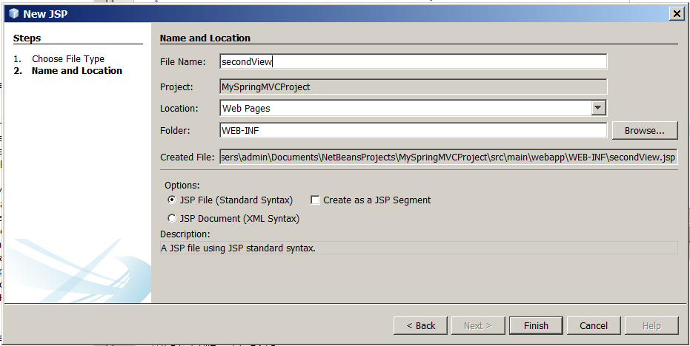
In this JSP template I write:
<%@page contentType="text/html" pageEncoding="UTF-8"%>
<!DOCTYPE html>
<html>
<head>
<meta http-equiv="Content-Type" content="text/html; charset=UTF-8">
<title>JSP Page</title>
</head>
<body>
<h1>${text}</h1>
${number}
</body>
</html>
In this moment I don't try whether it works. Soon I will write my handlers, I will configure the application context and then I will see if everything works.

I write two annotated handlers with annotated methods
Now I will write two annotated handlers with annotated methods.
I write the first one, I call it AnnotatedControllerWithAnnotatedMethodsOne:
package pl.kuku.myspringmvcproject;

import java.util.HashMap;
import org.springframework.web.bind.annotation.RequestMapping;
import org.springframework.web.servlet.ModelAndView;

@RequestMapping("/first")
public class AnnotatedControllerWithAnnotatedMethodsOne {
@RequestMapping("primera")
public ModelAndView firstMethod() {
return new ModelAndView("secondView", new HashMap<String, Object>() {{
put("number", 11);
put("text", "first primera");
}});
}
@RequestMapping("segunda")
public ModelAndView secondMethod() {
return new ModelAndView("secondView", new HashMap<String, Object>() {{
put("number", 12);
put("text", "first segunda");
}});
}
}
Then I write the second one, I call it AnnotatedControllerWithAnnotatedMethodsTwo :
package pl.kuku.myspringmvcproject;

import java.util.HashMap;
import org.springframework.web.bind.annotation.RequestMapping;
import org.springframework.web.servlet.ModelAndView;

@RequestMapping("/second")
public class AnnotatedControllerWithAnnotatedMethodsTwo {
@RequestMapping("primera")
public ModelAndView firstMethod() {
return new ModelAndView("secondView", new HashMap<String, Object>() {{
put("number", 21);
put("text", "second primera");
}});
}
@RequestMapping("segunda")
public ModelAndView secondMethod() {
return new ModelAndView("secondView", new HashMap<String, Object>() {{
put("number", 22);
put("text", "second segunda");
}});
}

}

I configure the application context and test if everything works
Now I configure the application context (the file mydispatcher-servlet.xml):
<?xml version="1.0" encoding="UTF-8"?>
<beans (...)>
<bean class="org.springframework.web.servlet.mvc.annotation.DefaultAnnotationHandlerMapping" />
<bean class="pl.kuku.myspringmvcproject.AnnotatedControllerWithAnnotatedMethodsOne" />
<bean class="pl.kuku.myspringmvcproject.AnnotatedControllerWithAnnotatedMethodsTwo" />
<bean class="org.springframework.web.servlet.mvc.annotation.AnnotationMethodHandlerAdapter" />
<bean class="org.springframework.web.servlet.view.InternalResourceViewResolver">
<property name="prefix" value="/WEB-INF/" />
<property name="suffix" value=".jsp" />
</bean>
</beans>
I redeploy the application (by running Maven's tomcat7:redeploy goal). I test it by visiting following URLs:
- http://127.0.0.1:8080/ink/first/primera
- http://127.0.0.1:8080/ink/first/segunda
- http://127.0.0.1:8080/ink/second/primera
- http://127.0.0.1:8080/ink/second/segunda
It works, I see something like this:
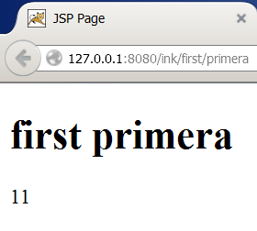

Limitations of DefaultAnnotationHandlerMapping and AnnotationMethodHandlerAdapter
Spring's documentation ( http://docs.spring.io/spring/docs/current/javadoc-api/org/springframework/web/servlet/mvc/annotation/DefaultAnnotationHandlerMapping.html ) says:
Method-level mappings are only allowed to narrow the mapping expressed at the class level (if any). HTTP paths need to uniquely map onto specific handler beans, with any given HTTP path only allowed to be mapped onto one specific handler bean (not spread across multiple handler beans). It is strongly recommended to co-locate related handler methods into the same bean.
I will do some experiments to see if it's true.

I do two controllers that are mapped to the same pattern, they only differ by the pattern of their methods
First I will do two controllers that are mapped to the same pattern, they only differ by the pattern of their methods.
I change AnnotatedControllerWithAnnotatedMethodsOne :
package pl.kuku.myspringmvcproject;

import java.util.HashMap;
import org.springframework.web.bind.annotation.RequestMapping;
import org.springframework.web.servlet.ModelAndView;

@RequestMapping("/first")
public class AnnotatedControllerWithAnnotatedMethodsOne {
@RequestMapping("primera")
public ModelAndView firstMethod() {
return new ModelAndView("secondView", new HashMap<String, Object>() {{
put("number", 11);
put("text", "first primera");
}});
}
}
I also change AnnotatedControllerWithAnnotatedMethodsTwo :
package pl.kuku.myspringmvcproject;

import java.util.HashMap;
import org.springframework.web.bind.annotation.RequestMapping;
import org.springframework.web.servlet.ModelAndView;

@RequestMapping("/first")
public class AnnotatedControllerWithAnnotatedMethodsTwo {
@RequestMapping("segunda")
public ModelAndView secondMethod() {
return new ModelAndView("secondView", new HashMap<String, Object>() {{
put("number", 12);
put("text", "first segunda");
}});
}

}
I redeploy the application (by running Maven's tomcat7:redeploy goal). I test it by visiting following URLs:
- http://127.0.0.1:8080/ink/first/primera
- http://127.0.0.1:8080/ink/first/segunda
It works. Hm, it suggests that the documentation is wrong.

I do two controllers that are mapped to the same pattern, they only differ that their methods are annotated to react to different HTTP methods
We haven't see it yet, but the @RequestMapping annotation can provide not only pattern, but also the HTTP method (get, post, delete etc) that given Java method responds to. Now I will do two controllers that are mapped to the same pattern, they will only differ that their methods are annotated to react to different HTTP methods.
I change AnnotatedControllerWithAnnotatedMethodsOne :
package pl.kuku.myspringmvcproject;

import java.util.HashMap;
import org.springframework.web.bind.annotation.RequestMapping;
import org.springframework.web.bind.annotation.RequestMethod;
import org.springframework.web.servlet.ModelAndView;

@RequestMapping("/first")
public class AnnotatedControllerWithAnnotatedMethodsOne {
@RequestMapping(method = RequestMethod.GET)
public ModelAndView firstMethod() {
return new ModelAndView("secondView", new HashMap<String, Object>() {{
put("number", 11);
put("text", "first GET");
}});
}
}
I change AnnotatedControllerWithAnnotatedMethodsTwo :
package pl.kuku.myspringmvcproject;

import java.util.HashMap;
import org.springframework.web.bind.annotation.RequestMapping;
import org.springframework.web.bind.annotation.RequestMethod;
import org.springframework.web.servlet.ModelAndView;

@RequestMapping("/first")
public class AnnotatedControllerWithAnnotatedMethodsTwo {
@RequestMapping(method = RequestMethod.POST)
public ModelAndView secondMethod() {
return new ModelAndView("secondView", new HashMap<String, Object>() {{
put("number", 12);
put("text", "first POST");
}});
}
}
In Firefox I install the addon called RESTClient. With it I send two HTTP requests to http://127.0.0.1:8080/ink/first – first using get HTTP method, second using post HTTP method. In both cases I get 500 error:
java.lang.IllegalStateException: Cannot map handler 'pl.kuku.myspringmvcproject.AnnotatedControllerWithAnnotatedMethodsTwo#0' to URL path [/first]: There is already handler of type [class pl.kuku.myspringmvcproject.AnnotatedControllerWithAnnotatedMethodsOne] mapped.
It means that documentation is (at least partially) right.

I test DefaultAnnotationHandlerMapping without dispatcher servlet
In such situations – like when I want to play with DefaultAnnotationHandlerMapping to see how it behaves when I have two controllers that are mapped to the same pattern, they only differ that their methods are annotated to react to different HTTP methods – it is useful to test it without dispatcher servlet. Now I will do that.
In my project I create a class called MyMainClassDoingSomeSimpleTests:
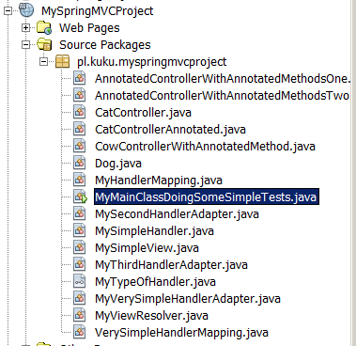
package pl.kuku.myspringmvcproject;

public class MyMainClassDoingSomeSimpleTests {
public static void main(String[] args) {
System.out.println("hello from MyMainClassDoingSomeSimpleTests");
}
}
I run it from commandline with command:
mvn exec:java -Dexec.mainClass=pl.kuku.myspringmvcproject.MyMainClassDoingSomeSimpleTests
I see:
(...)
[INFO] --- exec-maven-plugin:1.4.0:java (default-cli) @ MySpringMVCProject ---
hello from MyMainClassDoingSomeSimpleTests
(...)
Now I change the MyMainClassDoingSomeSimpleTests class to see if I can instantiate the application context and get a bean from it:
package pl.kuku.myspringmvcproject;

import org.springframework.context.ApplicationContext;
import org.springframework.context.support.FileSystemXmlApplicationContext;
import org.springframework.web.servlet.mvc.annotation.DefaultAnnotationHandlerMapping;

public class MyMainClassDoingSomeSimpleTests {
public static void main(String[] args) {
ApplicationContext ctx = new FileSystemXmlApplicationContext("C:\\Users\\admin\\Documents\\NetBeansProjects\\MySpringMVCProject\\src\\main\\webapp\\WEB-INF\\mydispatcher-servlet.xml");
DefaultAnnotationHandlerMapping m = ctx.getBean(DefaultAnnotationHandlerMapping.class);
System.out.println("DefaultAnnotationHandlerMapping bean: " + m);
}
}
I run this program with a command:
mvn exec:java -Dexec.mainClass=pl.kuku.myspringmvcproject.MyMainClassDoingSomeSimpleTests
It throws an exception:
[ERROR] Failed to execute goal org.codehaus.mojo:exec-maven-plugin:1.4.0:java (default-cli) on project MySpringMVCProject: An exception occured while executing the Java class. null: InvocationTargetException: Error creating bean with name 'org.springframework.web.servlet.mvc.annotation.DefaultAnnotationHandlerMapping#0' defined in file [C:\Users\admin\Documents\NetBeansProjects\MySpringMVCProject\src\main\webapp\WEB-INF\mydispatcher-servlet.xml]: Initialization of bean failed; nested exception is java.lang.IllegalStateException: Cannot map handler 'pl.kuku.myspringmvcproject.AnnotatedControllerWithAnnotatedMethodsTwo#0' to URL path [/first]: There is already handler of type [class pl.kuku.myspringmvcproject.AnnotatedControllerWithAnnotatedMethodsOne] mapped. -> [Help 1]
I have this error because I still have two controllers that have the same pattern. I comment out the @RequestMapping annotation on AnnotatedControllerWithAnnotatedMethodsTwo class:
package pl.kuku.myspringmvcproject;

import java.util.HashMap;
import org.springframework.web.bind.annotation.RequestMapping;
import org.springframework.web.bind.annotation.RequestMethod;
import org.springframework.web.servlet.ModelAndView;

//@RequestMapping("/first")
public class AnnotatedControllerWithAnnotatedMethodsTwo {
@RequestMapping(method = RequestMethod.POST)
public ModelAndView secondMethod() {
return new ModelAndView("secondView", new HashMap<String, Object>() {{
put("number", 12);
put("text", "first POST");
}});
}
}
Now I run my program again. This time it runs and prints a lot of useful information:
(...)
[INFO] --- exec-maven-plugin:1.4.0:java (default-cli) @ MySpringMVCProject ---
maj 30, 2015 4:13:10 PM org.springframework.context.support.AbstractApplicationContext prepareRefresh
INFO: Refreshing org.springframework.context.support.FileSystemXmlApplicationContext@29d89: startup date [Sat May 30 16:13:10 CEST 2015]; root of context hierarchy
maj 30, 2015 4:13:10 PM org.springframework.beans.factory.xml.XmlBeanDefinitionReader loadBeanDefinitions
INFO: Loading XML bean definitions from file [C:\Users\admin\Documents\NetBeansProjects\MySpringMVCProject\src\main\webapp\WEB-INF\mydispatcher-servlet.xml]
maj 30, 2015 4:13:10 PM org.springframework.web.servlet.handler.AbstractUrlHandlerMapping registerHandler
INFO: Mapped URL path [/first] onto handler 'pl.kuku.myspringmvcproject.AnnotatedControllerWithAnnotatedMethodsOne#0'
maj 30, 2015 4:13:10 PM org.springframework.web.servlet.handler.AbstractUrlHandlerMapping registerHandler
INFO: Mapped URL path [/first.*] onto handler 'pl.kuku.myspringmvcproject.AnnotatedControllerWithAnnotatedMethodsOne#0'
maj 30, 2015 4:13:10 PM org.springframework.web.servlet.handler.AbstractUrlHandlerMapping registerHandler
INFO: Mapped URL path [/first/] onto handler 'pl.kuku.myspringmvcproject.AnnotatedControllerWithAnnotatedMethodsOne#0'
DefaultAnnotationHandlerMapping bean: org.springframework.web.servlet.mvc.annotation.DefaultAnnotationHandlerMapping@133ea67
(...)
Now, when I can get the DefaultAnnotationHandlerMapping bean from the application context, I will try to see how it behaves when I call its getHandler method. However, when calling this method I will have to provide it the request object – the object of a class implementing the HttpServletRequest interface. It is tedious to implement this interface, because it requires a lot of methods. Spring has a lot of mockup classes for such situations, for instance it has a MockHttpServletRequest class.

So, I add do my pom.xml a dependency with that class:
<?xml version="1.0" encoding="UTF-8"?>
<project xmlns="http://maven.apache.org/POM/4.0.0" xmlns:xsi="http://www.w3.org/2001/XMLSchema-instance" xsi:schemaLocation="http://maven.apache.org/POM/4.0.0 http://maven.apache.org/xsd/maven-4.0.0.xsd">
<modelVersion>4.0.0</modelVersion>
<groupId>pl.kuku</groupId>
<artifactId>MySpringMVCProject</artifactId>
<version>1.0-SNAPSHOT</version>
<packaging>war</packaging>
<properties>
<project.build.sourceEncoding>UTF-8</project.build.sourceEncoding>
<maven.compiler.source>1.7</maven.compiler.source>
<maven.compiler.target>1.7</maven.compiler.target>
</properties>
<build>
<finalName>${project.artifactId}</finalName>
<plugins>
<plugin>
<groupId>org.apache.tomcat.maven</groupId>
<artifactId>tomcat7-maven-plugin</artifactId>
<version>2.2</version>
<configuration>
<url>http://localhost:8080/manager/text</url>
<server>TomcatServer</server>
<path>/ink</path>
</configuration>
</plugin>
</plugins>
</build>
<dependencies>
<dependency>
<groupId>org.springframework</groupId>
<artifactId>spring-webmvc</artifactId>
<version>4.0.1.RELEASE</version>
</dependency>
<dependency>
<groupId>org.springframework</groupId>
<artifactId>spring-test</artifactId>
<version>4.0.1.RELEASE</version>
</dependency>

<dependency>
<groupId>org.jboss.spec.javax.servlet</groupId>
<artifactId>jboss-servlet-api_3.0_spec</artifactId>
<version>1.0.2.Final</version>
</dependency>
<dependency>
<groupId>javax.servlet</groupId>
<artifactId>jsp-api</artifactId>
<version>2.0</version>
<scope>provided</scope>
</dependency>
</dependencies>
</project>
Now I add in MyMainClassDoingSomeSimpleTests a fragment which calls getHandler on the DefaultAnnotationHandlerMapping bean and prints out the result:
package pl.kuku.myspringmvcproject;

import org.springframework.context.ApplicationContext;
import org.springframework.context.support.FileSystemXmlApplicationContext;
import org.springframework.mock.web.MockHttpServletRequest;
import org.springframework.web.servlet.HandlerExecutionChain;
import org.springframework.web.servlet.mvc.annotation.DefaultAnnotationHandlerMapping;

public class MyMainClassDoingSomeSimpleTests {
public static void main(String[] args) throws Exception {
ApplicationContext ctx = new FileSystemXmlApplicationContext("C:\\Users\\admin\\Documents\\NetBeansProjects\\MySpringMVCProject\\src\\main\\webapp\\WEB-INF\\mydispatcher-servlet.xml");
DefaultAnnotationHandlerMapping m = ctx.getBean(DefaultAnnotationHandlerMapping.class);
System.out.println("DefaultAnnotationHandlerMapping bean: " + m);
MockHttpServletRequest r = new MockHttpServletRequest("GET", "/first");
HandlerExecutionChain h = m.getHandler(r);
System.out.println("handler=" + h);
}
}
Again I run my program. It works:
(...)
handler=HandlerExecutionChain with handler [pl.kuku.myspringmvcproject.AnnotatedControllerWithAnnotatedMethodsOne@333027] and 1 interceptor
This technique – running parts of my application without the dispatcher servlet – can be very useful during debugging and learning.

I take a look at the mapping that DefaultAnnotationHandlerMapping uses to map requests to handlers
Now I will take a look at the mapping that DefaultAnnotationHandlerMapping uses to map requests to handlers.
First I download sources of all the dependencies my project uses. I do it by running this maven goal:
dependency:sources
The output of this command is:
------------------------------------------------------------------
Building MySpringMVCProject 1.0-SNAPSHOT
------------------------------------------------------------------

--- maven-dependency-plugin:2.1:sources (default-cli) @ MySpringMVCProject ---

The following files have been resolved:
none

The following files were skipped:
aopalliance:aopalliance:java-source:sources:1.0
commons-logging:commons-logging:java-source:sources:1.1.1
javax.servlet:jsp-api:java-source:sources:2.0
javax.servlet:servlet-api:java-source:sources:2.4
org.jboss.spec.javax.servlet:jboss-servlet-api_3.0_spec:java-source:sources:1.0.2.Final
org.springframework:spring-aop:java-source:sources:4.0.1.RELEASE
org.springframework:spring-beans:java-source:sources:4.0.1.RELEASE
org.springframework:spring-context:java-source:sources:4.0.1.RELEASE
org.springframework:spring-core:java-source:sources:4.0.1.RELEASE
org.springframework:spring-expression:java-source:sources:4.0.1.RELEASE
org.springframework:spring-test:java-source:sources:4.0.1.RELEASE
org.springframework:spring-web:java-source:sources:4.0.1.RELEASE
org.springframework:spring-webmvc:java-source:sources:4.0.1.RELEASE
It means that somebody who packed the Spring Framework for Maven did not package its sources. So I have to download it from somewhere else. The sources of Spring Framework are on Github. I can read the sources of AbstractHandlerMapping class and other classes online at https://github.com/spring-projects/spring-framework/blob/master/spring-webmvc/src/main/java/org/springframework/web/servlet/handler/AbstractHandlerMapping.java . I can also download the whole sources of Spring Framework from https://github.com/spring-projects/spring-framework (the zip is at https://github.com/spring-projects/spring-framework/archive/master.zip ). So I download that master.zip and I attach it to spring-webmvc-4.0.1.RELEASE.jar. Maybe it is possible to do it more simply, but I had to unzip that master.zip, inside it find directory find the spring-framework-master/spring-webmvc/src/main/java, zip the contents of this directory (nb: I have to zip the contents of this directory, not the directory itself – I create a jar), rename this zip to something.jar, right-click on spring-webmvc-4.0.1.RELEASE.jar (in Netbeans), choose add local sources and point netbeans to the jar I just created.
Now in Netbeans I control click on the method getHandler:
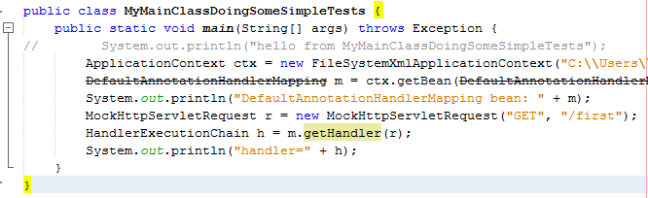
and I can read the sources of this method and its surroundings.
So I read the sources of this method and its surroundings and I find that DefaultAnnotationHandlerMapping extends org.springframework.web.servlet.handler.AbstractUrlHandlerMapping and that AbstractUrlHandlerMapping has a field called handlerMap. This handlerMap is of type Map<String, Object>. Its keys are URL patterns and its values are handlers (or handlers' names).
I can take a look at how this handlerMap looks like when I have two annotated controllers that are mapped to the same pattern, they only differ that their methods are annotated to react to different patterns.

I edit the class AnnotatedControllerWithAnnotatedMethodsOne so it looks like that:
package pl.kuku.myspringmvcproject;

import java.util.HashMap;
import org.springframework.web.bind.annotation.RequestMapping;
import org.springframework.web.bind.annotation.RequestMethod;
import org.springframework.web.servlet.ModelAndView;

@RequestMapping("/first")
public class AnnotatedControllerWithAnnotatedMethodsOne {
@RequestMapping("primera")
public ModelAndView firstMethod() {
return new ModelAndView("secondView", new HashMap<String, Object>() {{
put("number", 11);
put("text", "first GET");
}});
}
}
I also edit the class AnnotatedControllerWithAnnotatedMethodsTwo so it looks like that:
package pl.kuku.myspringmvcproject;

import java.util.HashMap;
import org.springframework.web.bind.annotation.RequestMapping;
import org.springframework.web.bind.annotation.RequestMethod;
import org.springframework.web.servlet.ModelAndView;

@RequestMapping("/first")
public class AnnotatedControllerWithAnnotatedMethodsTwo {
@RequestMapping("segunda")
public ModelAndView secondMethod() {
return new ModelAndView("secondView", new HashMap<String, Object>() {{
put("number", 12);
put("text", "first POST");
}});
}
}

I also make sure that mydispatcher-servlet.xml still looks like that:
<?xml version="1.0" encoding="UTF-8"?>
<beans (...)>
<bean class="org.springframework.web.servlet.mvc.annotation.DefaultAnnotationHandlerMapping" />
<bean class="pl.kuku.myspringmvcproject.AnnotatedControllerWithAnnotatedMethodsOne" />
<bean class="pl.kuku.myspringmvcproject.AnnotatedControllerWithAnnotatedMethodsTwo" />
<bean class="org.springframework.web.servlet.mvc.annotation.AnnotationMethodHandlerAdapter" />
<bean class="org.springframework.web.servlet.view.InternalResourceViewResolver">
<property name="prefix" value="/WEB-INF/" />
<property name="suffix" value=".jsp" />
</bean>
</beans>

Now in MyMainClassDoingSomeSimpleTests I add a few lines which print out the field handlerMap from an object of class DefaultAnnotationHandlerMapping. I must do it using introspection because it is not public:
package pl.kuku.myspringmvcproject;

import java.lang.reflect.Field;
import org.springframework.context.ApplicationContext;
import org.springframework.context.support.FileSystemXmlApplicationContext;
import org.springframework.mock.web.MockHttpServletRequest;
import org.springframework.web.servlet.HandlerExecutionChain;
import org.springframework.web.servlet.handler.AbstractUrlHandlerMapping;
import org.springframework.web.servlet.mvc.annotation.DefaultAnnotationHandlerMapping;

public class MyMainClassDoingSomeSimpleTests {
public static void main(String[] args) throws Exception {
ApplicationContext ctx = new FileSystemXmlApplicationContext("C:\\Users\\Excel\\Desktop\\psobolewski\\java_ee\\spring_notatki\\MySpringMVCProject\\src\\main\\webapp\\WEB-INF\\mydispatcher-servlet.xml");
DefaultAnnotationHandlerMapping m = ctx.getBean(DefaultAnnotationHandlerMapping.class);
System.out.println("DefaultAnnotationHandlerMapping bean: " + m);
MockHttpServletRequest r = new MockHttpServletRequest("GET", "/first");
HandlerExecutionChain h = m.getHandler(r);
System.out.println("handler=" + h);
Field handlerMapField = AbstractUrlHandlerMapping.class.getDeclaredField("handlerMap");
handlerMapField.setAccessible(true);
Object handlerMap = handlerMapField.get(m);
System.out.println("handlerMap = " + handlerMap);
}
}
I run this program by running maven's goal exec:java -Dexec.mainClass=pl.kuku.myspringmvcproject.MyMainClassDoingSomeSimpleTests . It prints out:
handlerMap = {/first/primera=pl.kuku.myspringmvcproject.AnnotatedControllerWithAnnotatedMethodsOne@41ef27bf, /first/primera.*=pl.kuku.myspringmvcproject.AnnotatedControllerWithAnnotatedMethodsOne@41ef27bf, /first/primera/=pl.kuku.myspringmvcproject.AnnotatedControllerWithAnnotatedMethodsOne@41ef27bf, /first/segunda=pl.kuku.myspringmvcproject.AnnotatedControllerWithAnnotatedMethodsTwo@682bd2de, /first/segunda.*=pl.kuku.myspringmvcproject.AnnotatedControllerWithAnnotatedMethodsTwo@682bd2de, /first/segunda/=pl.kuku.myspringmvcproject.AnnotatedControllerWithAnnotatedMethodsTwo@682bd2de}
Everything is clear now. In the mapping of DefaultAnnotationHandlerMapping keys are URL patterns. So we just can't have two controllers reacting to the same URL pattern.

I use the RequestMappingHandlerMapping handler mapping and the RequestMappingHandlerAdapter handler adapter
As of 2019 (and Spring Framework version 5) DefaultAnnotationHandlerMapping and AnnotationMethodHandlerAdapter are not enabled by default by the properties file of the dispatcher servlet. They are replaced by RequestMappingHandlerMapping and RequestMappingAdapter.
RequestMappingHandlerMapping is a handler mapping which finds all beans annotated (at class level) with @Controller or @RequestMapping annotation, finds in them all methods annotated with @RequestMapping and then for each of these methods combines the filter (path, HTTP method etc) from class level @RequestMapping with the filter from method level @RequestMapping and for a request matching this filter returns a handler (of type HandlerMethod) which can call this method. There also exists a handler adapter – called RequestMappingHandlerAdapter – which can execute handlers of type HandlerMethod.
FIXME: here I should have an example which uses RequestMappingHandlerMapping handler mapping and the RequestMappingHandlerAdapter handler adapter.

Dispatcher servlet has a property file with a default configuration
Dispatcher servlet has a property file with a default configuration. We can see this file here:
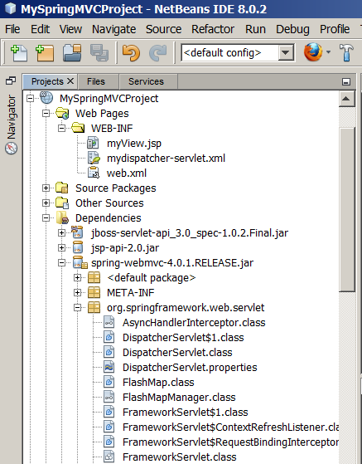
This properties file decides which handler mappings will be used when context does not contain any handler mapping beans, which handler adapters will be used when context does not contain any handler adapter beans etc.

Summary
Here we have a short summary of how some parts of Spring Framework work.

Core
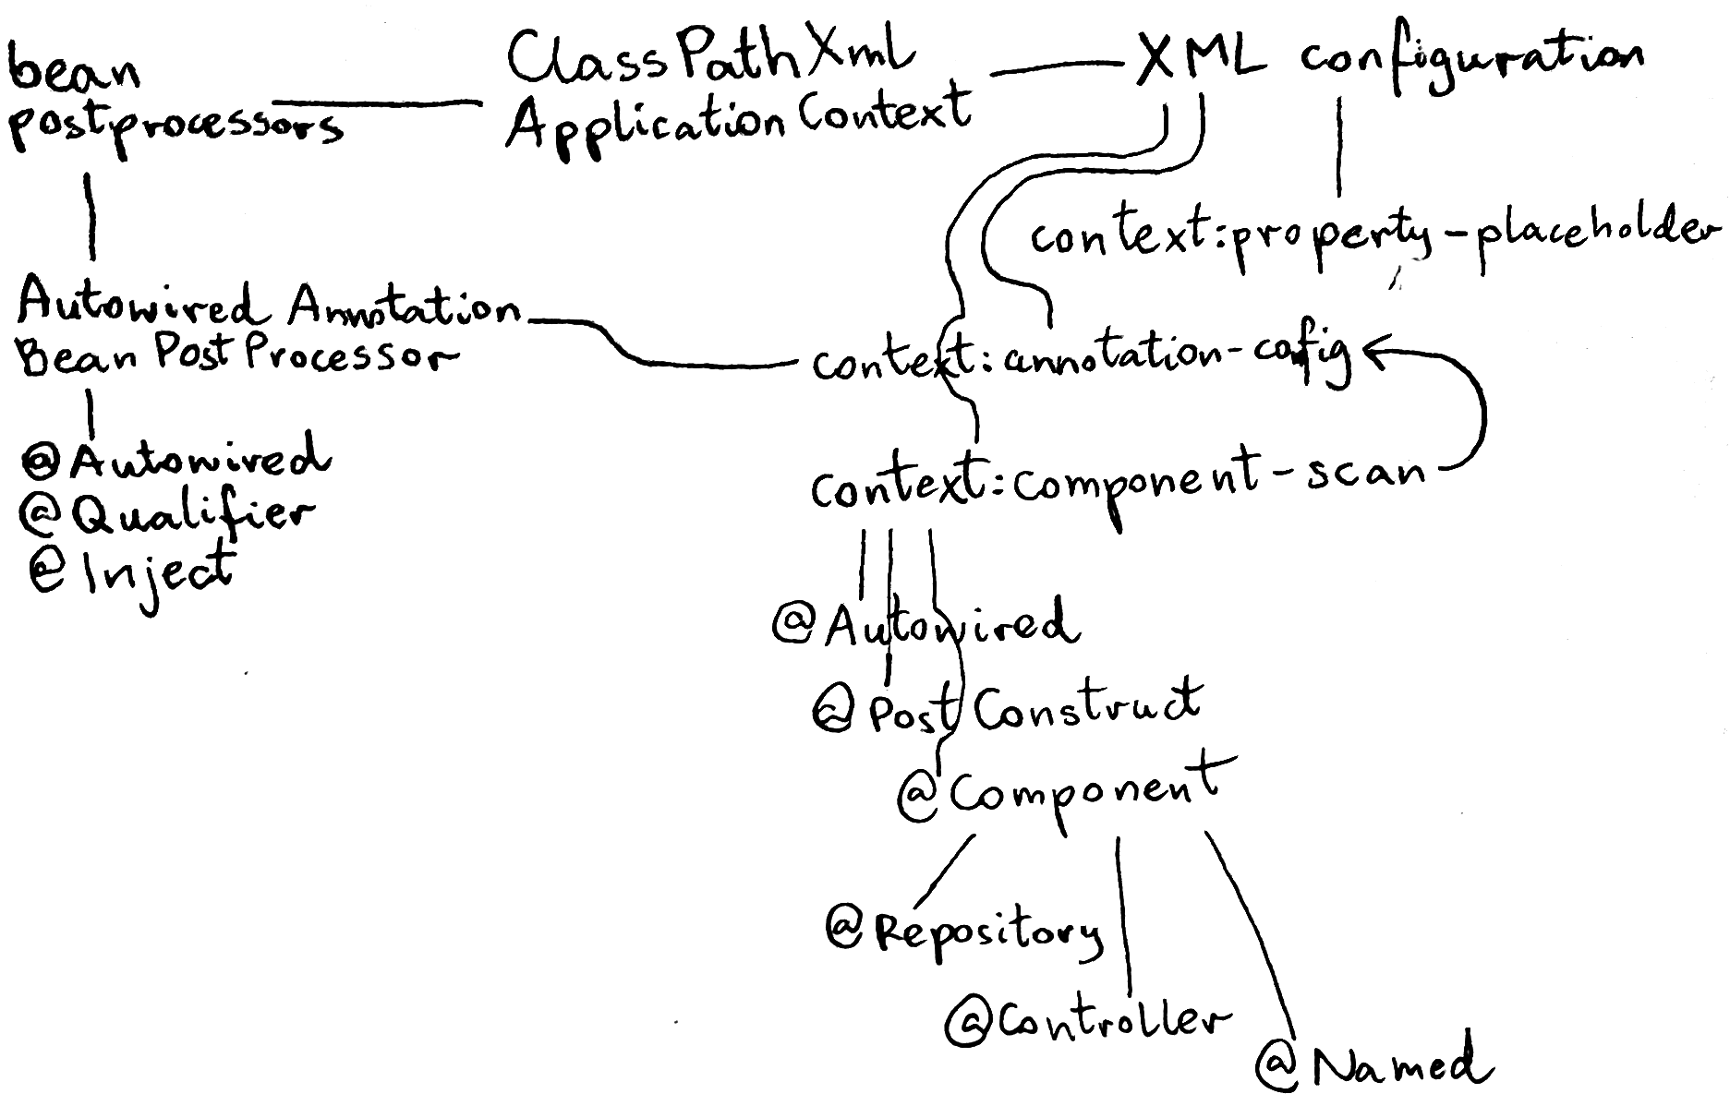
ClassPathXmlApplicationContext (a.k.a. context) is a container which creates objects, configures them (by setting their properties), stores them and let the programmer get them. This container has XML configuration which says which objects should be created and how they should should be connected. Configuration can contain context:property-placeholder tag which lets us include and use property files in the configuration.
The context can have bean postprocessors configured: such postprocessor is a class which is called whenever context creates a bean, postprocessor can then alter the bean. An interesting postprocessor is AutowiredAnnotationBeanPostProcessor which lets inject dependencies into beans with annotations: @Autowired, @Qualifier, @Inject. This postprocessor can be enabled with context:annotation-config tag. There is also another interesting configuration tag: context:component-scan. This tag enables AutowiredAnnotationBeanPostProcessor and also scans all Java packages, finds classes annotated with @Component (or: @Repository, @Controller or @Named) and adds their instances to the context. It also supports @PostConstruct annotation: if a bean contains a method annotated with this annotation, this method is executed after the bean has been created and its dependencies has been injected.

Web MVC
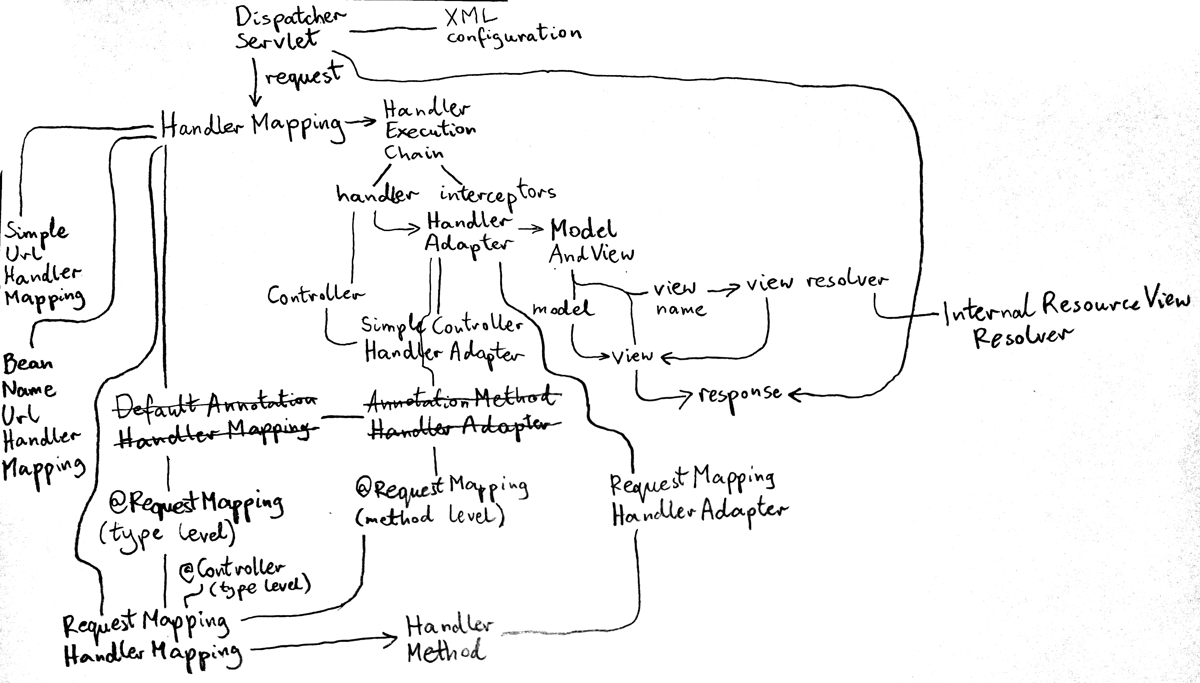
DispatcherServlet is a web servlet which receives HTTP requests, executes some handler (which consumes request and produces response’s contents) and returns HTTP response.
When DispatcherServlet receives request, it passes it to handler mappings. One of handler mappings decide that it can handle this request: it produces handler execution chain, which consists of any number of interceptors and one handler. Then dispatcher servlet passes the handler to handler adapters. One of handler adapters decides that it can execute this handler. It executes the handler, gets the result returned by the handler, puts the result into a model and returns an object called ModelAndView. ModelAndView contains two things:
- model
- either view (which is an object which can turn a model into HTTP response) or view name
If ModelAndView returned by handler adapter contains view name, dispatcher servlet passes this name to view resolvers. One of view resolvers decide that it can handle this view name and returns a view.
Dispatcher servlet passes the model to the view. It also passes response object to the view. View converts data from model to the contents of HTTP response and puts it into response object which it got from the dispatcher servlet. Dispatcher servlet uses the response object to produce HTTP response and send it to HTTP client.
When we make web applications with Spring Web MVC, we deal with three types of stuff (classes, interfaces, annotations etc):
- stuff created by authors of Spring – it is a part of Spring Web MVC framework, you must use it when you use Spring
- stuff which you yourself must create – it contains the business logic of your web application, nobody but you can make it
- stuff which in theory you could write yourself, but in practice it makes more sense is to use something provided by Spring authors – it connects your business logic with Spring MVC
On below picture stuff which you must create is yellow, stuff which you must not create is red and stuff which you could create but it is better to use what Spring authors have provided is green:
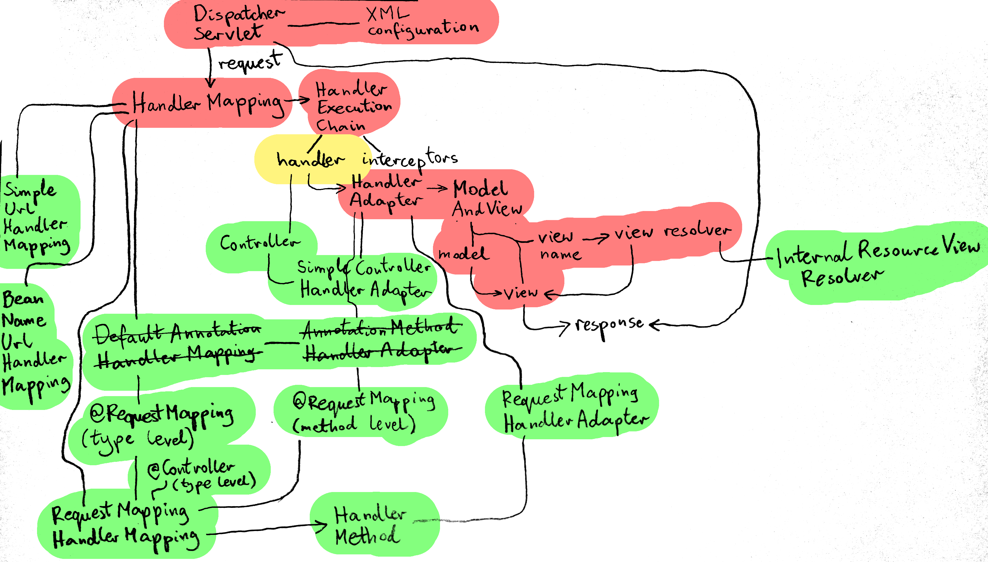

Stuff which you don’t want to write yourself
Stuff which you don’t want to write yourself (the green stuff on the picture) is used (by Spring Web MVC framework) to connect the framework (red) with our business logic (yellow). Authors of Spring have decided that it is a good idea to allow programmers to write business logic in different ways, they created a lot of green stuff. For instance, in your web application you only need one HandlerAdapter (to connect the framework with your handler), but you can choose from several different handler adapters – with each of them you write your handlers in a different way.
Controller is a simple interface for handlers: it contains a method which must produce handler’s response. Attention: it has nothing to do with @Controller annotation. SimpleControllerHandlerAdapter is a handler adapter which can
SimpleUrlHandlerMapping is a handler mapping which has a map which maps URLs to handlers. You configure it by setting this map in the XML configuration of application context, by setting a property of SimpleUrlHandlerMapping bean.
BeanNameUrlHandlerMapping is a handler mapping which treats bean names as patterns, it compares the URL with the pattern and returns the bean if the pattern matches.
DefaultAnnotationHandlerMapping and AnnotationMethodHandlerAdapter is a deprecated pair of handler mapping and handler adapter. DefaultAnnotationHandlerMapping chooses a class which will be used as a handler based on the pattern provided in @RequestMappping annotation on this class. AnnotationMethodHandlerAdapter calls one of methods of this class – which method should be used is chosen based on patterns provided in @RequestMapping annotation on methods.
This deprecated pair is replaced with RequestMappingHandlerMapping and RequestMappingHandlerAdapter. RequestMappingHandlerMapping iterates through all beans annotated with @Controller or @RequestMapping, for each bean it iterates through all its methods annotated with @RequestMapping, it uses patterns provided in these @RequestMapping annotations to choose the method which will handle the request and produces a handler (of type HandlerMethod) which call this method. Then RequestMappingHandlerAdapter handler adapter can execute this HandlerMethod handler.
InternalResourceViewResolver is a view resolver which produces a view which redirects a request to a resource (for instance, to JSP template).

Once I was interesting why this entity manager factory is called local. I asked about it on Stack Overflow ( http://stackoverflow.com/questions/29283419/why-localentitymanagerfactorybean-class-is-called-local/29289555#29289555 ) and somebody has answered: I dont have an authoritative source, however I'm pretty sure that it is "Local" in that it is local to the spring application context used by the application. Spring doesn't provide a Remote EMF, however other components such as application servers will. For instance JBoss AS (an open source J2EE app server) can manage JPA EMF's and will make it available to your application at runtime, eg over JNDI, refer to the JBoss docs ( https://docs.jboss.org/author/display/AS71/JPA+Reference+Guide#JPAReferenceGuide-Entitymanager )
It is true that the postprocessor enabled by context:component-scan treats all those annotations the same – but other code may treat them differently. The only difference between them which I know about is that RequestMappingHandlerMapping maps incoming requests only to those beans which are annotated with @Controller (and not, for instance, @Component) or @RequestMapping.
If you don't know what's the difference between /* and / url-pattern, read this: https://stackoverflow.com/questions/4140448/difference-between-and-in-servlet-mapping-url-pattern?rq=1 https://stackoverflow.com/questions/14018215/what-is-url-pattern-in-web-xml-and-how-to-configure-servlet
http://docs.spring.io/spring-framework/docs/2.5.6/api/org/springframework/web/servlet/view/InternalResourceViewResolver.html says: BTW, it's good practice to put JSP files that just serve as views under WEB-INF, to hide them from direct access (e.g. via a manually entered URL). Only controllers will be able to access them then.
It was true in 2015, when I first wrote this document. Now, in 2019, it is no longer true. DefaultAnnotationHandlerMapping and AnnotationMethodHandlerAdapter are not enabled by default. Probably there is no reason to know them anymore.
This was (maybe) true in 2015, when I first wrote this document. Now, in 2019, sources of Spring Web MVC can be downloaded with maven. It can be easily done in maven by right clicking on jar and choosing download sources.

